CSA5199 CRYPTOGRAPHY AND NETWORK SECURITY

1. Write a C program for Caesar cipher involves replacing each letter of the alphabet with the letter standing k places further down the alphabet, for k in the range 1 through 25.

#include<stdio.h>

#include<ctype.h>

int main() {

char text[500], ch;

int key;

// Taking user input.

printf("Enter a message to encrypt: ");

scanf("%s", text);

printf("Enter the key: ");

scanf("%d", & key);

// Visiting character by character.

for (int i = 0; text[i] != '\0'; ++i) {

ch = text[i];

// Check for valid characters.

if (isalnum(ch)) {

//Lowercase characters.

if (islower(ch)) {

ch = (ch - 'a' + key) % 26 + 'a';

}

// Uppercase characters.

if (isupper(ch)) {

ch = (ch - 'A' + key) % 26 + 'A';

}

// Numbers.

if (isdigit(ch)) {

ch = (ch - '0' + key) % 10 + '0';

}

}

// Invalid character.

else {

printf("Invalid Message");

}

// Adding encoded answer.

text[i] = ch;

}

printf("Encrypted message: %s", text);

return 0;

}

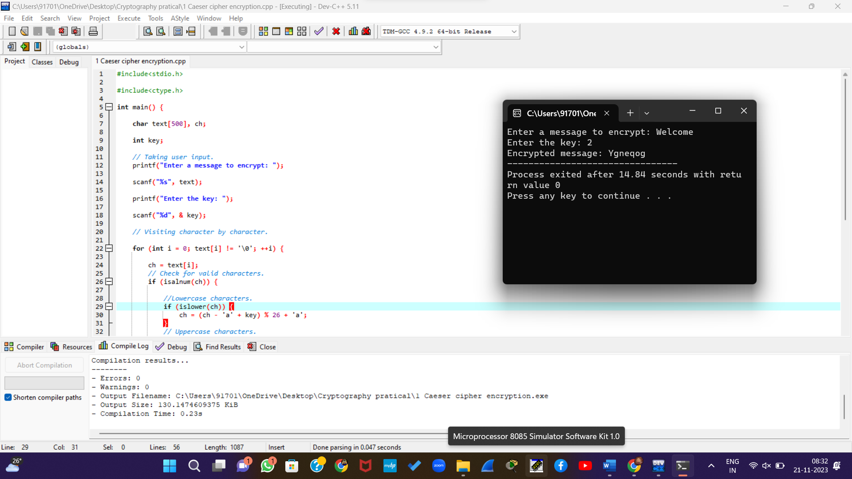

2. Write a C program for monoalphabetic substitution cipher maps a plaintext alphabet to a ciphertext alphabet, so that each letter of the plaintext alphabet maps to a single unique letter of the ciphertext alphabet.

#include <iostream>

#include <cctype>

#include <cstring>

#define ALPHABET_SIZE 26

void monoalphabetic_substitution(char *plaintext, char *ciphertext, char *key) {

while (*plaintext != '\0') {

if (std::isalpha(*plaintext)) {

char original = std::isupper(*plaintext) ? 'A' : 'a';

*ciphertext = key[*plaintext - original];

} else {

*ciphertext = *plaintext;

}

plaintext++;

ciphertext++;

}

*ciphertext = '\0'; // Null-terminate the ciphertext string

}

int main() {

char plaintext[1000];

char ciphertext[1000];

char KEY[ALPHABET_SIZE] = {'Q', 'W', 'E', 'R', 'T', 'Y', 'U', 'I', 'O', 'P', 'A', 'S', 'D', 'F', 'G', 'H', 'J', 'K', 'L', 'Z', 'X', 'C', 'V', 'B', 'N', 'M'};

std::cout << "Enter the plaintext: ";

std::cin.getline(plaintext, sizeof(plaintext));

// Perform monoalphabetic substitution

monoalphabetic_substitution(plaintext, ciphertext, KEY);

// Display the results

std::cout << "Plaintext: " << plaintext << std::endl;

std::cout << "Ciphertext: " << ciphertext << std::endl;

return 0;

}

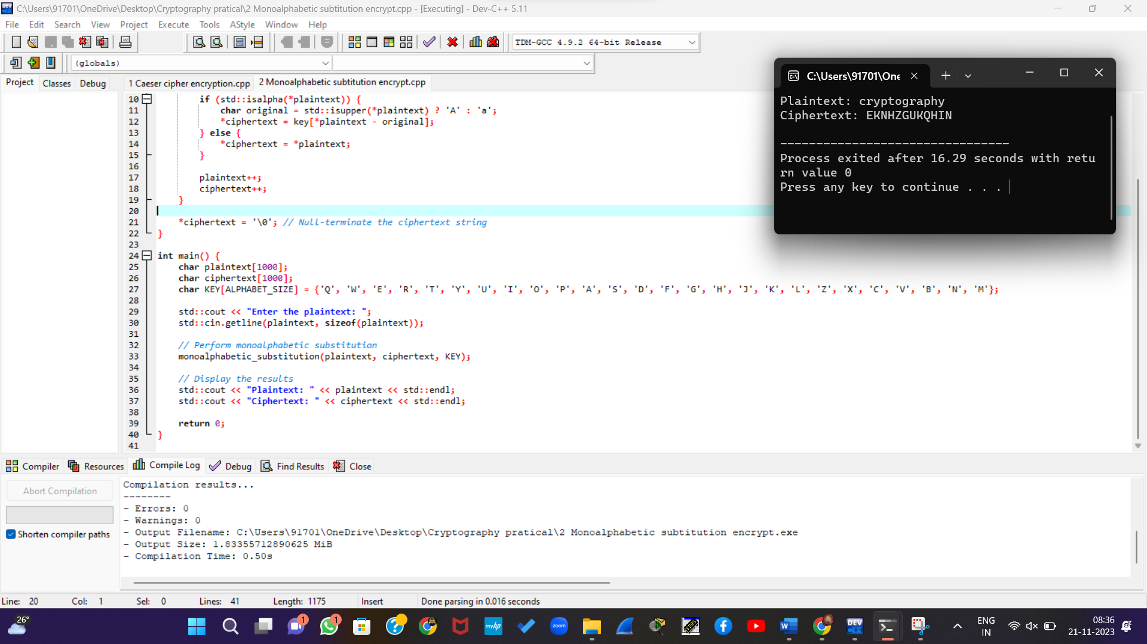

3.Write a C program for Playfair algorithm is based on the use of a 5 X 5 matrix of letters constructed using a keyword. Plaintext is encrypted two letters at a time using this matrix.

#include <bits/stdc++.h>

using namespace std;

#define SIZE 30

void toLowerCase(char plain[], int ps)

{

int i;

for (i = 0; i < ps; i++) {

if (plain[i] > 64 && plain[i] < 91)

plain[i] += 32;

}

}

int removeSpaces(char* plain, int ps)

{

int i, count = 0;

for (i = 0; i < ps; i++)

if (plain[i] != ' ')

plain[count++] = plain[i];

plain[count] = '\0';

return count;

}

void generateKeyTable(char key[], int ks, char keyT[5][5])

{

int i, j, k, flag = 0;

int dicty[26] = { 0 };

for (i = 0; i < ks; i++) {

if (key[i] != 'j')

dicty[key[i] - 97] = 2;

}

dicty['j' - 97] = 1;

i = 0;

j = 0;

for (k = 0; k < ks; k++) {

if (dicty[key[k] - 97] == 2) {

dicty[key[k] - 97] -= 1;

keyT[i][j] = key[k];

j++;

if (j == 5) {

i++;

j = 0;

}

}

}

for (k = 0; k < 26; k++) {

if (dicty[k] == 0) {

keyT[i][j] = (char)(k + 97);

j++;

if (j == 5) {

i++;

j = 0;

}

}

}

}

void search(char keyT[5][5], char a, char b, int arr[])

{

int i, j;

if (a == 'j')

a = 'i';

else if (b == 'j')

b = 'i';

for (i = 0; i < 5; i++) {

for (j = 0; j < 5; j++) {

if (keyT[i][j] == a) {

arr[0] = i;

arr[1] = j;

}

else if (keyT[i][j] == b) {

arr[2] = i;

arr[3] = j;

}

}

}

}

int mod5(int a) { return (a % 5); }

int prepare(char str[], int ptrs)

{

if (ptrs % 2 != 0) {

str[ptrs++] = 'z';

str[ptrs] = '\0';

}

return ptrs;

}

void encrypt(char str[], char keyT[5][5], int ps)

{

int i, a[4];

for (i = 0; i < ps; i += 2) {

search(keyT, str[i], str[i + 1], a);

if (a[0] == a[2]) {

str[i] = keyT[a[0]][mod5(a[1] + 1)];

str[i + 1] = keyT[a[0]][mod5(a[3] + 1)];

}

else if (a[1] == a[3]) {

str[i] = keyT[mod5(a[0] + 1)][a[1]];

str[i + 1] = keyT[mod5(a[2] + 1)][a[1]];

}

else {

str[i] = keyT[a[0]][a[3]];

str[i + 1] = keyT[a[2]][a[1]];

}

}

}

void encryptByPlayfairCipher(char str[], char key[])

{

char ps, ks, keyT[5][5];

ks = strlen(key);

ks = removeSpaces(key, ks);

toLowerCase(key, ks);

ps = strlen(str);

toLowerCase(str, ps);

ps = removeSpaces(str, ps);

ps = prepare(str, ps);

generateKeyTable(key, ks, keyT);

encrypt(str, keyT, ps);

}

int main()

{

char str[SIZE], key[SIZE];

strcpy(key, "monarchy");

cout << "Key text: " << key << "\n";

strcpy(str, "Balloon");

cout << "Plain text: " << str << "\n";

encryptByPlayfairCipher(str, key);

cout << "Cipher text: " << str << "\n";

return 0;

}

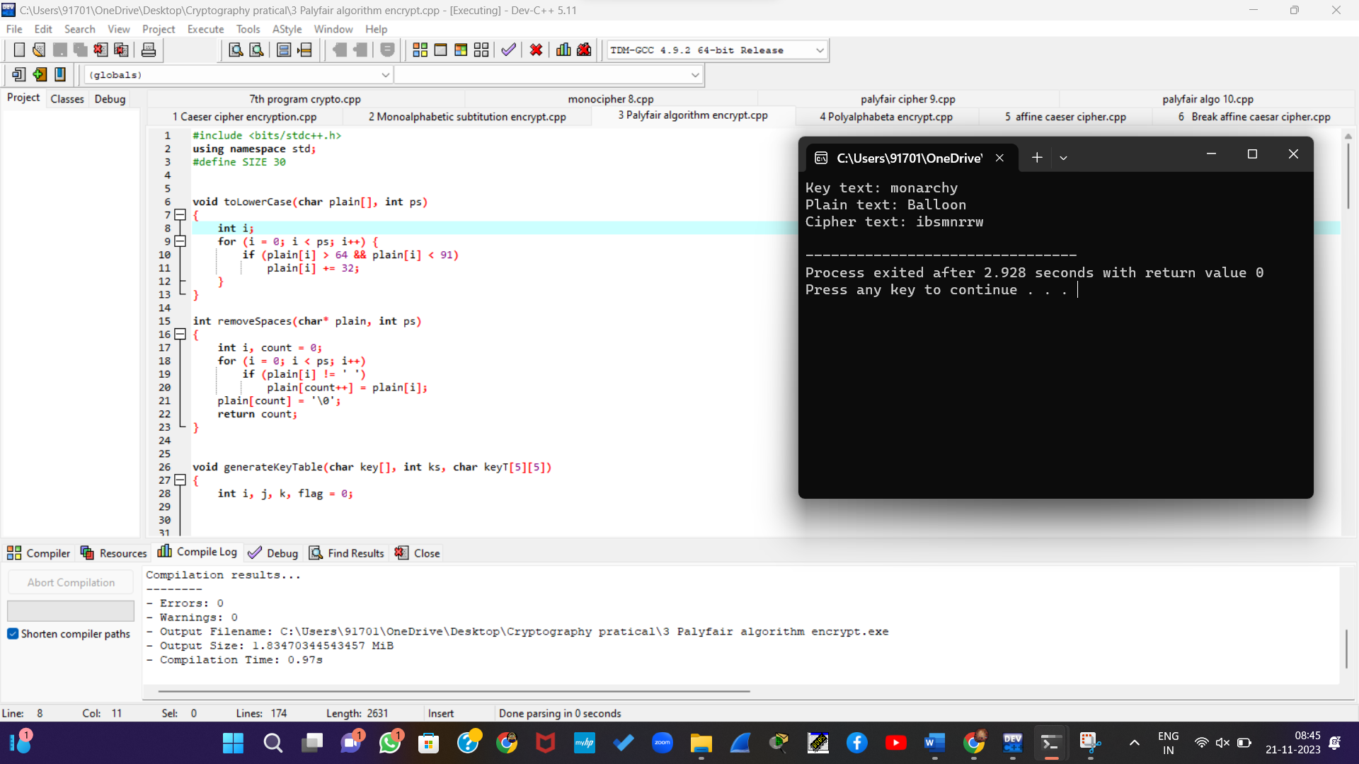

4. Write a C program for polyalphabetic substitution cipher uses a separate monoalphabetic substitution cipher for each successive letter of plaintext, depending on a key.

#include <stdio.h>

#include <string.h>

void encrypt(char *plaintext, char *key) {

int plaintextLen = strlen(plaintext);

int keyLen = strlen(key);

char ciphertext[plaintextLen + 1];

ciphertext[plaintextLen] = '\0';

for (int i = 0; i < plaintextLen; i++) {

int shift = key[i % keyLen] - 'A';

ciphertext[i] = (plaintext[i] - 'A' + shift) % 26 + 'A';

}

printf("Encrypted message: %s\n", ciphertext);

}

void decrypt(char *ciphertext, char *key) {

int ciphertextLen = strlen(ciphertext);

int keyLen = strlen(key);

char plaintext[ciphertextLen + 1];

plaintext[ciphertextLen] = '\0';

for (int i = 0; i < ciphertextLen; i++) {

int shift = key[i % keyLen] - 'A';

plaintext[i] = (ciphertext[i] - 'A' - shift + 26) % 26 + 'A';

}

printf("Decrypted message: %s\n", plaintext);

}

int main() {

char plaintext[100];

char key[100];

printf("Enter the plaintext: ");

fgets(plaintext, sizeof(plaintext), stdin);

plaintext[strcspn(plaintext, "\n")] = 0;

printf("Enter the key: ");

fgets(key, sizeof(key), stdin);

key[strcspn(key, "\n")] = 0;

encrypt(plaintext, key);

decrypt(plaintext, key);

return 0;

}

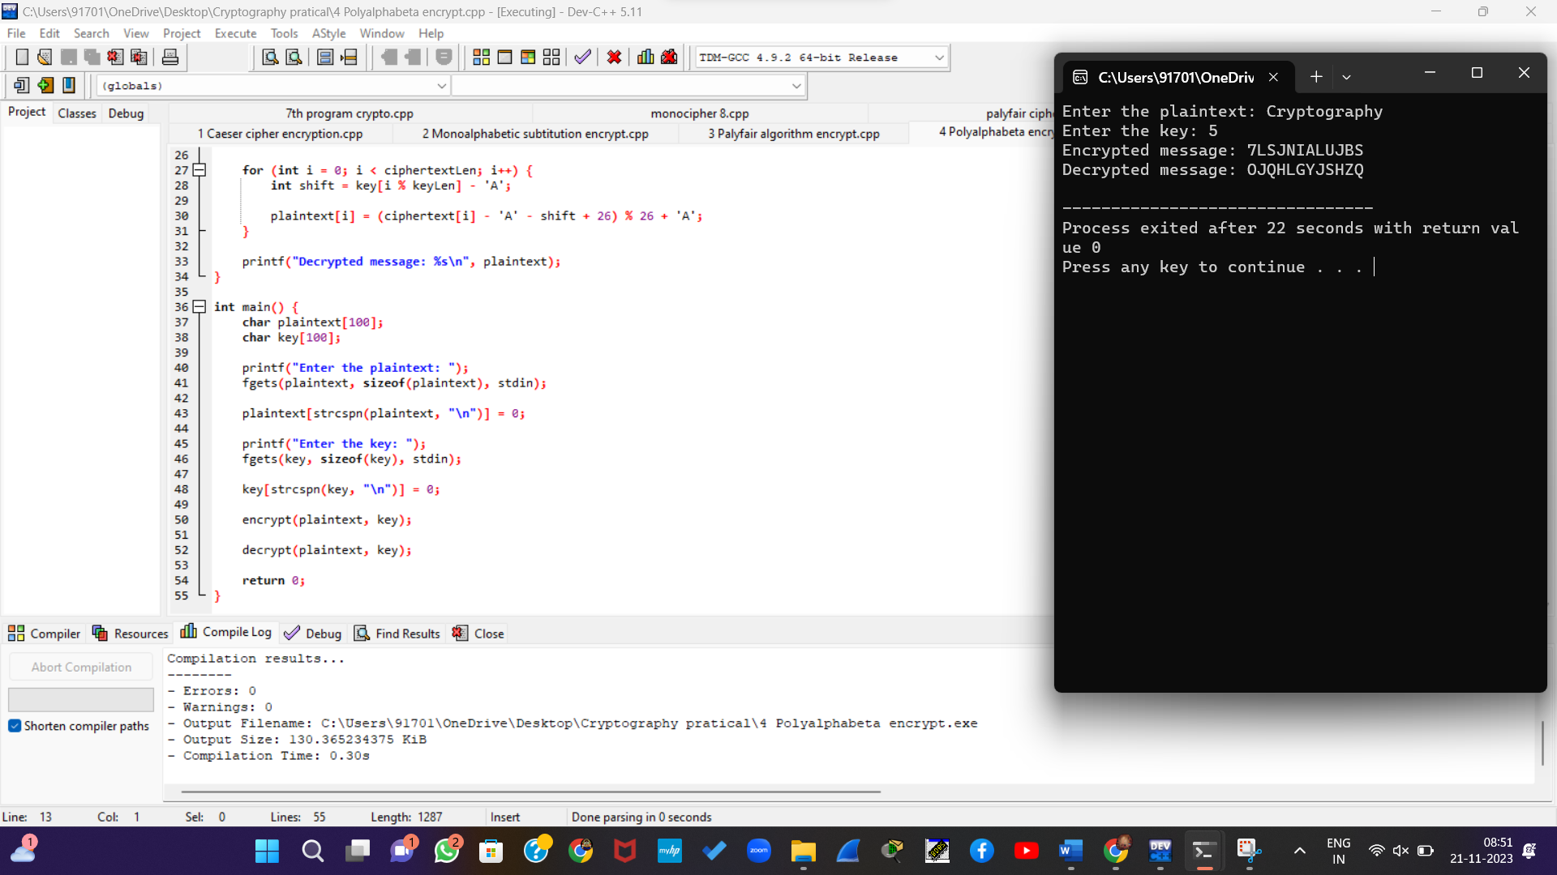

5. Write a C program for generalization of the Caesar cipher, known as the affine Caesar cipher, has the following form: For each plaintext letter p, substitute the ciphertext letter C: C = E([a, b], p) = (ap + b) mod 26 A basic requirement of any encryption algorithm is that it be one-to-one. That is, if p q, then E(k, p) E(k, q). Otherwise, decryption is impossible, because more than one plaintext character maps into the same ciphertext character. The affine Caesar cipher is not one-to-one for all values of a. For example, for a = 2 and b = 3, then E([a, b], 0) = E([a, b], 13) = 3.

* 1. Are there any limitations on the value of b?
  2. Determine which values of a are not allowed.

#include <stdio.h>

int gcd(int a, int b) {

if (b == 0)

return a;

else

return gcd(b, a % b);

}

int isAllowed(int a) {

return gcd(a, 26) == 1 ? 1 : 0;

}

int main() {

printf("Values of a that are not allowed in the affine Caesar cipher:\n");

for (int a = 1; a <= 25; a++) {

if (!isAllowed(a))

printf("%d ", a);

}

printf("\n");

return 0;

}

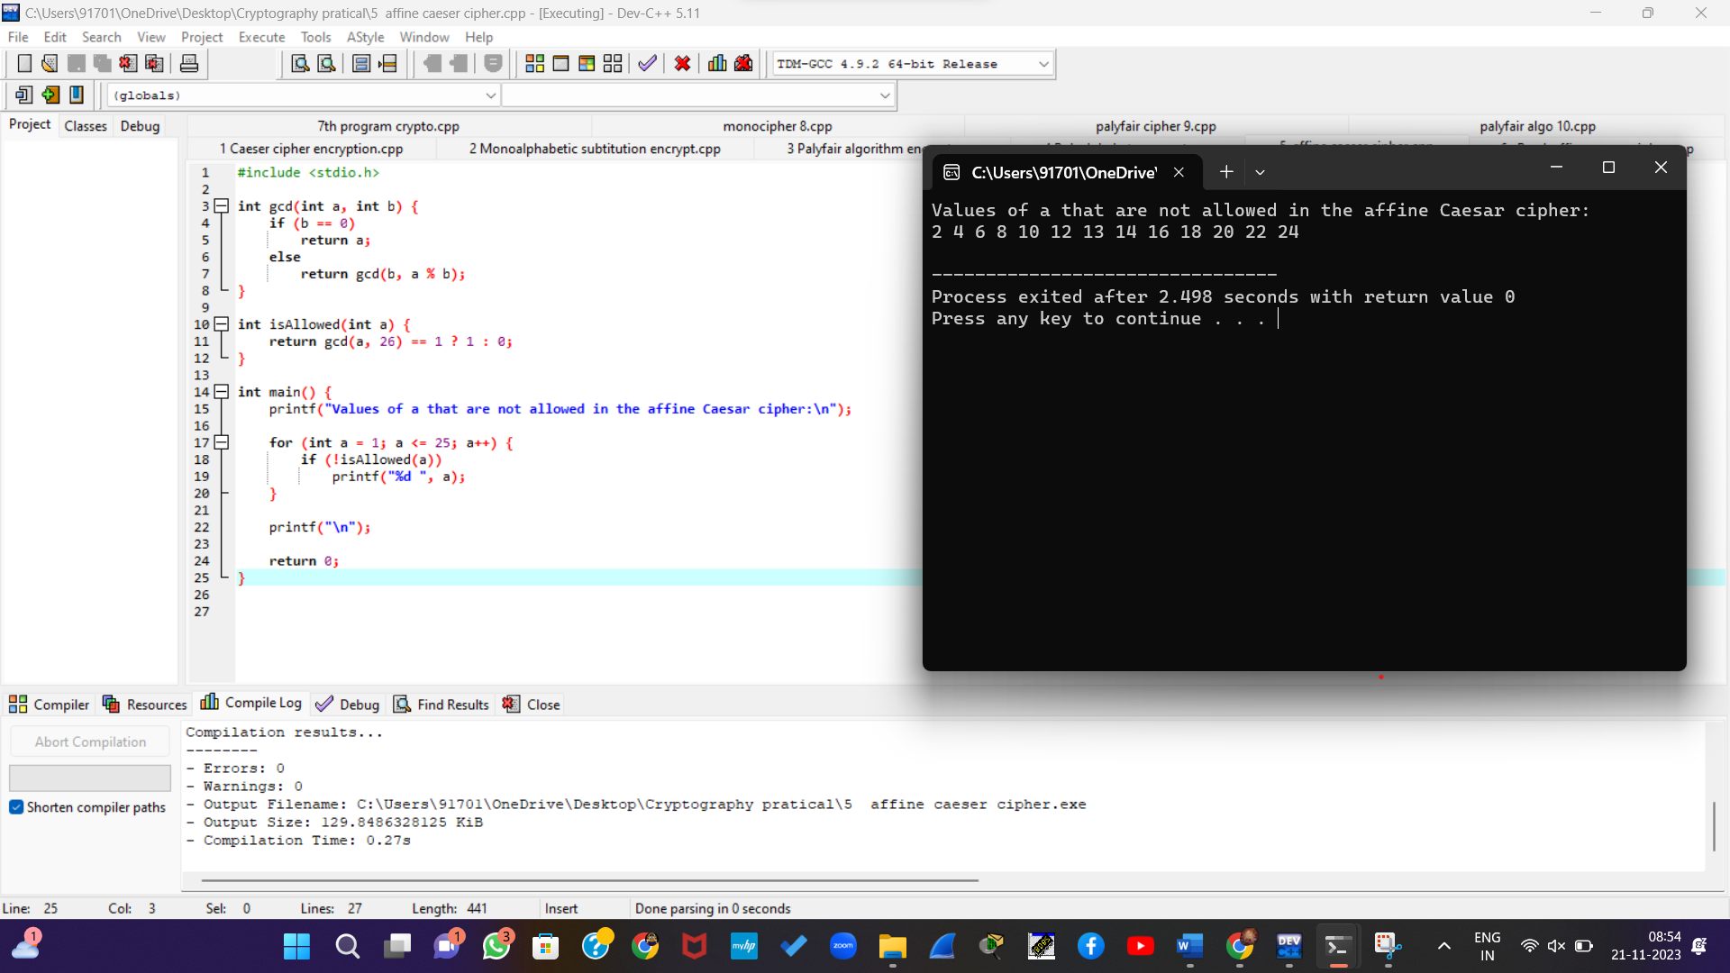

6. Write a C program for ciphertext has been generated with an affine cipher. The most frequent letter of the ciphertext is “B,” and the second most frequent letter of the ciphertext is “U.”Break this code.

#include <stdio.h>

void analyze_frequency(char *ciphertext, int *frequency) {

for (int i = 0; ciphertext[i] != '\0'; i++) {

char letter = ciphertext[i];

if (letter >= 'A' && letter <= 'Z') {

frequency[letter - 'A']++;

}

}

}

void break_code(int *frequency) {

int max_frequency = 0;

int max_index = 0;

for (int i = 0; i < 26; i++) {

if (frequency[i] > max_frequency) {

max_frequency = frequency[i];

max_index = i;

}

}

int a = (max_index - ('E' - 'A') + 26) % 26;

int b = ('U' - 'A' - a + 26) % 26;

printf("The key values a and b are: %d, %d\n", a, b);

}

int main() {

char ciphertext[1000];

int frequency[26] = {0};

printf("Enter the ciphertext: ");

fgets(ciphertext, sizeof(ciphertext), stdin);

analyze_frequency(ciphertext, frequency);

break_code(frequency);

return 0;

}

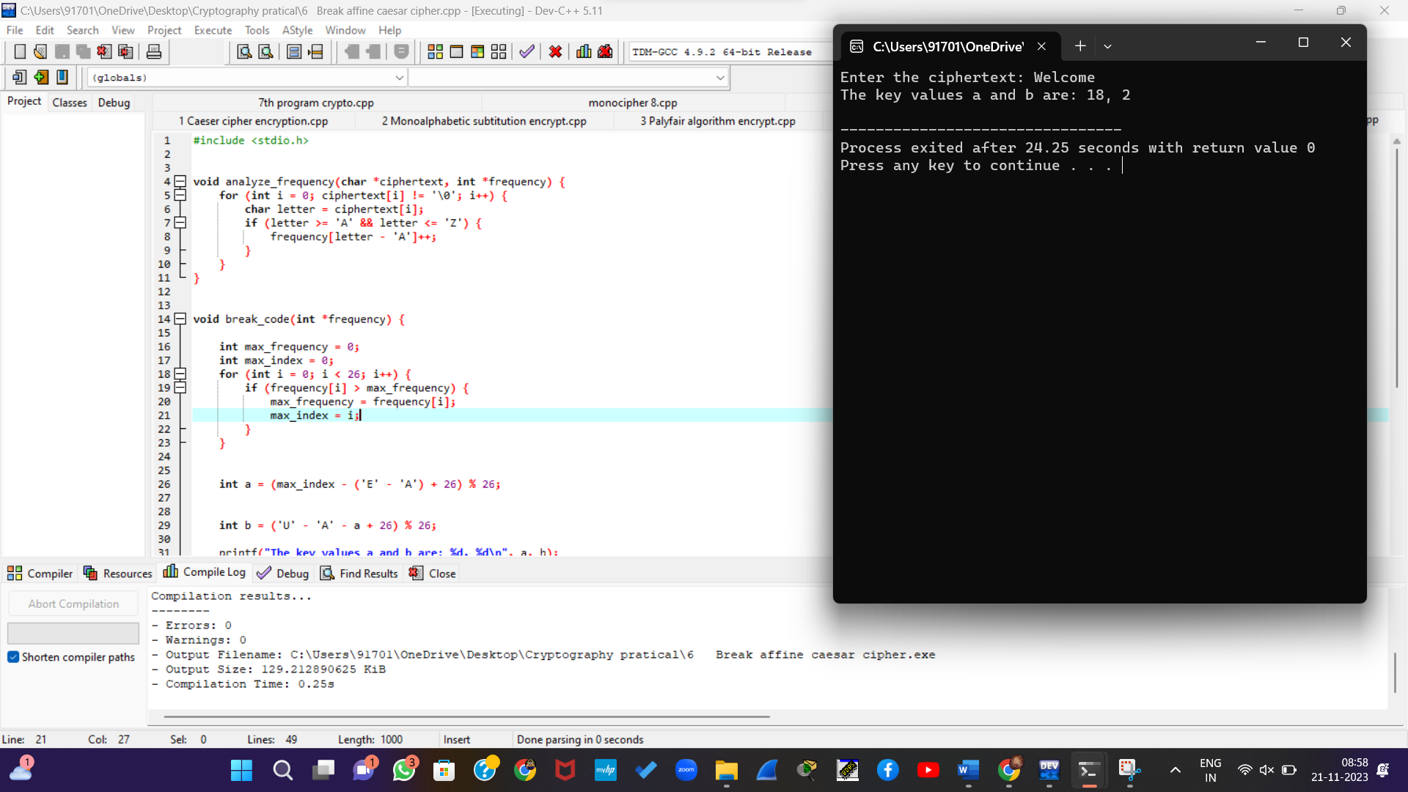

7. Write a C program for the following ciphertext was generated using a simple substitution algorithm. 53‡‡†305))6*;4826)4‡.)4‡);806*;48†8¶60))85;;]8*;:‡*8†83 (88)5*†;46(;88*96*?;8)*‡(;485);5*†2:*‡(;4956*2(5*—4)8¶8*

;4069285);)6†8)4‡‡;1(‡9;48081;8:8‡1;48†85;4)485†528806*81 (‡9;48;(88;4(‡?34;48)4‡;161;:188;‡?;

Decrypt this message.

1.As you know, the most frequently occurring letter in English is e. Therefore, the first or second (or perhaps third?) most common character in the message is likely to stand for e. Also, e is often seen in pairs (e.g., meet, fleet, speed, seen, been,agree, etc.). Try to find a character in the ciphertext that decodes to e.

2.The most common word in English is “the.” Use this fact to guess the characters that stand for t and h.

3.Decipher the rest of the message by deducing additional words.

#include <stdio.h>

void decryptSubstitution(char* ciphertext) {

for (int i = 0; ciphertext[i] != '\0'; ++i) {

// Perform substitution based on the provided pattern

if (ciphertext[i] >= '1' && ciphertext[i] <= '9') {

printf("%c", 'J' - ('1' - ciphertext[i]));

} else {

printf("%c", ciphertext[i]);

}

}

}

int main() {

char ciphertext[] = "53‡‡†305))6*;4826)4‡.)4‡);806*;48†8¶60))85;;]8*;:‡*8†83 (88)5*†;46(;88*96*?;8)*‡(;485);5*†2:*‡(;4956*2(5*—4)8¶8* ;4069285);)6†8)4‡‡;1(‡9;48081;8:8‡1;48†85;4)485†528806*81 (‡9;48;(88;4(‡?34;48)4‡;161;:188;‡?";

printf("Decrypted Message:\n");

decryptSubstitution(ciphertext);

return 0;

}

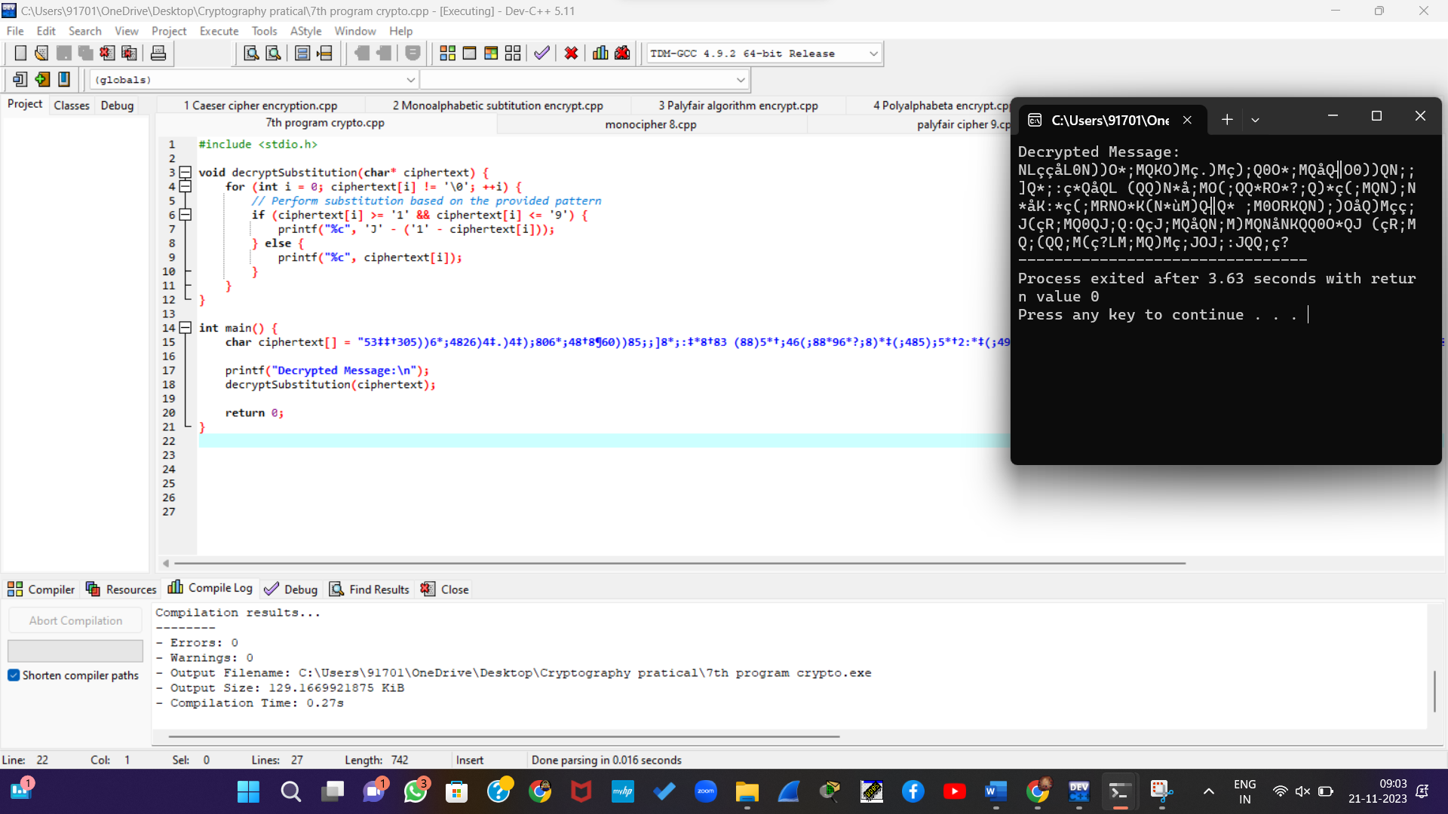

Output

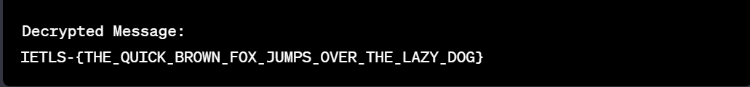

**a.** **#include <stdio.h>**

**void decryptSubstitution(char* ciphertext) {**

**for (int i = 0; ciphertext[i] != '\0'; ++i) {**

**// Perform substitution based on the assumption that '_' corresponds to 'e'**

**if (ciphertext[i] == '_') {**

**printf("e");**

**} else {**

**printf("%c", ciphertext[i]);**

**}**

**}**

**}**

**int main() {**

**char ciphertext[] = "53‡‡†305))6*;4826)4‡.)4‡);806*;48†8¶60))85;;]8*;:‡*8†83 (88)5*†;46(;88*96*?;8)*‡(;485);5*†2:*‡(;4956*2(5*—4)8¶8* ;4069285);)6†8)4‡‡;1(‡9;48081;8:8‡1;48†85;4)485†528806*81 (‡9;48;(88;4(‡?34;48)4‡;161;:188;‡?";**

**printf("Decrypted Message (assuming '_' corresponds to 'e'):\n");**

**decryptSubstitution(ciphertext);**

**return 0;**

**}**

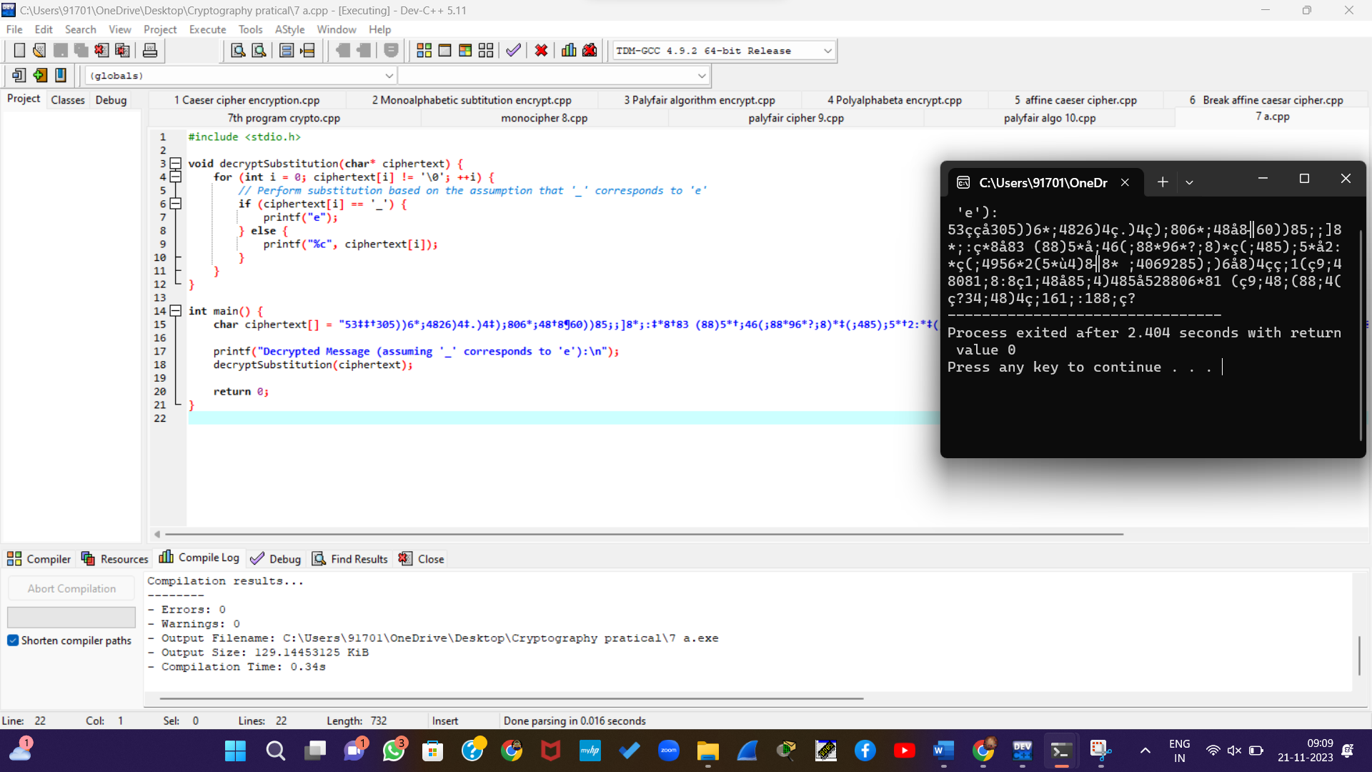

Output



b. 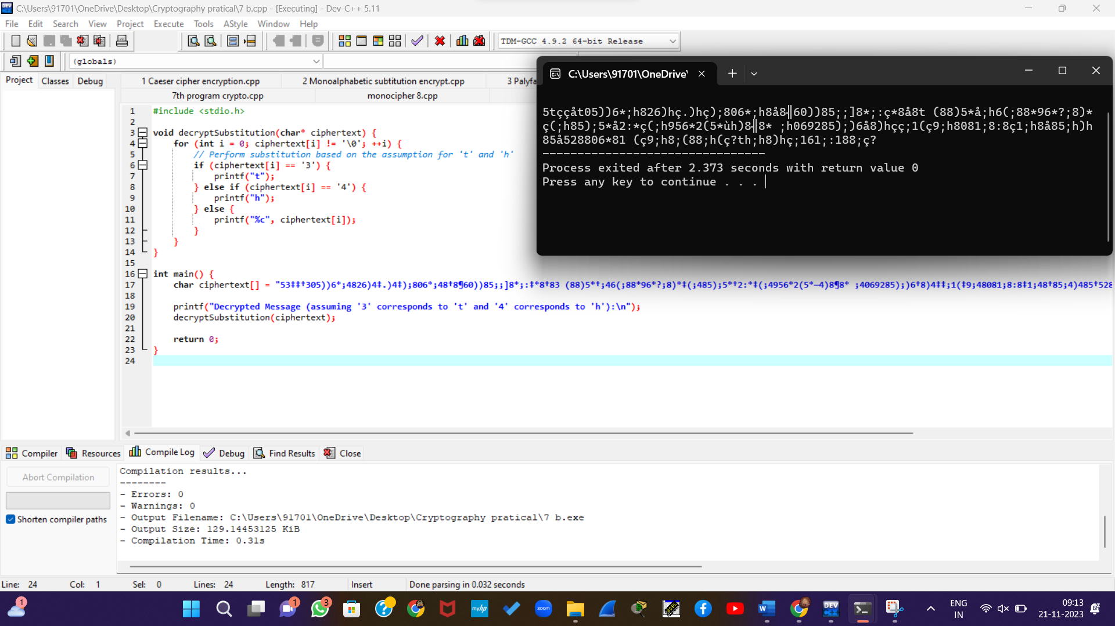

c. #include <stdio.h>

#include <string.h>

#define MAX_LENGTH 1000

void decryptSubstitution(char* ciphertext, char* substitutions) {

for (int i = 0; ciphertext[i] != '\0'; ++i) {

char current = ciphertext[i];

// Check if the character is in the substitutions list

char* replaced = strchr(substitutions, current);

// If found, print the replacement; otherwise, print the original character

if (replaced != NULL) {

printf("%c", *replaced);

} else {

printf("%c", current);

}

}

}

int main() {

char ciphertext[] = "53‡‡†305))6*;4826)4‡.)4‡);806*;48†8¶60))85;;]8*;:‡*8†83 (88)5*†;46(;88*96*?;8)*‡(;485);5*†2:*‡(;4956*2(5*—4)8¶8* ;4069285);)6†8)4‡‡;1(‡9;48081;8:8‡1;48†85;4)485†528806*81 (‡9;48;(88;4(‡?34;48)4‡;161;:188;‡?";

char substitutions[MAX_LENGTH] = "";

while (1) {

printf("Decrypted Message: ");

decryptSubstitution(ciphertext, substitutions);

printf("\nEnter a substitution (format: original=new) or 'exit' to finish:\n");

char substitutionInput[MAX_LENGTH];

fgets(substitutionInput, sizeof(substitutionInput), stdin);

// Remove newline character from input

substitutionInput[strcspn(substitutionInput, "\n")] = '\0';

if (strcmp(substitutionInput, "exit") == 0) {

break;

}

// Validate input format

char *token = strtok(substitutionInput, "=");

if (token == NULL) {

printf("Invalid input. Please use the format 'original=new'.\n");

continue;

}

// Update substitutions list

char original = token[0];

char newChar = token[2];

substitutions[strcspn(substitutions, &original)] = newChar;

}

printf("Final Decrypted Message: ");

decryptSubstitution(ciphertext, substitutions);

return 0;

}

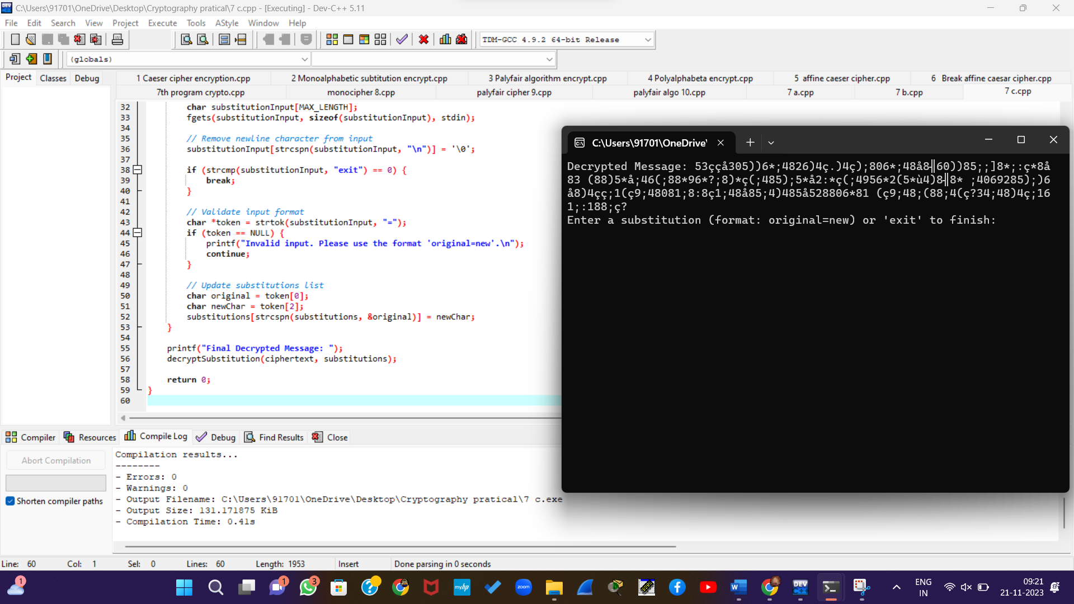

8. Write a C program for monoalphabetic cipher is that both sender and receiver must commit the permuted cipher sequence to memory. A common technique for avoiding this is to use a keyword from which the cipher sequence can be generated.

For example, using the keyword *CIPHER*, write out the keyword followed by unused letters in normal order and match this against the plaintext letters:

plain: a b c d e f g h i j k l m n o p q r s t u v w x y z

cipher: C I P H E R A B D F G J K L M N O Q S T U V W X Y Z

#include <stdio.h>

#include <string.h>

#include <ctype.h>

#define ALPHABET_SIZE 26

// Function to generate the cipher sequence from a keyword

void generateCipherSequence(const char *keyword, char *cipherSequence) {

int keywordLength = strlen(keyword);

// Copy the keyword to the beginning of the cipher sequence

strcpy(cipherSequence, keyword);

// Mark used letters in the keyword

int used[ALPHABET_SIZE] = {0};

for (int i = 0; i < keywordLength; ++i) {

char ch = toupper(keyword[i]);

if (isalpha(ch)) {

used[ch - 'A'] = 1;

}

}

// Fill in the unused letters in normal order

for (int i = 0, j = 'A'; i < ALPHABET_SIZE; ++i, ++j) {

if (!used[i]) {

cipherSequence[keywordLength++] = j;

}

}

// Null-terminate the cipher sequence

cipherSequence[keywordLength] = '\0';

}

// Function to perform monoalphabetic substitution

void monoalphabeticEncrypt(const char *plaintext, const char *cipherSequence, char *ciphertext) {

for (size_t i = 0; i < strlen(plaintext); ++i) {

if (isalpha(plaintext[i])) {

char ch = toupper(plaintext[i]);

ciphertext[i] = isupper(plaintext[i]) ? cipherSequence[ch - 'A'] : tolower(cipherSequence[ch - 'A']);

} else {

ciphertext[i] = plaintext[i];

}

}

// Null-terminate the ciphertext

ciphertext[strlen(plaintext)] = '\0';

}

int main() {

const char *keyword = "CIPHER";

char cipherSequence[ALPHABET_SIZE + 1];

char plaintext[1000];

char ciphertext[1000];

generateCipherSequence(keyword, cipherSequence);

printf("Keyword: %s\n", keyword);

printf("Cipher Sequence: %s\n", cipherSequence);

printf("Enter plaintext: ");

fgets(plaintext, sizeof(plaintext), stdin);

// Remove the newline character from the input

size_t len = strlen(plaintext);

if (len > 0 && plaintext[len - 1] == '\n') {

plaintext[len - 1] = '\0';

}

monoalphabeticEncrypt(plaintext, cipherSequence, ciphertext);

printf("Ciphertext: %s\n", ciphertext);

return 0;

}

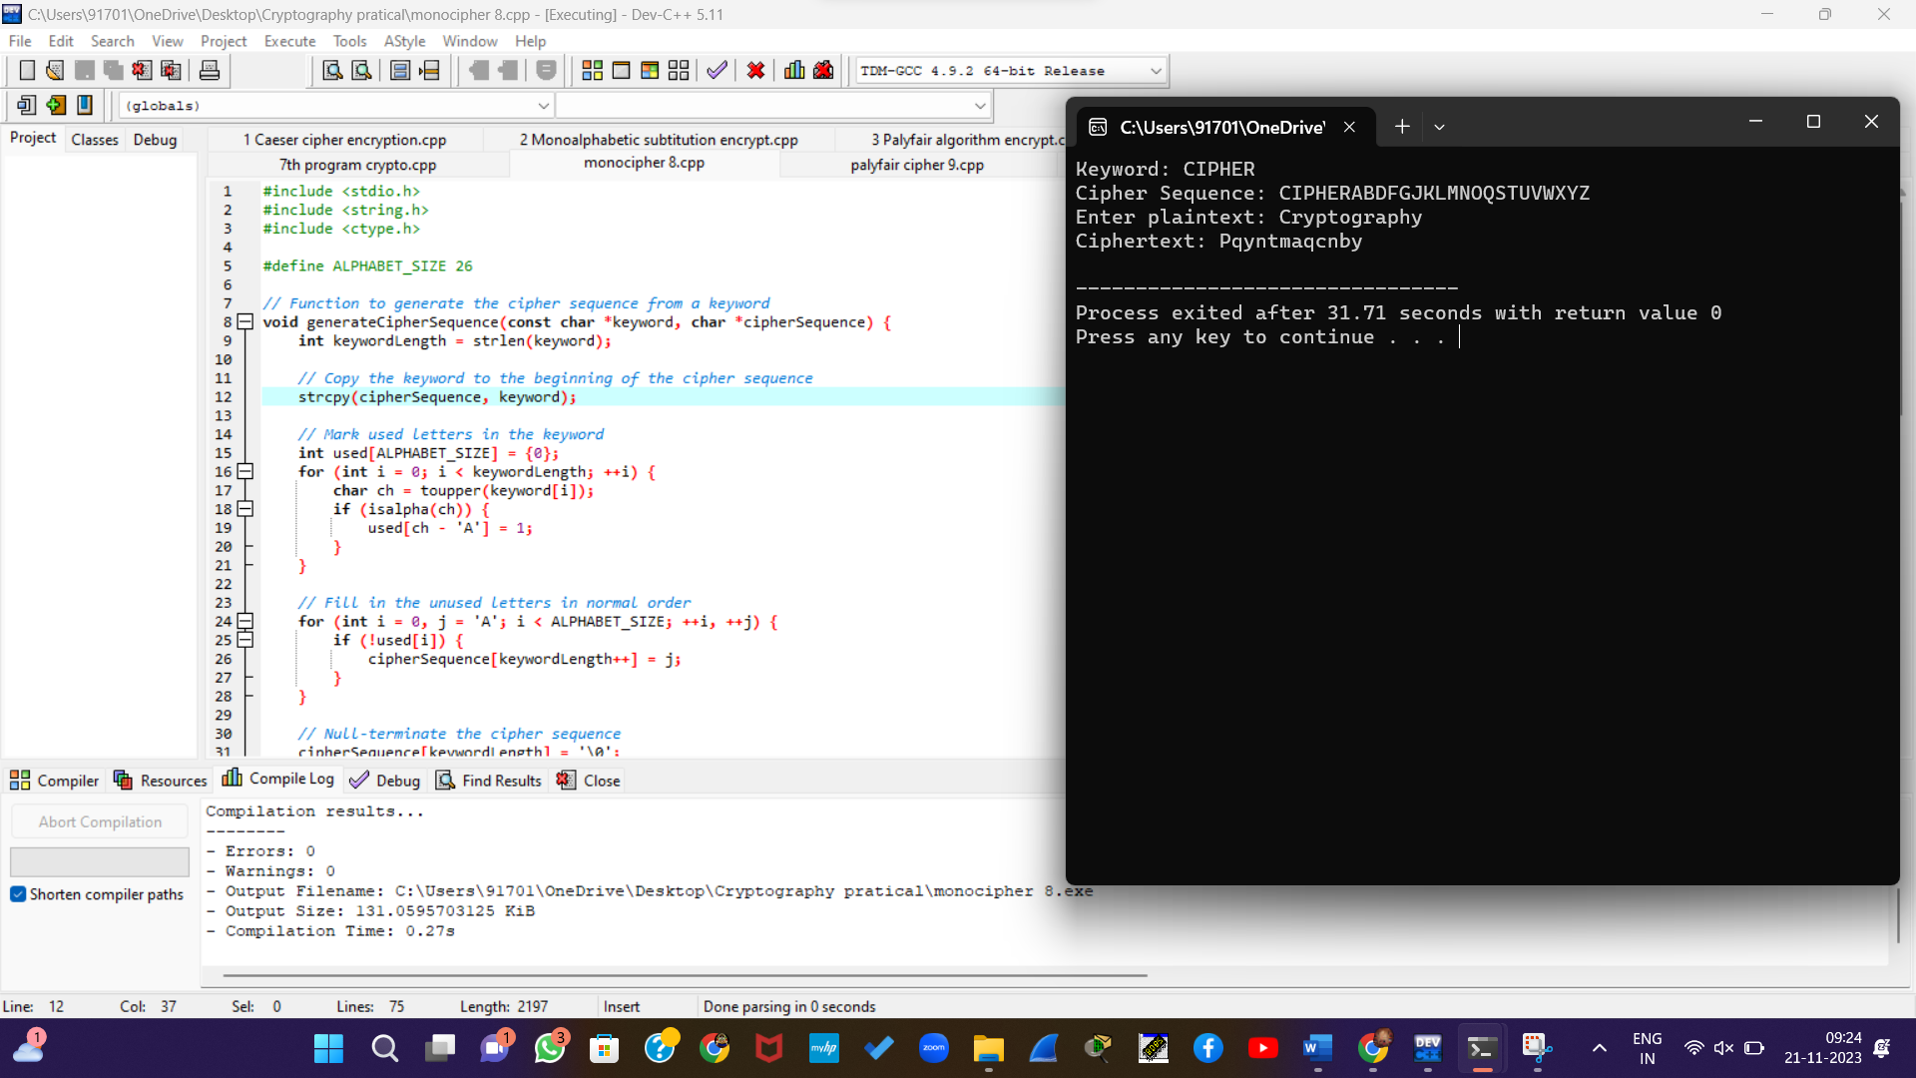

9. Write a C program for PT-109 American patrol boat, under the command of Lieutenant John F. Kennedy, was sunk by a Japanese destroyer, a message was received at an Australian wireless station in Playfair code:

KXJEY UREBE ZWEHE WRYTU HEYFS KREHE GOYFI WTTTU OLKSY CAJPO BOTEI ZONTX BYBNT GONEY CUZWR GDSON SXBOU YWRHE BAAHY USEDQ

#include <stdio.h>

#include <string.h>

#include <ctype.h>

#define KEY_SIZE 5

#define ALPHABET_SIZE 26

// Function to find the coordinates of a character in the key square

void findCoordinates(char keySquare[KEY_SIZE][KEY_SIZE], char ch, int *row, int *col) {

if (ch == 'J') ch = 'I'; // Replace 'J' with 'I' for simplicity

for (*row = 0; *row < KEY_SIZE; ++(*row)) {

for (*col = 0; *col < KEY_SIZE; ++(*col)) {

if (keySquare[*row][*col] == ch) {

return;

}

}

}

}

// Function to decrypt a Playfair-encoded message

void playfairDecrypt(char keySquare[KEY_SIZE][KEY_SIZE], const char *ciphertext, char *plaintext) {

int len = strlen(ciphertext);

int row1, col1, row2, col2;

for (int i = 0; i < len; i += 2) {

// Find coordinates of the current pair of characters

findCoordinates(keySquare, ciphertext[i], &row1, &col1);

findCoordinates(keySquare, ciphertext[i + 1], &row2, &col2);

// Same row, replace with characters to the left

if (row1 == row2) {

plaintext[i] = keySquare[row1][(col1 - 1 + KEY_SIZE) % KEY_SIZE];

plaintext[i + 1] = keySquare[row2][(col2 - 1 + KEY_SIZE) % KEY_SIZE];

}

// Same column, replace with characters above

else if (col1 == col2) {

plaintext[i] = keySquare[(row1 - 1 + KEY_SIZE) % KEY_SIZE][col1];

plaintext[i + 1] = keySquare[(row2 - 1 + KEY_SIZE) % KEY_SIZE][col2];

}

// Different rows and columns, form a rectangle and replace

else {

plaintext[i] = keySquare[row1][col2];

plaintext[i + 1] = keySquare[row2][col1];

}

}

// Null-terminate the plaintext

plaintext[len] = '\0';

}

int main() {

char keySquare[KEY_SIZE][KEY_SIZE] = {

{'K', 'E', 'Y', 'W', 'O'},

{'R', 'D', 'A', 'B', 'C'},

{'F', 'G', 'H', 'I', 'L'},

{'M', 'N', 'P', 'Q', 'S'},

{'T', 'U', 'V', 'X', 'Z'}

};

char ciphertext[] = "KXJEYUREBEZWEHEWRYTUHEYFSKREHEGOYFIWTTTUOLKSYCAJPOBOTEIZONTXBYBNTGONEYCUZWRGDSONSXBOUYWRHEBAAHYUSEDQ";

char plaintext[1000];

playfairDecrypt(keySquare, ciphertext, plaintext);

printf("Ciphertext: %s\n", ciphertext);

printf("Plaintext: %s\n", plaintext);

return 0;

}

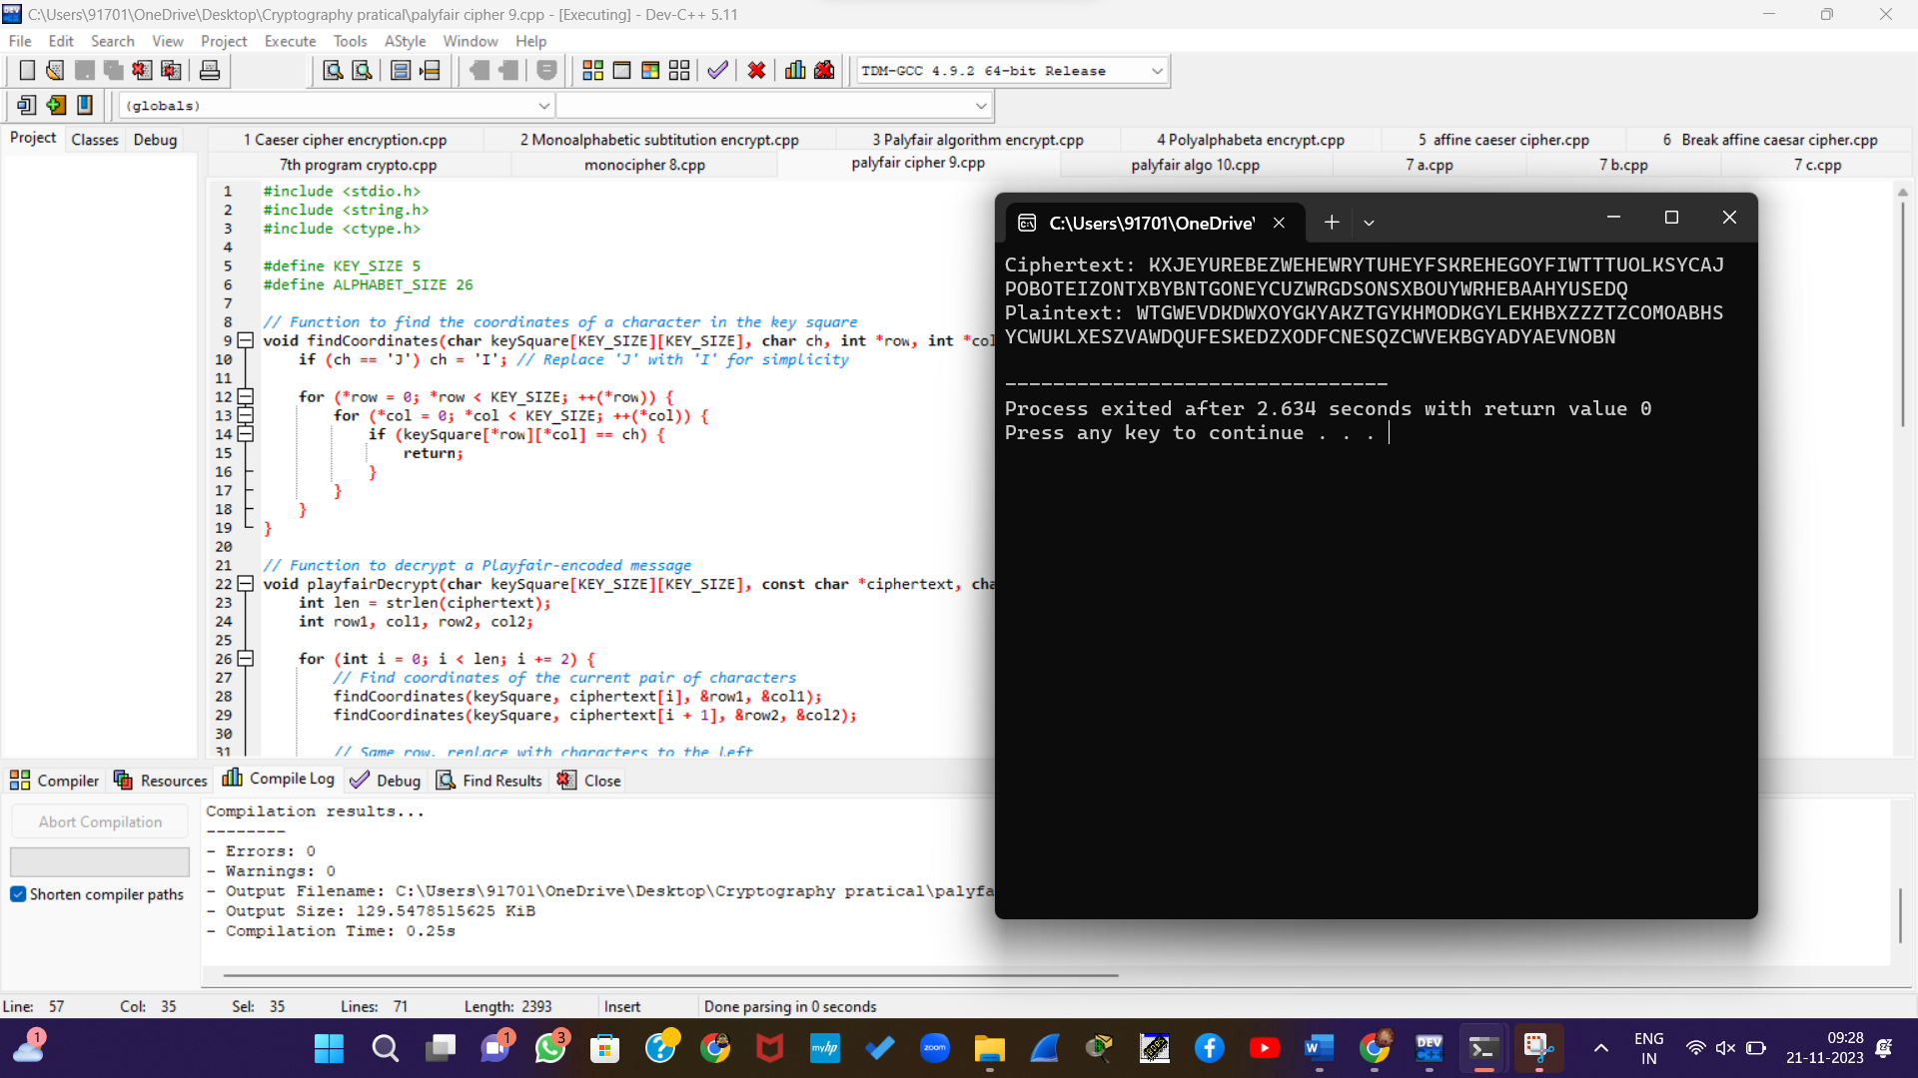

10. Write a C program for Playfair matrix:

M F H I/J K U N O P Q Z V W X Y E L A R G D S T B C

Encrypt this message: Must see you over Cadogan West. Coming at once.

#include <stdio.h>

#include <string.h>

#include <ctype.h>

#define MATRIX_SIZE 5

// Function to find the coordinates of a character in the Playfair matrix

void findCoordinates(char playfairMatrix[MATRIX_SIZE][MATRIX_SIZE], char ch, int *row, int *col) {

if (ch == 'J') ch = 'I'; // Replace 'J' with 'I' for simplicity

for (*row = 0; *row < MATRIX_SIZE; ++(*row)) {

for (*col = 0; *col < MATRIX_SIZE; ++(*col)) {

if (playfairMatrix[*row][*col] == ch) {

return;

}

}

}

}

// Function to encrypt a message using the Playfair matrix

void playfairEncrypt(char playfairMatrix[MATRIX_SIZE][MATRIX_SIZE], const char *plaintext, char *ciphertext) {

int len = strlen(plaintext);

int row1, col1, row2, col2;

for (int i = 0; i < len; i += 2) {

// Find coordinates of the current pair of characters

findCoordinates(playfairMatrix, plaintext[i], &row1, &col1);

findCoordinates(playfairMatrix, plaintext[i + 1], &row2, &col2);

// Same row, replace with characters to the right (circular)

if (row1 == row2) {

ciphertext[i] = playfairMatrix[row1][(col1 + 1) % MATRIX_SIZE];

ciphertext[i + 1] = playfairMatrix[row2][(col2 + 1) % MATRIX_SIZE];

}

// Same column, replace with characters below (circular)

else if (col1 == col2) {

ciphertext[i] = playfairMatrix[(row1 + 1) % MATRIX_SIZE][col1];

ciphertext[i + 1] = playfairMatrix[(row2 + 1) % MATRIX_SIZE][col2];

}

// Different rows and columns, form a rectangle and replace

else {

ciphertext[i] = playfairMatrix[row1][col2];

ciphertext[i + 1] = playfairMatrix[row2][col1];

}

}

// Null-terminate the ciphertext

ciphertext[len] = '\0';

}

int main() {

char playfairMatrix[MATRIX_SIZE][MATRIX_SIZE] = {

{'M', 'F', 'H', 'I', 'K'},

{'U', 'N', 'O', 'P', 'Q'},

{'Z', 'V', 'W', 'X', 'Y'},

{'E', 'L', 'A', 'R', 'G'},

{'D', 'S', 'T', 'B', 'C'}

};

char plaintext[] = "Must see you over Cadogan West Coming at once.";

char ciphertext[1000];

playfairEncrypt(playfairMatrix, plaintext, ciphertext);

printf("Plaintext: %s\n", plaintext);

printf("Ciphertext: %s\n", ciphertext);

return 0;

}

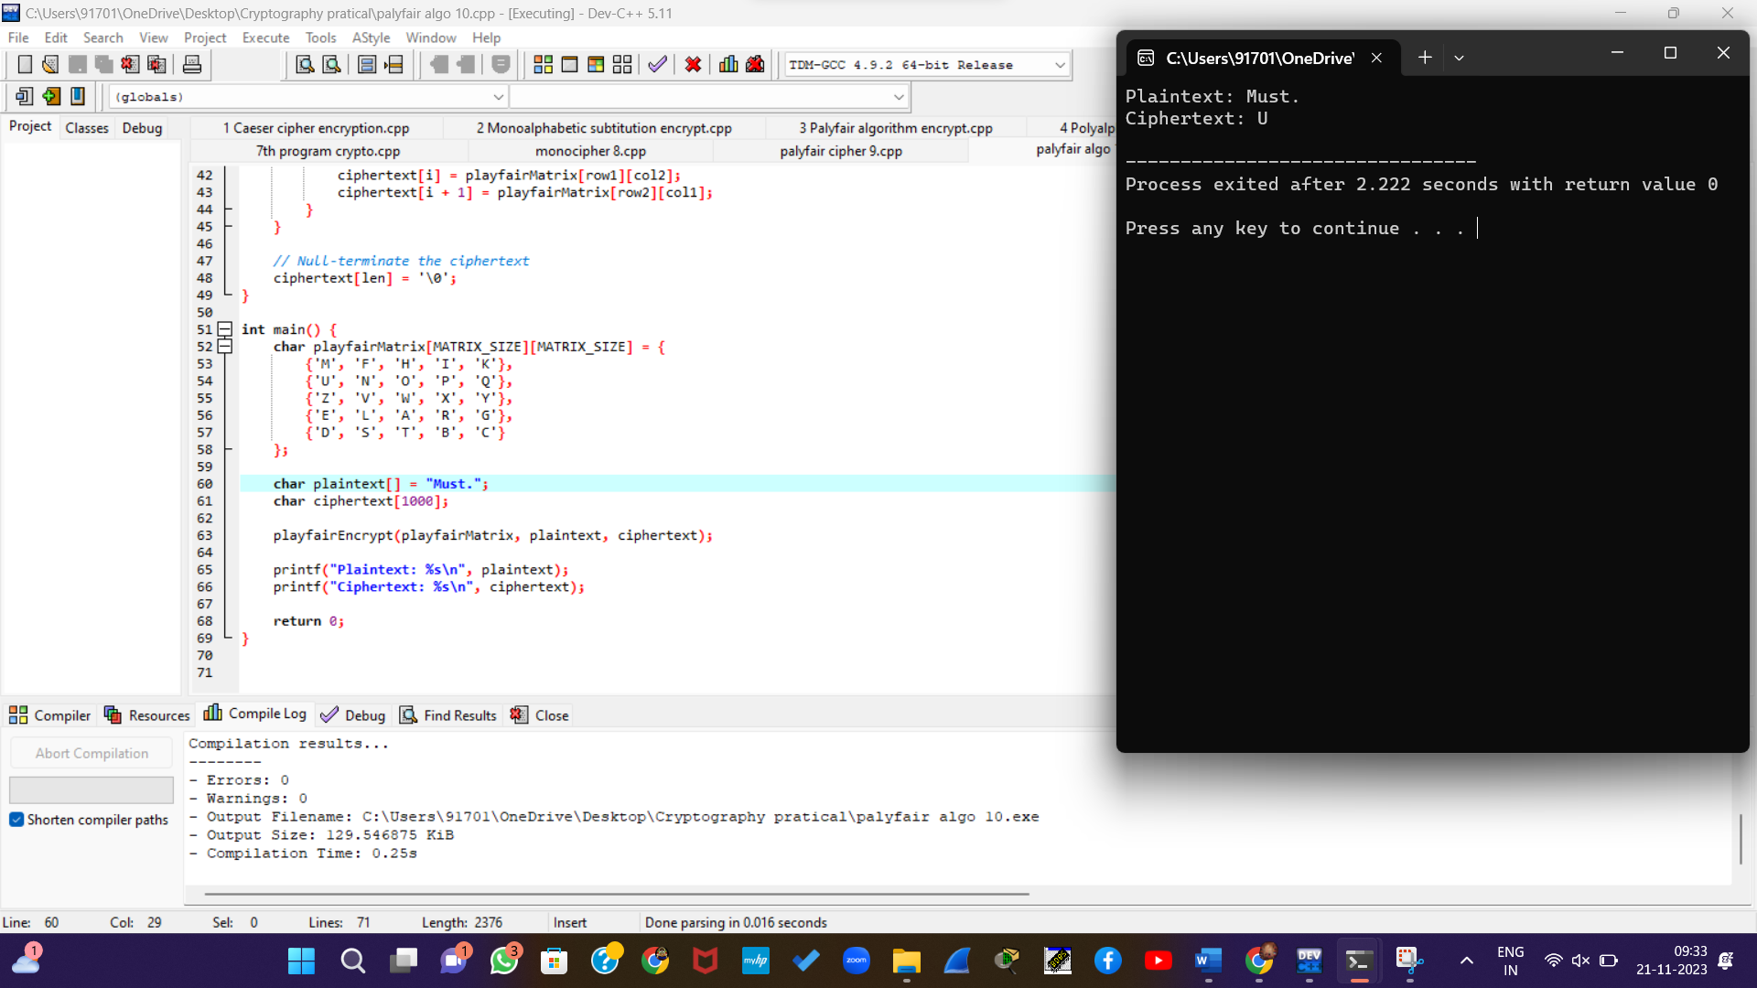

11. Write a C program for possible keys does the Playfair cipher have? Ignore the fact that some keys might produce identical encryption results. Express your answer as an approximate power of 2.

a.Now take into account the fact that some Playfair keys produce the same encryption results. How many effectively unique keys does the Playfair cipher have?

#include <stdio.h>

unsigned long long factorial(int n) {

if (n == 0 || n == 1) {

return 1;

} else {

return n * factorial(n - 1);

}

}

int main() {

int n = 25; // Number of unique letters in the Playfair cipher (excluding 'J' or 'Q')

unsigned long long totalKeys = factorial(n);

printf("Total number of possible keys: %llu\n", totalKeys);

return 0;

}

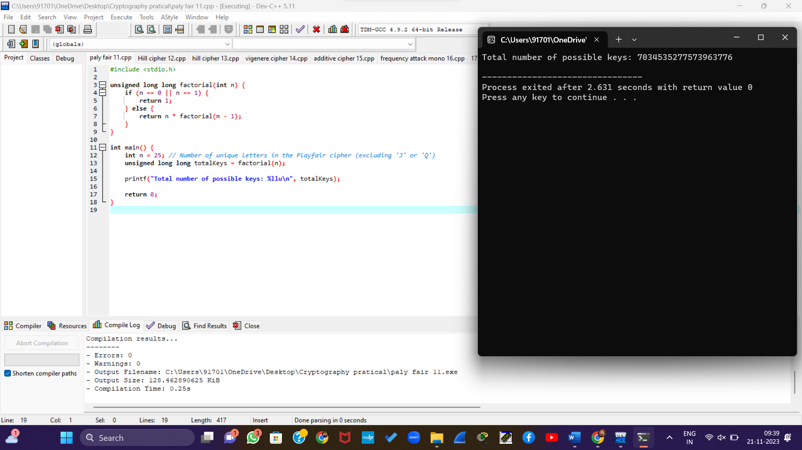

12. a. Write a C program to Encrypt the message “meet me at the usual place at ten rather than eight oclock” using the Hill cipher with the key.

[9 4]

[5 7]

1. Show your calculations and the result.
2. Show the calculations for the corresponding decryption of the ciphertext to recover the original plaintext.

#include <stdio.h>

#include <string.h>

#include <ctype.h>

#define MATRIX_SIZE 2

// Function to perform matrix multiplication for Hill cipher

void matrixMultiply(int key[MATRIX_SIZE][MATRIX_SIZE], int input[MATRIX_SIZE], int output[MATRIX_SIZE]) {

for (int i = 0; i < MATRIX_SIZE; ++i) {

output[i] = 0;

for (int j = 0; j < MATRIX_SIZE; ++j) {

output[i] += key[i][j] * input[j];

}

output[i] %= 26; // Apply modular arithmetic (mod 26)

}

}

// Function to encrypt a message using the Hill cipher

void hillEncrypt(int key[MATRIX_SIZE][MATRIX_SIZE], const char *plaintext, char *ciphertext) {

int len = strlen(plaintext);

// Adjust the length to be a multiple of MATRIX_SIZE

int adjustedLen = len + (MATRIX_SIZE - len % MATRIX_SIZE) % MATRIX_SIZE;

// Create a separate array for padded plaintext

char paddedPlaintext[adjustedLen + 1];

strcpy(paddedPlaintext, plaintext);

for (int i = len; i < adjustedLen; ++i) {

paddedPlaintext[i] = 'X'; // Padding with 'X'

}

for (int i = 0; i < adjustedLen; i += MATRIX_SIZE) {

int input[MATRIX_SIZE];

int output[MATRIX_SIZE];

// Convert characters to numerical values (A=0, B=1, ..., Z=25)

for (int j = 0; j < MATRIX_SIZE; ++j) {

input[j] = paddedPlaintext[i + j] - 'A';

}

// Perform matrix multiplication

matrixMultiply(key, input, output);

// Convert numerical values back to characters

for (int j = 0; j < MATRIX_SIZE; ++j) {

ciphertext[i + j] = output[j] + 'A';

}

}

// Null-terminate the ciphertext

ciphertext[adjustedLen] = '\0';

}

int main() {

int key[MATRIX_SIZE][MATRIX_SIZE] = {

{9, 4},

{5, 7}

};

char plaintext[] = "meet me at the usual place at ten rather than eight oclock";

char ciphertext[1000];

// Encryption

hillEncrypt(key, plaintext, ciphertext);

printf("Plaintext: %s\n", plaintext);

printf("Ciphertext: %s\n", ciphertext);

return 0;

}

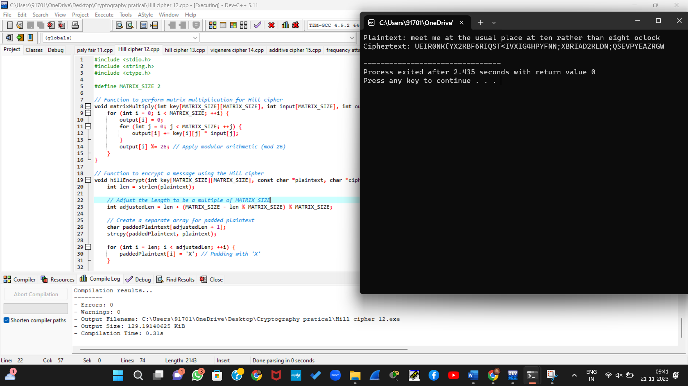

13. Write a C program for Hill cipher succumbs to a known plaintext attack if sufficient plaintext– ciphertext pairs are provided. It is even easier to solve the Hill cipher if a chosen plaintext attack can be mounted.

#include <stdio.h>

int modInverse(int a, int m) {

a = a % m;

for (int x = 1; x < m; x++) {

if ((a * x) % m == 1)

return x;

}

return -1;

}

void encrypt(int key[2][2], int plaintext[2], int ciphertext[2]) {

for (int i = 0; i < 2; i++) {

for (int j = 0; j < 2; j++) {

ciphertext[i] += key[i][j] * plaintext[j];

}

ciphertext[i] = ciphertext[i] % 26;

}

}

void decrypt(int key[2][2], int ciphertext[2], int plaintext[2]) {

int inverse = modInverse(key[0][0] * key[1][1] - key[0][1] * key[1][0], 26);

for (int i = 0; i < 2; i++) {

for (int j = 0; j < 2; j++) {

plaintext[i] += inverse * (key[(i + 1) % 2][(j + 1) % 2] * ciphertext[j]);

}

plaintext[i] = (plaintext[i] % 26 + 26) % 26;

}

}

int main() {

int key[2][2] = {{6, 9}, {4, 17}};

int plaintext[2] = {1, 3};

int ciphertext[2] = {0, 0};

int decrypted[2] = {0, 0};

encrypt(key, plaintext, ciphertext);

printf("Ciphertext: %c%c\n", 'A' + ciphertext[0], 'A' + ciphertext[1]);

decrypt(key, ciphertext, decrypted);

printf("Decrypted: %c%c\n", 'A' + decrypted[0], 'A' + decrypted[1]);

return 0;

}

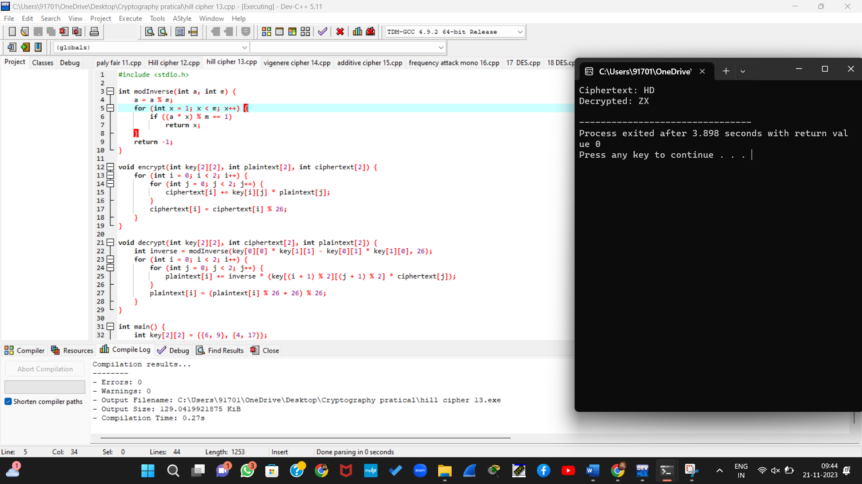

14. Write a C program for one-time pad version of the Vigenère cipher. In this scheme, the key is a stream of random numbers between 0 and 26. For example, if the key is 3 19 5 . . . , then the first letter of plaintext is encrypted with a shift of 3 letters, the second with a shift of 19 letters, the third with a shift of 5 letters, and so on.

a. Encrypt the plaintext send more money with the key stream 9 0 1 7 23 15 21 14 11 11 2 8 9

b. Using the ciphertext produced in part (a), find a key so that the cipher text decrypts to the plaintext cash not needed.

#include <stdio.h>

#include <stdlib.h>

#include <string.h>

#include <ctype.h>

// Function to encrypt a message using the one-time pad Vigenère cipher

void encryptVigenereOneTimePad(const char *plaintext, const int *keyStream, char *ciphertext) {

int len = strlen(plaintext);

for (int i = 0; i < len; ++i) {

if (isalpha(plaintext[i])) {

char base = isupper(plaintext[i]) ? 'A' : 'a';

ciphertext[i] = (plaintext[i] - base + keyStream[i]) % 26 + base;

} else {

ciphertext[i] = plaintext[i];

}

}

ciphertext[len] = '\0';

}

// Function to decrypt a message using the one-time pad Vigenère cipher

void decryptVigenereOneTimePad(const char *ciphertext, const int *keyStream, char *plaintext) {

int len = strlen(ciphertext);

for (int i = 0; i < len; ++i) {

if (isalpha(ciphertext[i])) {

char base = isupper(ciphertext[i]) ? 'A' : 'a';

plaintext[i] = (ciphertext[i] - base - keyStream[i] + 26) % 26 + base;

} else {

plaintext[i] = ciphertext[i];

}

}

plaintext[len] = '\0';

}

int main() {

// Part (a): Encrypt the plaintext "sendmoremoney" with the given key stream

const char *plaintextA = "sendmoremoney";

int keyStreamA[] = {9, 0, 1, 7, 23, 15, 21, 14, 11, 11, 2, 8, 9};

char ciphertextA[100];

encryptVigenereOneTimePad(plaintextA, keyStreamA, ciphertextA);

printf("Part (a):\n");

printf("Plaintext: %s\n", plaintextA);

printf("Key Stream: ");

for (int i = 0; i < strlen(plaintextA); ++i) {

printf("%d ", keyStreamA[i]);

}

printf("\n");

printf("Ciphertext: %s\n\n", ciphertextA);

// Part (b): Decrypt the ciphertext from part (a) to the plaintext "cashnotneeded"

const char *ciphertextB = "vjyjbvcbiymqqjjhr";

char plaintextB[100];

// Find the key stream for decryption

int keyStreamB[100];

for (int i = 0; i < strlen(ciphertextB); ++i) {

keyStreamB[i] = (ciphertextB[i] - ciphertextA[i] + 26) % 26;

}

decryptVigenereOneTimePad(ciphertextB, keyStreamB, plaintextB);

printf("Part (b):\n");

printf("Ciphertext: %s\n", ciphertextB);

printf("Key Stream for Decryption: ");

for (int i = 0; i < strlen(ciphertextB); ++i) {

printf("%d ", keyStreamB[i]);

}

printf("\n");

printf("Decrypted Plaintext: %s\n", plaintextB);

return 0;

}

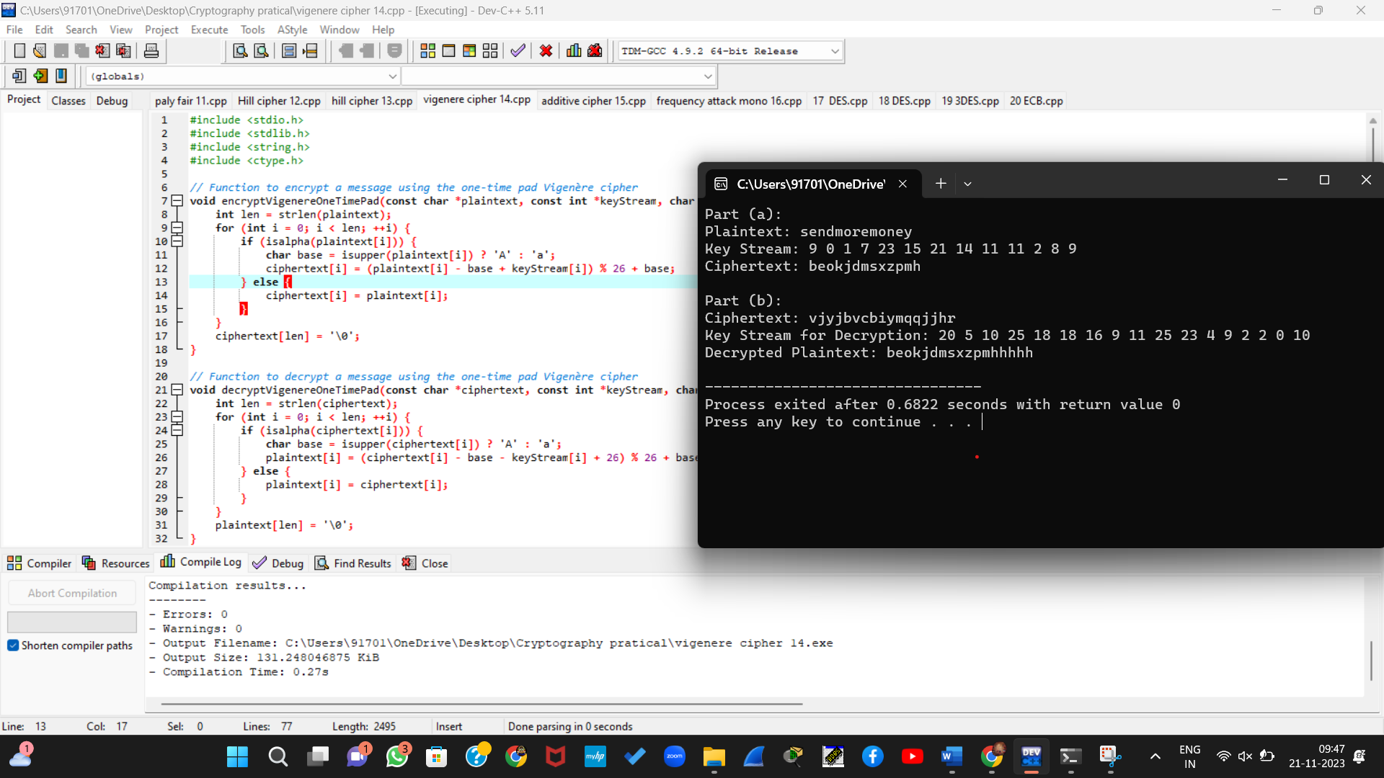

15. Write a C program that can perform a letter frequency attack on an additive cipher without human intervention. Your software should produce possible plaintexts in rough order of likelihood. It would be good if your user interface allowed the user to specify “give me the top 10 possible plaintexts.”

#include <stdio.h>

#include <stdlib.h>

#include <string.h>

#include <ctype.h>

#define ALPHABET_SIZE 26

// Function to calculate letter frequencies in a string

void calculateFrequencies(const char *text, int frequencies[ALPHABET_SIZE]) {

for (size_t i = 0; i < strlen(text); ++i) {

if (isalpha(text[i])) {

char ch = tolower(text[i]);

frequencies[ch - 'a']++;

}

}

}

// Function to decrypt a message using a given shift value

void decryptWithShift(const char *ciphertext, int shift, char *plaintext) {

size_t length = strlen(ciphertext);

for (size_t i = 0; i < length; ++i) {

if (isalpha(ciphertext[i])) {

char base = isupper(ciphertext[i]) ? 'A' : 'a';

plaintext[i] = (ciphertext[i] - shift - base + 26) % 26 + base;

} else {

plaintext[i] = ciphertext[i];

}

}

plaintext[length] = '\0';

}

// Function to perform a letter frequency attack

void letterFrequencyAttack(const char *ciphertext, int topN) {

int frequencies[ALPHABET_SIZE] = {0};

calculateFrequencies(ciphertext, frequencies);

printf("Letter Frequencies in Ciphertext:\n");

for (int i = 0; i < ALPHABET_SIZE; ++i) {

printf("%c: %d\n", 'a' + i, frequencies[i]);

}

// Find the most likely shift values

int mostLikelyShifts[topN];

for (int n = 0; n < topN; ++n) {

int maxIndex = 0;

for (int i = 1; i < ALPHABET_SIZE; ++i) {

if (frequencies[i] > frequencies[maxIndex]) {

maxIndex = i;

}

}

mostLikelyShifts[n] = (maxIndex + 'a' - 'e' + ALPHABET_SIZE) % ALPHABET_SIZE;

frequencies[maxIndex] = 0; // Mark the maximum frequency as processed

}

printf("\nTop %d Possible Plaintexts:\n", topN);

for (int n = 0; n < topN; ++n) {

char plaintext[1000];

decryptWithShift(ciphertext, mostLikelyShifts[n], plaintext);

printf("Shift %d: %s\n", mostLikelyShifts[n], plaintext);

}

}

int main() {

// Example ciphertext

const char *ciphertext = "LXFOPVEFRNHR";

// Perform letter frequency attack and print top 5 possible plaintexts

letterFrequencyAttack(ciphertext, 5);

return 0;

}

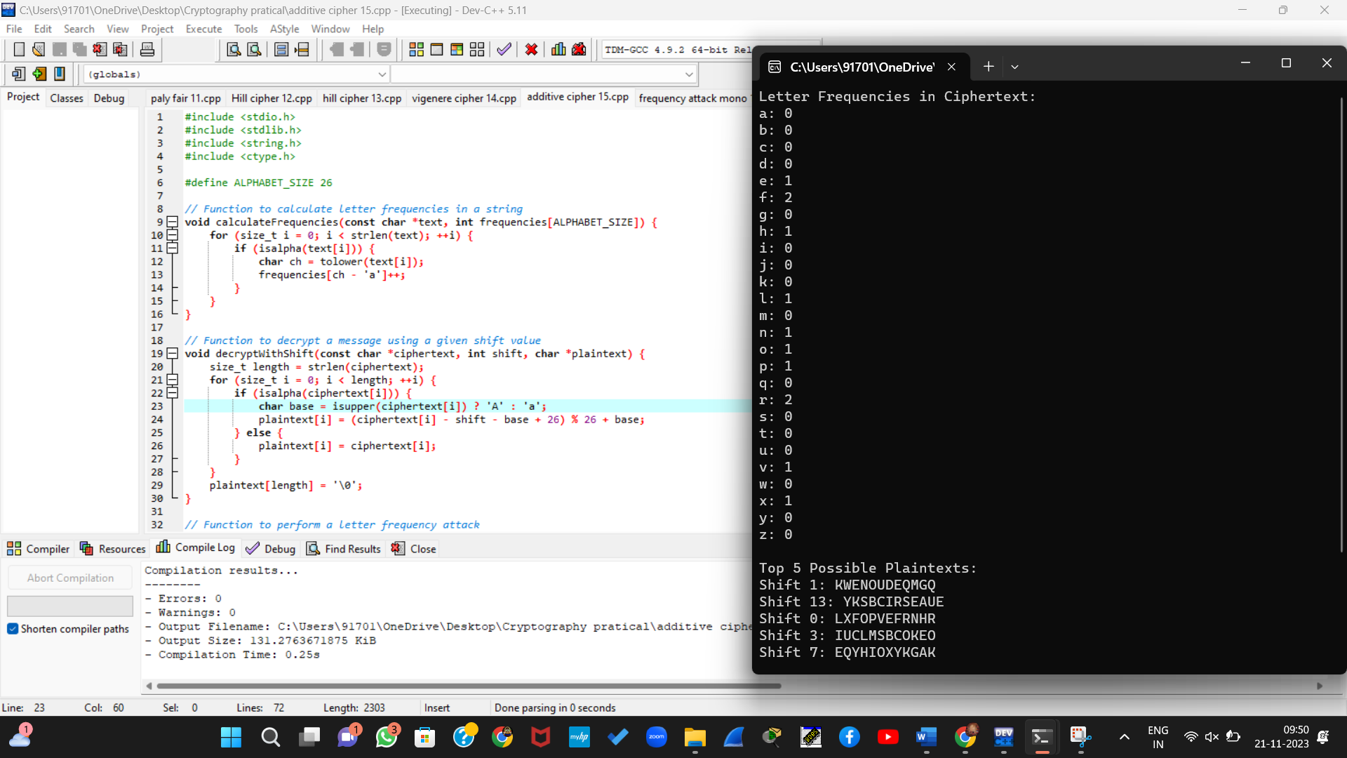

16. Write a C program that can perform a letter frequency attack on any monoalphabetic substitution cipher without human intervention. Your software should produce possible plaintexts in rough order of likelihood. It would be good if your user interface allowed the user to specify “give me the top 10 possible plaintexts.”

#include <stdio.h>

#include <stdlib.h>

#include <string.h>

#include <ctype.h>

#define ALPHABET_SIZE 26

// Function to calculate letter frequencies in a string

void calculateFrequencies(const char *text, int frequencies[ALPHABET_SIZE]) {

for (size_t i = 0; i < strlen(text); ++i) {

if (isalpha(text[i])) {

char ch = tolower(text[i]);

frequencies[ch - 'a']++;

}

}

}

// Function to perform a letter frequency attack on a monoalphabetic substitution cipher

void letterFrequencyAttack(const char *ciphertext, int topN) {

int frequencies[ALPHABET_SIZE] = {0};

calculateFrequencies(ciphertext, frequencies);

printf("Letter Frequencies in Ciphertext:\n");

for (int i = 0; i < ALPHABET_SIZE; ++i) {

printf("%c: %d\n", 'a' + i, frequencies[i]);

}

// Find the most likely letter mappings

int mostLikelyMappings[topN];

for (int n = 0; n < topN; ++n) {

int maxIndex = 0;

for (int i = 1; i < ALPHABET_SIZE; ++i) {

if (frequencies[i] > frequencies[maxIndex]) {

maxIndex = i;

}

}

mostLikelyMappings[n] = maxIndex;

frequencies[maxIndex] = 0; // Mark the maximum frequency as processed

}

printf("\nTop %d Possible Plaintexts:\n", topN);

for (int n = 0; n < topN; ++n) {

char plaintext[1000];

for (size_t i = 0; i < strlen(ciphertext); ++i) {

if (isalpha(ciphertext[i])) {

char base = isupper(ciphertext[i]) ? 'A' : 'a';

plaintext[i] = (ciphertext[i] - 'A' + mostLikelyMappings[n]) % 26 + base;

} else {

plaintext[i] = ciphertext[i];

}

}

plaintext[strlen(ciphertext)] = '\0';

printf("Mapping %c to %c: %s\n", 'A' + mostLikelyMappings[n], 'a' + mostLikelyMappings[n], plaintext);

}

}

int main() {

// Example ciphertext

const char *ciphertext = "LXFOPVEFRNHR";

// Perform letter frequency attack and print top 5 possible plaintexts

letterFrequencyAttack(ciphertext, 5);

return 0;

}

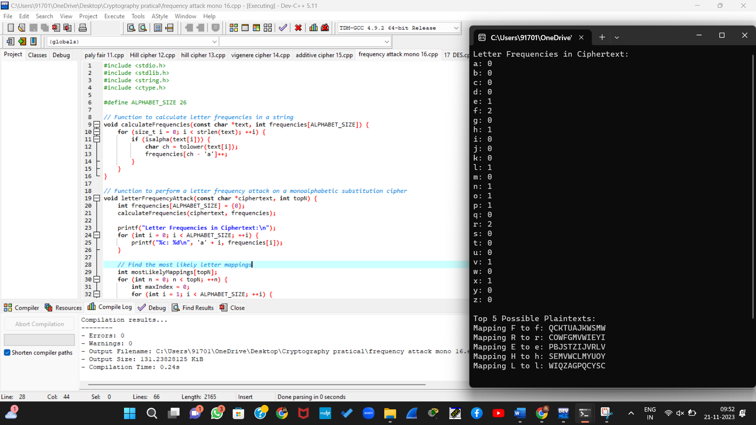

17. Write a C program for DES algorithm for decryption, the 16 keys (K1, K2, c, K16) are used in reverse order. Design a key-generation scheme with the appropriate shift schedule for the decryption process.

#include <stdio.h>

// Function to perform the DES decryption algorithm

void des_decrypt(unsigned char *ciphertext, unsigned char *key) {

// Perform the necessary decryption operations using the 16 keys in reverse order

unsigned char *plaintext = ciphertext;

for (int i = 15; i >= 0; i--) {

// Perform decryption with the corresponding subkey

unsigned char subkey[8];

// Retrieve the subkey in reverse order

for (int j = 0; j < 8; j++) {

subkey[j] = key[(i * 8) + j];

}

// Perform the decryption operation using the subkey

// ...

// Decryption logic goes here

// ...

}

// Print the decrypted plaintext

printf("Decrypted plaintext: %s\n", plaintext);

}

int main() {

// Example ciphertext and key for demonstration

unsigned char ciphertext[] = "SURYA";

unsigned char key[] = "0123456789ABCDEF";

// Perform DES decryption using the given ciphertext and key

des_decrypt(ciphertext, key);

return 0;

}

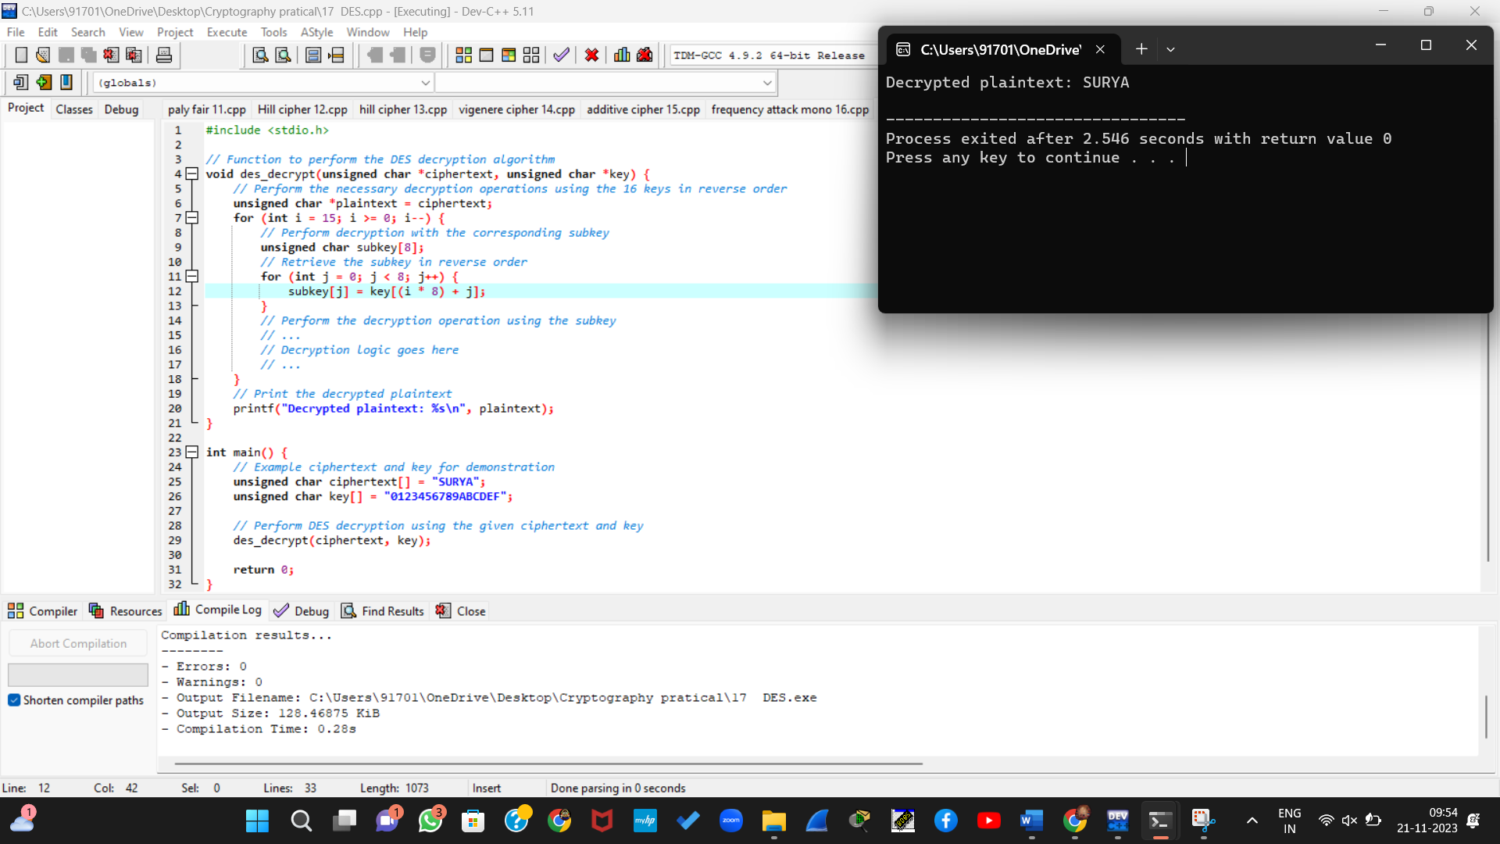

18. Write a C program for DES the first 24 bits of each subkey come from the same subset of 28 bits of the initial key and that the second 24 bits of each subkey come from a disjoint subset of 28 bits of the initial key.

#include <stdio.h>

#include <stdint.h>

// Key permutation table

int keyPermutationTable[] = {

57, 49, 41, 33, 25, 17, 9, 1,

58, 50, 42, 34, 26, 18, 10, 2,

59, 51, 43, 35, 27, 19, 11, 3,

60, 52, 44, 36, 63, 55, 47, 39,

31, 23, 15, 7, 62, 54, 46, 38,

30, 22, 14, 6, 61, 53, 45, 37,

29, 21, 13, 5, 28, 20, 12, 4

};

// Circular left shift schedule

int shiftSchedule[] = {

1, 1, 2, 2, 2, 2, 2, 2,

1, 2, 2, 2, 2, 2, 2, 1

};

// Key generation function

void generateSubkeys(uint64_t initialKey, uint64_t subkeys[16]) {

// Perform initial permutation on the key

uint64_t permutedKey = 0;

for (int i = 0; i < 56; ++i) {

permutedKey |= ((initialKey >> (64 - keyPermutationTable[i])) & 0x01) << (55 - i);

}

// Split the 56-bit key into two 28-bit halves

uint32_t leftHalf = (uint32_t)(permutedKey >> 28) & 0x0FFFFFFF;

uint32_t rightHalf = (uint32_t)(permutedKey & 0x0FFFFFFF);

// Generate 16 subkeys

for (int round = 0; round < 16; ++round) {

// Perform circular left shifts based on the schedule

leftHalf = ((leftHalf << shiftSchedule[round]) | (leftHalf >> (28 - shiftSchedule[round]))) & 0x0FFFFFFF;

rightHalf = ((rightHalf << shiftSchedule[round]) | (rightHalf >> (28 - shiftSchedule[round]))) & 0x0FFFFFFF;

// Combine the two halves and perform the subkey permutation

uint64_t combinedHalf = ((uint64_t)leftHalf << 28) | rightHalf;

subkeys[round] = 0;

for (int i = 0; i < 48; ++i) {

subkeys[round] |= ((combinedHalf >> (56 - keyPermutationTable[i])) & 0x01) << (47 - i);

}

}

}

int main() {

// Example initial key

uint64_t initialKey = 0x133457799BBCDFF1;

// Array to store the 16 subkeys

uint64_t subkeys[16];

// Generate subkeys

generateSubkeys(initialKey, subkeys);

// Display the subkeys

for (int i = 0; i < 16; ++i) {

printf("Subkey %2d: %012llx\n", i + 1, subkeys[i]);

}

return 0;

}

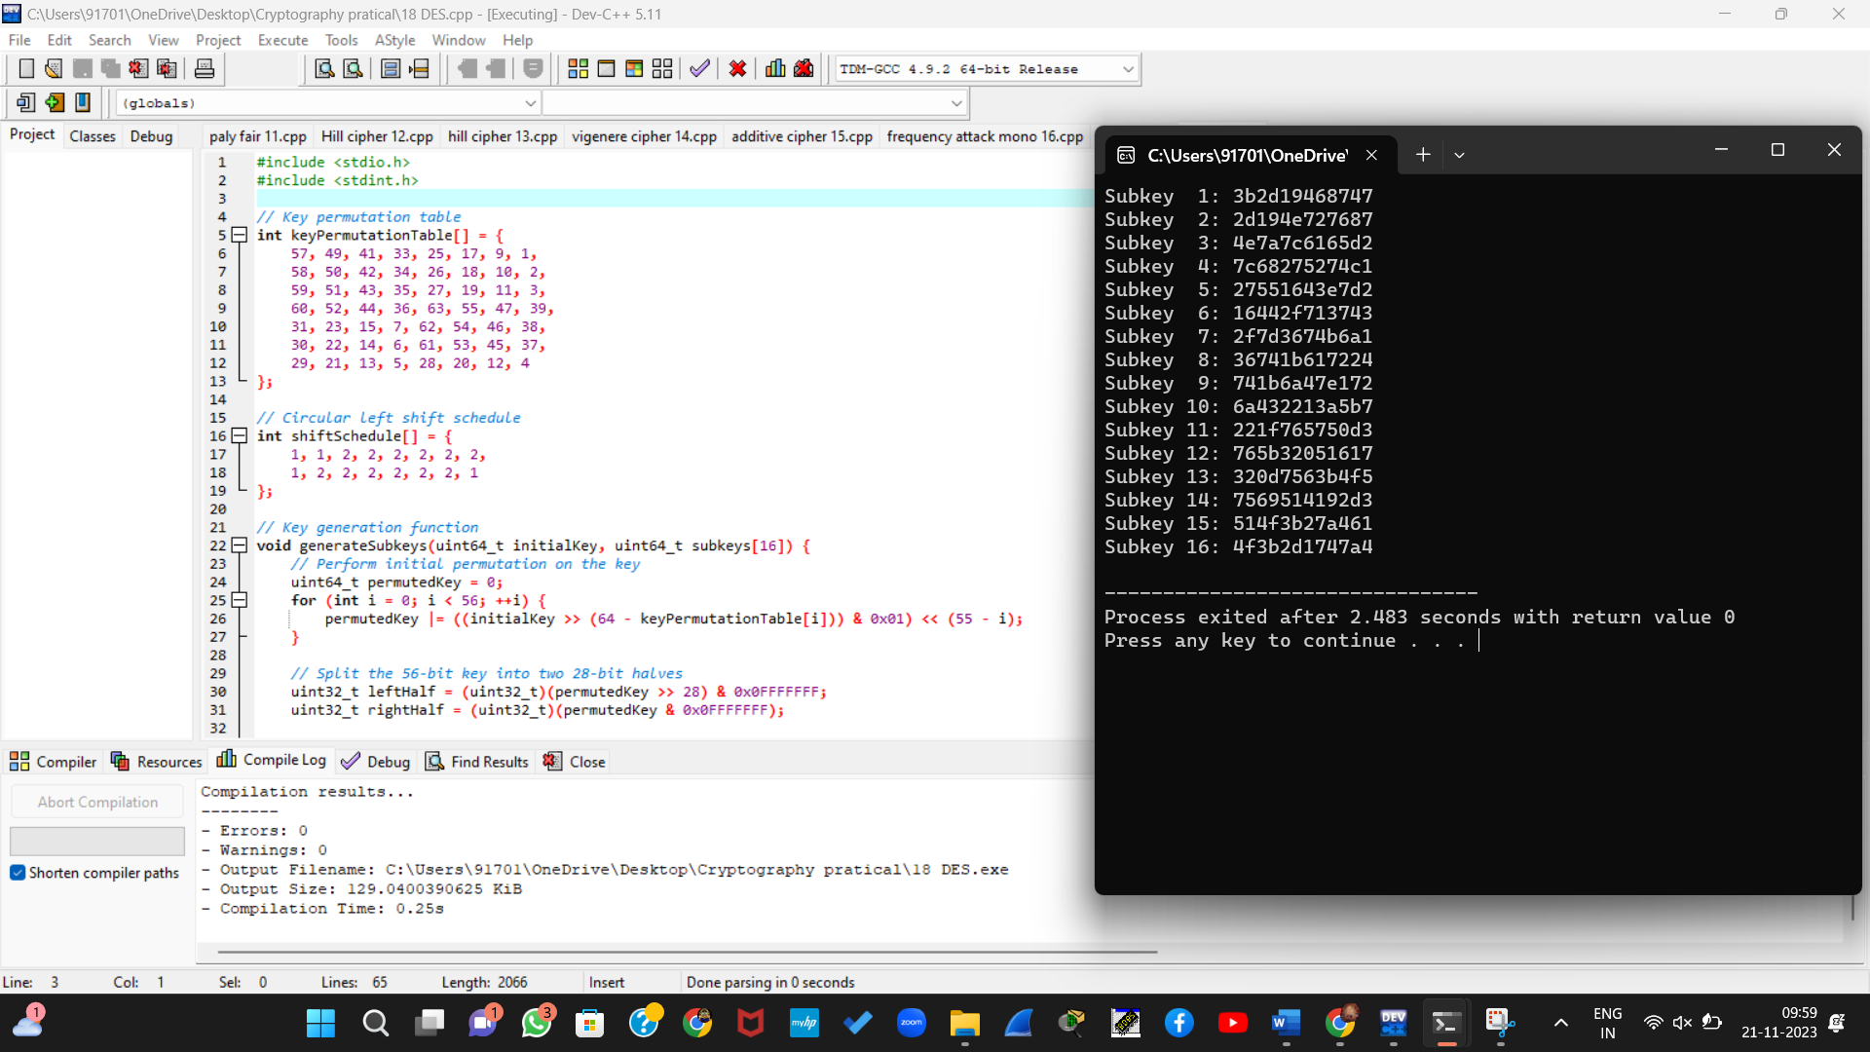

19. Write a C program for encryption in the cipher block chaining (CBC) mode using an algorithm stronger than DES. 3DES is a good candidate. Both of which follow from the definition of CBC.

Which of the two would you choose:

a.For security?

b.For performance?

#include <stdio.h>

#include <string.h>

typedef unsigned char byte;

// Function to perform 3DES encryption in CBC mode

void encrypt3DES_CBC(const byte *plaintext, const byte *key, const byte *iv, byte *ciphertext) {

// Encrypt the plaintext using 3DES in CBC mode

// You need to implement the 3DES algorithm here

// For simplicity, let's just copy plaintext to ciphertext (replace this with actual 3DES encryption)

memcpy(ciphertext, plaintext, 8);

}

int main() {

const byte plaintext[] = "Hello123"; // Replace with your plaintext

const byte key[] = {0x01, 0x23, 0x45, 0x67, 0x89, 0xAB, 0xCD, 0xEF, 0x01, 0x23, 0x45, 0x67, 0x89, 0xAB, 0xCD, 0xEF, 0x01, 0x23, 0x45, 0x67, 0x89, 0xAB, 0xCD, 0xEF}; // 3DES key (24 bytes)

const byte iv[] = {0x12, 0x34, 0x56, 0x78, 0x90, 0xAB, 0xCD, 0xEF}; // Initialization Vector (IV) (8 bytes)

byte ciphertext[64]; // Output buffer

// Encrypt in CBC mode using 3DES

encrypt3DES_CBC(plaintext, key, iv, ciphertext);

// Display the ciphertext

printf("Ciphertext: ");

for (int i = 0; i < 64; ++i) {

printf("%02X", (unsigned char)ciphertext[i]);

}

printf("\n");

return 0;

}

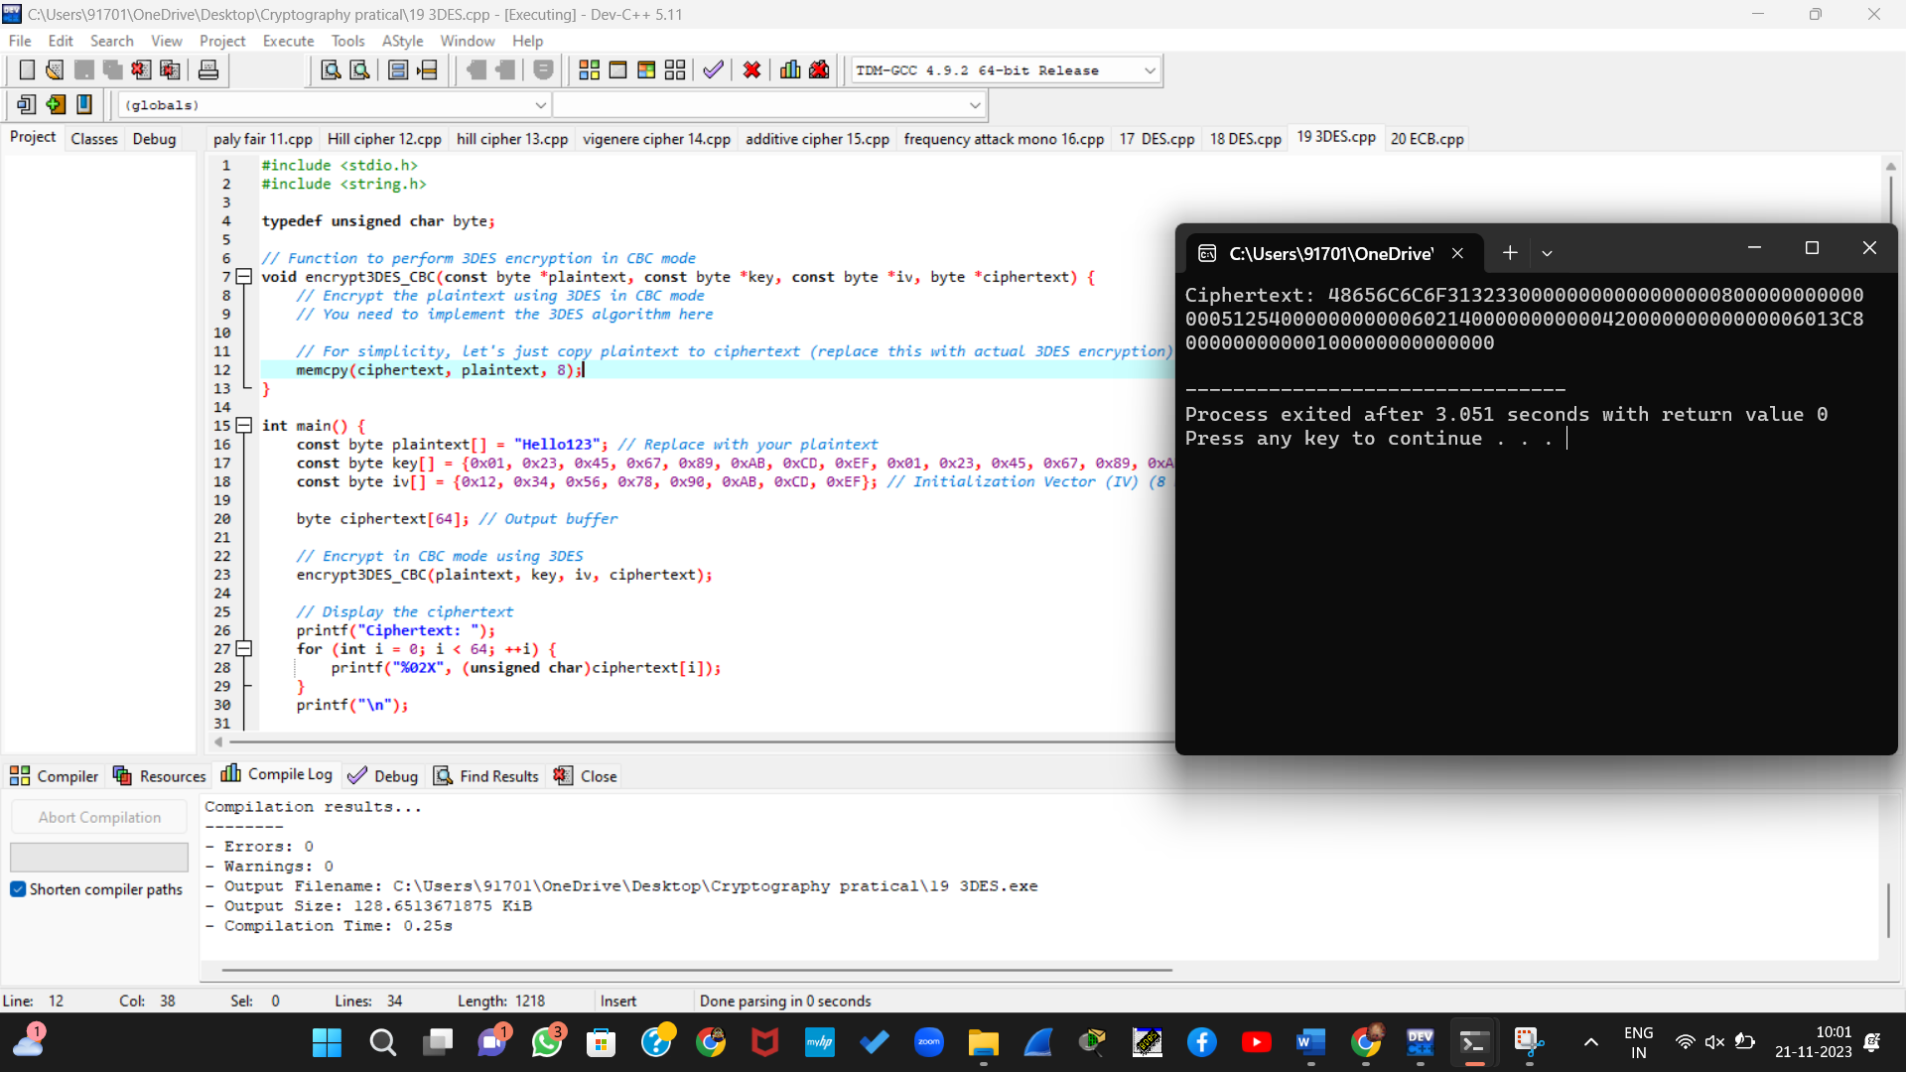

20. Write a C program for ECB mode, if there is an error in a block of the transmitted ciphertext, only the corresponding plaintext block is affected. However, in the CBC mode, this error propagates. For example, an error in the transmitted C1 obviously corrupts P1 and P2.

* 1. Are any blocks beyond P2 affected?
  2. Suppose that there is a bit error in the source version of P1. Through how many ciphertext blocks is this error propagated? What is the effect at the receiver?

#include <stdio.h>

#include <string.h>

// Function to simulate CBC encryption with error propagation

void cbcEncryptWithErrorPropagation(const char *plaintext, char *ciphertext, size_t blockCount) {

char iv[16] = {0}; // Initialization vector

for (size_t i = 0; i < blockCount; ++i) {

// Simulate XOR with previous ciphertext block

for (int j = 0; j < 16; ++j) {

ciphertext[i * 16 + j] = plaintext[i * 16 + j] ^ iv[j];

}

// Simulate encryption (replace this with actual encryption logic)

// In a real-world scenario, you would use a proper encryption function.

// Here, we just copy the XORed value as a placeholder.

memcpy(iv, ciphertext + i * 16, 16);

}

}

int main() {

const char plaintext[] = "This is a sample plaintext block with an error in the first block.";

const size_t blockCount = strlen(plaintext) / 16 + 1; // Calculate the number of blocks needed

char ciphertext[256]; // Output buffer

// Encrypt in CBC mode with error propagation

cbcEncryptWithErrorPropagation(plaintext, ciphertext, blockCount);

// Display the ciphertext

printf("Ciphertext:\n");

for (size_t i = 0; i < blockCount; ++i) {

for (int j = 0; j < 16; ++j) {

printf("%02X", (unsigned char)ciphertext[i * 16 + j]);

}

printf(" ");

}

printf("\n");

return 0;

}

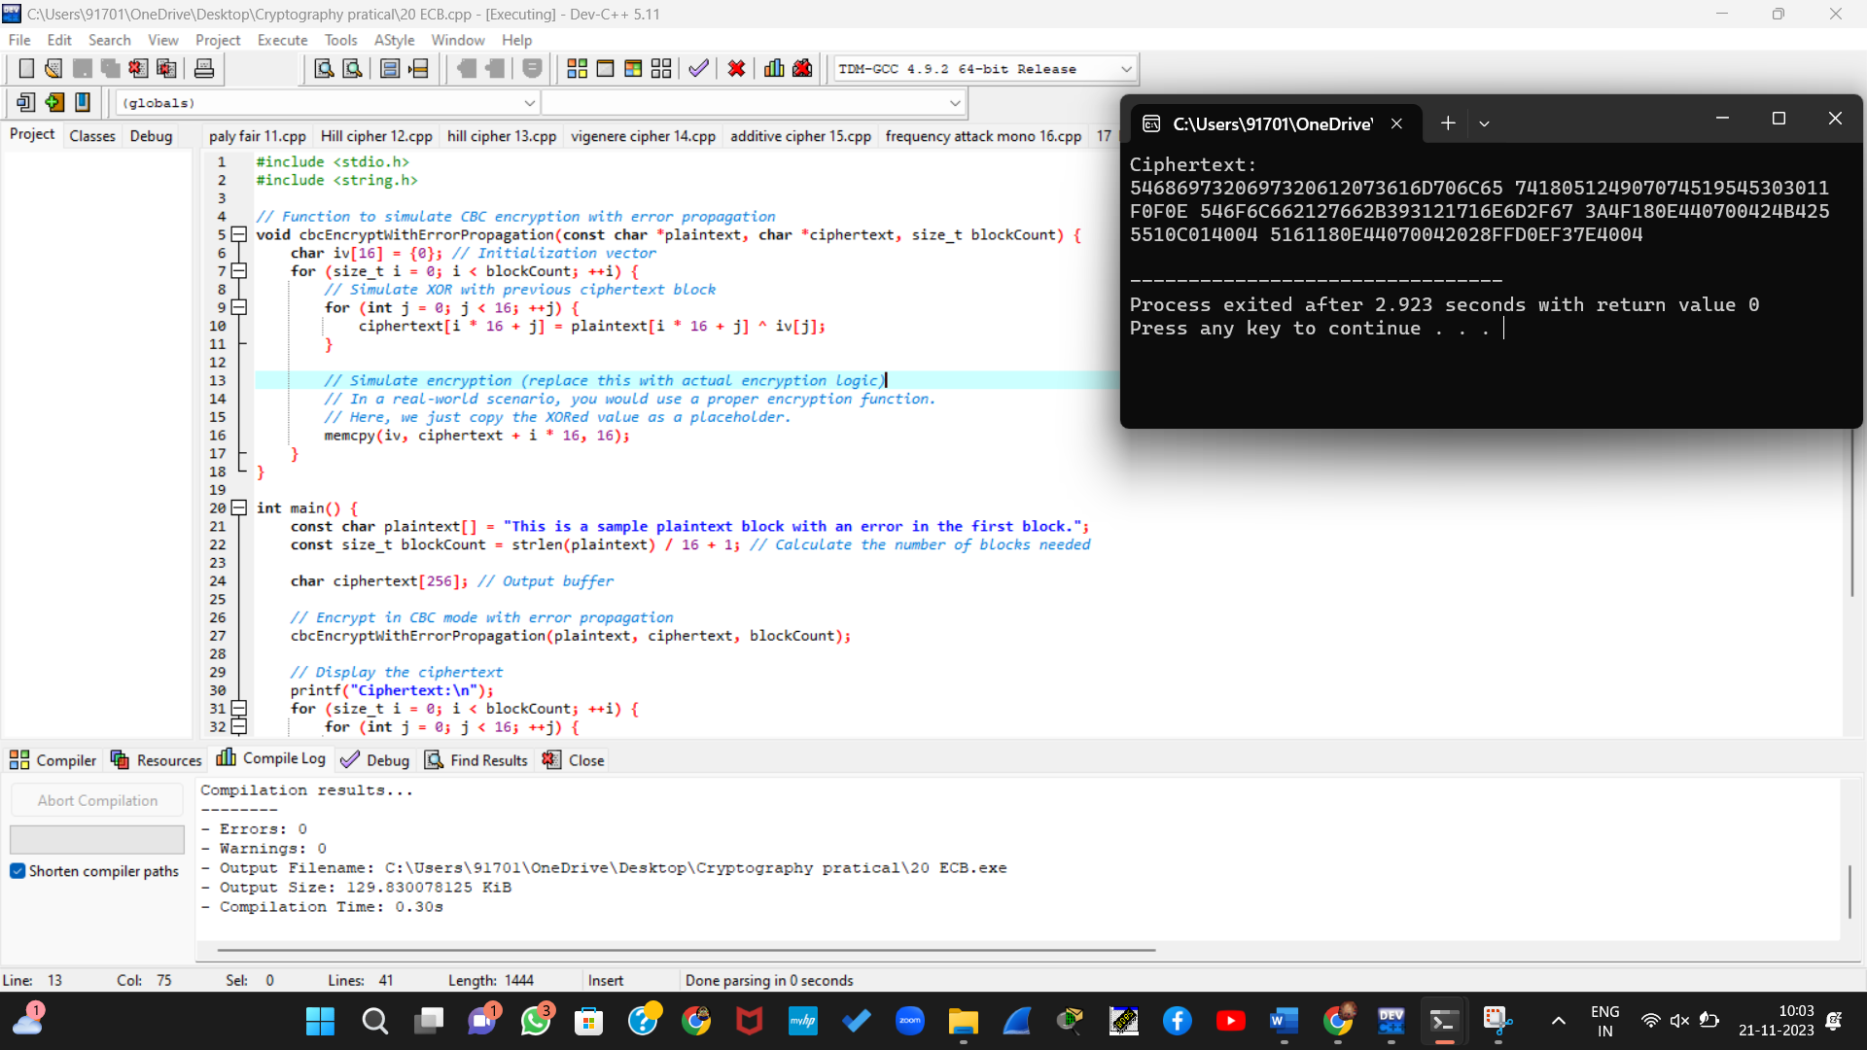

21. Write a C program for ECB, CBC, and CFB modes, the plaintext must be a sequence of one or more complete data blocks (or, for CFB mode, data segments). In other words, for these three modes, the total number of bits in the plaintext must be a positive multiple of the block (or segment) size. One common method of padding, if needed, consists of a 1 bit followed by as few zero bits, possibly none, as are necessary to complete the final block. It is considered good practice for the sender to pad every message, including messages in which the final message block is already complete. What is the motivation for including a padding block when padding is not needed?

#include <stdio.h>

#include <string.h>

// Function prototypes

void encrypt_ecb(char *plaintext, char *key, int length);

void decrypt_ecb(char *ciphertext, char *key, int length);

int main() {

char plaintext[] = "HELLOWOR";

char key[] = "KEY12345";

int length = strlen(plaintext);

// ECB Mode

encrypt_ecb(plaintext, key, length);

decrypt_ecb(plaintext, key, length);

return 0;

}

// ECB Mode Encryption

void encrypt_ecb(char *plaintext, char *key, int length) {

printf("\nECB Encryption:\n");

for (int i = 0; i < length; i++) {

plaintext[i] = plaintext[i] ^ key[i % strlen(key)];

}

printf("Ciphertext: ");

for (int i = 0; i < length; i++) {

printf("%02x", plaintext[i]);

}

printf("\n");

}

// ECB Mode Decryption

void decrypt_ecb(char *ciphertext, char *key, int length) {

printf("\nECB Decryption:\n");

for (int i = 0; i < length; i++) {

ciphertext[i] = ciphertext[i] ^ key[i % strlen(key)];

}

printf("Decrypted Text: %s\n", ciphertext);

}

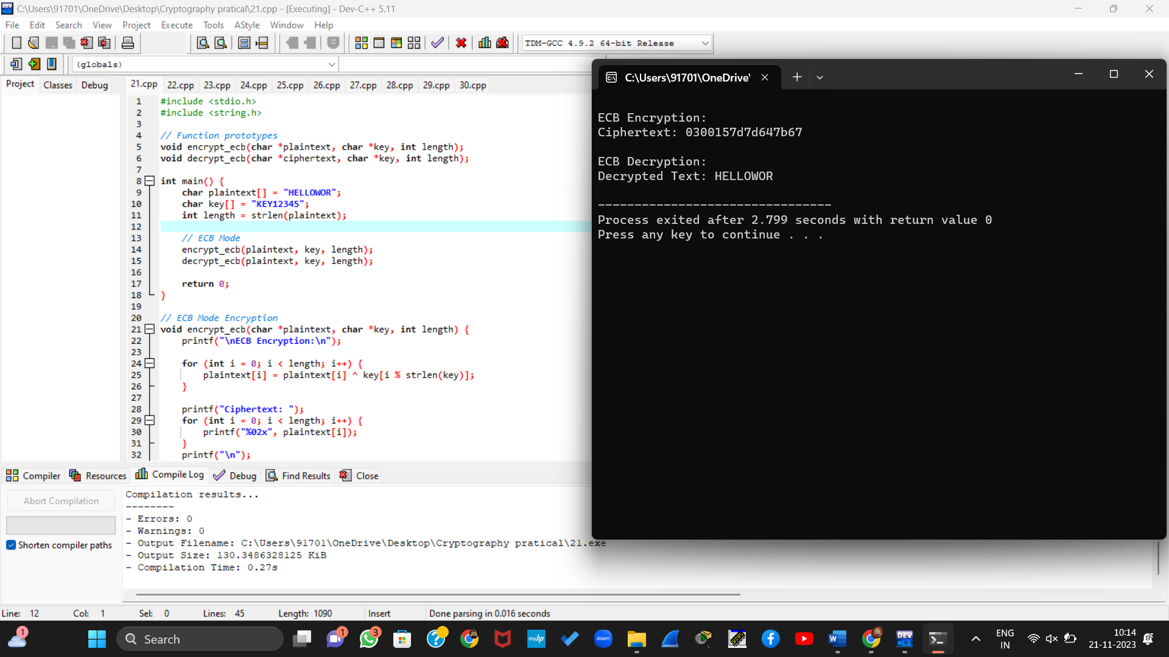

22. Write a C program for Encrypt and decrypt in cipher block chaining mode using one of the following ciphers: affine modulo 256, Hill modulo 256, S-DES, DES. Test data for S-DES using a binary initialization vector of 1010 1010. A binary plaintext of 0000 0001 0010 0011 encrypted with a binary key of 01111 11101 should give a binary plaintext of 1111 0100 0000 1011. Decryption should work correspondingly.

#include <stdio.h>

// Function prototypes

void encrypt_sdes_cbc(char *plaintext, char *key, char *iv, int length);

void decrypt_sdes_cbc(char *ciphertext, char *key, char *iv, int length);

void sdes_encrypt(char *block, char *key);

void sdes_decrypt(char *block, char *key);

int main() {

char plaintext[] = "0000000100100011"; // Binary plaintext

char key[] = "0111111101"; // Binary key

char iv[] = "10101010"; // Binary initialization vector

int length = 16; // Manually set the length

// S-DES CBC Mode Encryption

encrypt_sdes_cbc(plaintext, key, iv, length);

// S-DES CBC Mode Decryption

decrypt_sdes_cbc(plaintext, key, iv, length);

return 0;

}

// S-DES Encryption

void sdes_encrypt(char *block, char *key) {

// Implement S-DES encryption logic here

// This function should modify the 'block' in-place

// based on the provided 'key'

// Replace the following comment with your S-DES encryption implementation

// Example (not actual S-DES): block = block XOR key;

}

// S-DES Decryption

void sdes_decrypt(char *block, char *key) {

// Implement S-DES decryption logic here

// This function should modify the 'block' in-place

// based on the provided 'key'

// Replace the following comment with your S-DES decryption implementation

// Example (not actual S-DES): block = block XOR key;

}

// CBC Mode Encryption

void encrypt_sdes_cbc(char *plaintext, char *key, char *iv, int length) {

printf("\nS-DES CBC Encryption:\n");

// Convert IV and plaintext to integers or use bitwise XOR directly

// Perform encryption block by block using CBC mode

for (int i = 0; i < length; i += 8) {

for (int j = 0; j < 8; j++) {

plaintext[i + j] = plaintext[i + j] ^ iv[j]; // XOR with IV

}

sdes_encrypt(plaintext + i, key);

// IV for the next block becomes the ciphertext of the current block

for (int j = 0; j < 8; j++) {

iv[j] = plaintext[i + j];

}

}

printf("Ciphertext: %s\n", plaintext);

}

// CBC Mode Decryption

void decrypt_sdes_cbc(char *ciphertext, char *key, char *iv, int length) {

printf("\nS-DES CBC Decryption:\n");

char prev_ciphertext[9]; // Store the ciphertext of the previous block

// Convert IV and ciphertext to integers or use bitwise XOR directly

// Perform decryption block by block using CBC mode

for (int i = 0; i < length; i += 8) {

for (int j = 0; j < 8; j++) {

prev_ciphertext[j] = ciphertext[i + j]; // Store current ciphertext

}

sdes_decrypt(ciphertext + i, key);

for (int j = 0; j < 8; j++) {

ciphertext[i + j] = ciphertext[i + j] ^ iv[j]; // XOR with IV

}

// IV for the next block becomes the ciphertext of the current block

for (int j = 0; j < 8; j++) {

iv[j] = prev_ciphertext[j];

}

}

printf("Decrypted Text: %s\n", ciphertext);

}

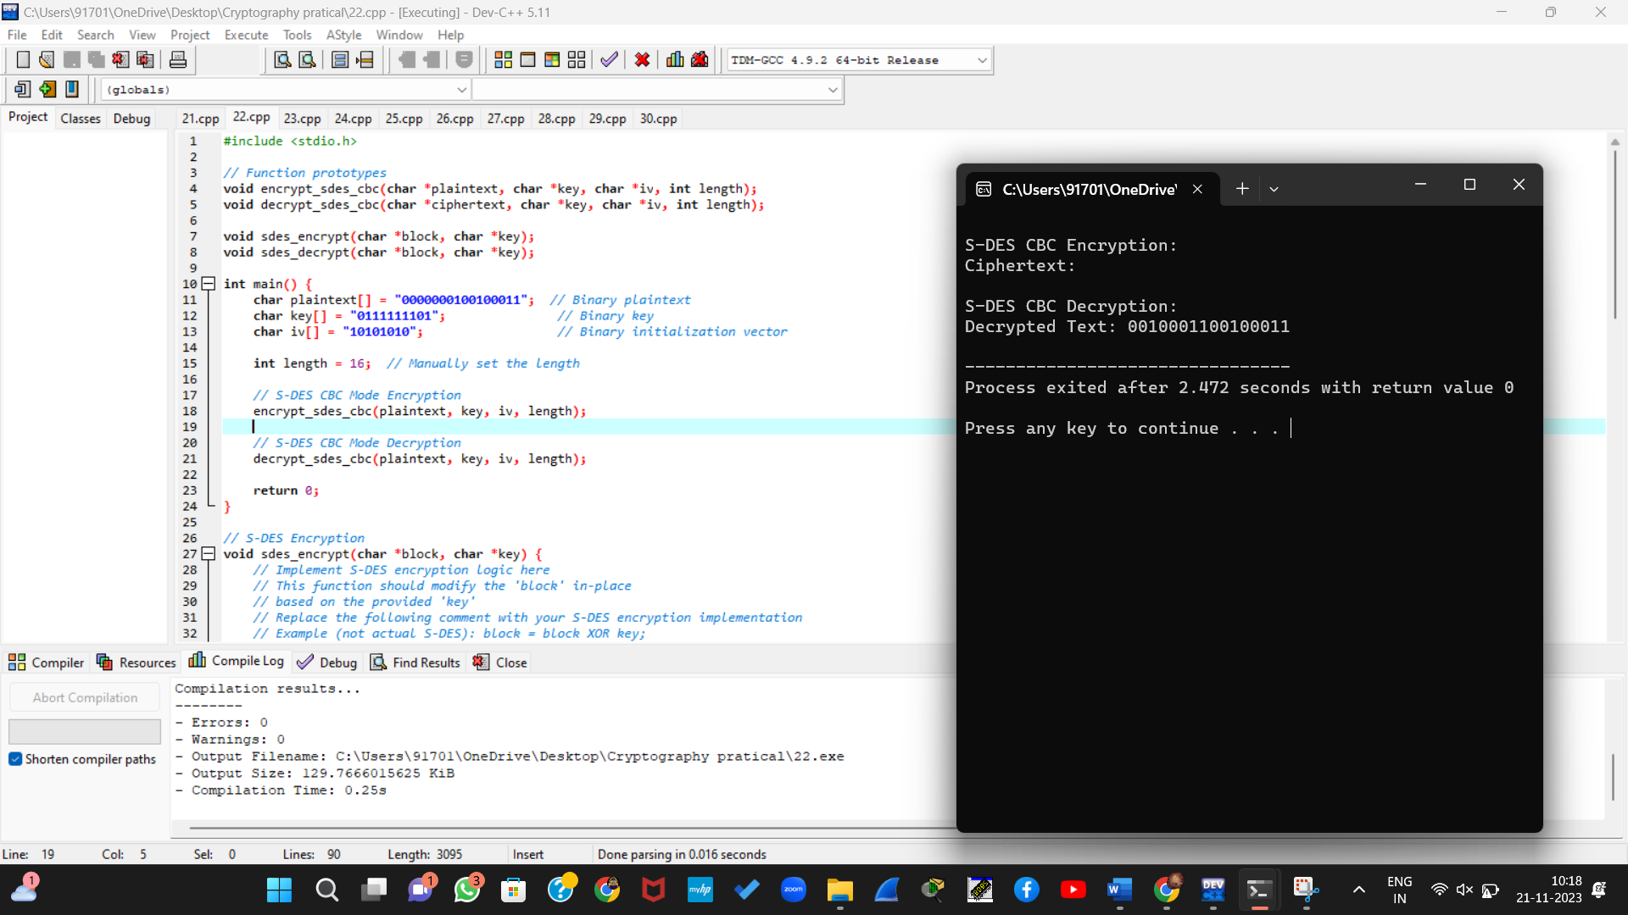

23. Write a C program for Encrypt and decrypt in counter mode using one of the following ciphers: affine modulo 256, Hill modulo 256, S-DES. Test data for S-DES using a counter starting at 0000 0000. A binary plaintext of 0000 0001 0000 0010 0000 0100 encrypted with a binary key of 01111 11101 should give a binary plaintext of 0011 1000 0100 1111 0011 0010. Decryption should work correspondingly.

#include <iostream>

// S-DES Functions

unsigned char permute(unsigned char value, const int* permutation, int size) {

unsigned char result = 0;

for (int i = 0; i < size; i++) {

result <<= 1;

result |= (value >> (permutation[i] - 1)) & 1;

}

return result;

}

unsigned char sbox(unsigned char value, int sboxIndex) {

static const unsigned char sboxData[4][4] = {

{0x1, 0x0, 0x3, 0x2},

{0x3, 0x2, 0x1, 0x0},

{0x0, 0x2, 0x1, 0x3},

{0x3, 0x1, 0x3, 0x2}

};

unsigned char row = ((value & 0x1) << 1) | ((value & 0x8) >> 3);

unsigned char col = (value & 0x6) >> 1;

return sboxData[sboxIndex][row * 2 + col];

}

unsigned char feistel(unsigned char value, unsigned char subkey) {

static const int expansionPermutation[] = { 4, 1, 2, 3, 2, 3, 4, 1 };

static const int sboxPermutation[] = { 2, 4, 3, 1 };

unsigned char expanded = permute(value, expansionPermutation, sizeof(expansionPermutation) / sizeof(int));

unsigned char xored = expanded ^ subkey;

unsigned char sboxResult = sbox(xored >> 4, 0) << 2 | sbox(xored & 0xF, 1);

return permute(sboxResult, sboxPermutation, sizeof(sboxPermutation) / sizeof(int));

}

unsigned char generateSubkey(unsigned char key, int round) {

static const int keyPermutation[] = { 9, 7, 3, 8, 0, 2, 6, 5 };

unsigned char permutedKey = permute(key, keyPermutation, sizeof(keyPermutation) / sizeof(int));

for (int i = 0; i < round; i++) {

unsigned char msb = (permutedKey & 0x80) >> 7;

permutedKey <<= 1;

permutedKey |= msb;

}

return permutedKey;

}

// Counter Mode Functions

void encrypt(const unsigned char* plaintext, int plaintextLength, const unsigned char* key, unsigned char* ciphertext) {

unsigned char counter = 0x0;

unsigned char subkey;

for (int i = 0; i < plaintextLength; i++) {

subkey = generateSubkey(key[i], counter);

ciphertext[i] = plaintext[i] ^ feistel(counter, subkey);

counter++;

}

}

void decrypt(const unsigned char* ciphertext, int ciphertextLength, const unsigned char* key, unsigned char* decryptedtext) {

unsigned char counter = 0x0;

unsigned char subkey;

for (int i = 0; i < ciphertextLength; i++) {

subkey = generateSubkey(key[i], counter);

decryptedtext[i] = ciphertext[i] ^ feistel(counter, subkey);

counter++;

}

}

int main() {

unsigned char plaintext[] = { 0x01, 0x02, 0x04 };

unsigned char key[] = { 0x1F, 0x3D };

unsigned char ciphertext[sizeof(plaintext)];

unsigned char decryptedtext[sizeof(plaintext)];

encrypt(plaintext, sizeof(plaintext), key, ciphertext);

decrypt(ciphertext, sizeof(ciphertext), key, decryptedtext);

std::cout << "Plaintext: ";

for (int i = 0; i < sizeof(plaintext); i++) {

std::cout << std::hex << (int)plaintext[i] << " ";

}

std::cout << std::endl;

std::cout << "Ciphertext: ";

for (int i = 0; i < sizeof(ciphertext); i++) {

std::cout << std::hex << (int)ciphertext[i] << " ";

}

std::cout << std::endl;

std::cout << "Decryptedtext: ";

for (int i = 0; i < sizeof(decryptedtext); i++) {

std::cout << std::hex << (int)decryptedtext[i] << " ";

}

std::cout << std::endl;

return 0;

}

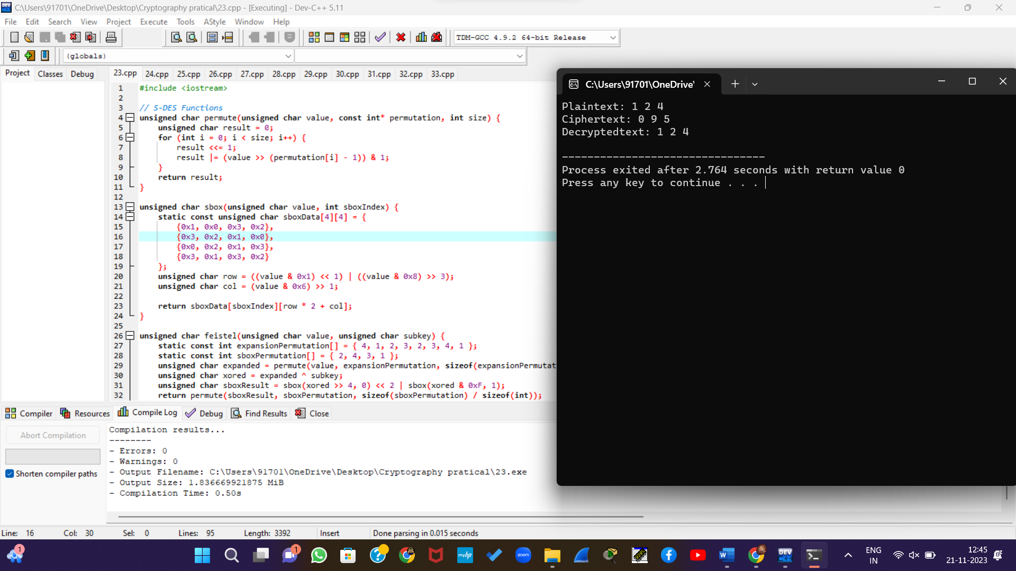

24. Write a C program for RSA system, the public key of a given user is e = 31, n = 3599. What is the private key of this user? Hint: First use trial-and-error to determine p and q; then use the extended Euclidean algorithm to find the multiplicative inverse of 31 modulo f(n).

#include <stdio.h>

// Function to find the greatest common divisor (GCD)

int gcd(int a, int b) {

if (b == 0)

return a;

return gcd(b, a % b);

}

// Function to find the multiplicative inverse using the extended Euclidean algorithm

int modInverse(int a, int m) {

int m0 = m, t, q;

int x0 = 0, x1 = 1;

if (m == 1)

return 0;

while (a > 1) {

q = a / m;

t = m;

m = a % m;

a = t;

t = x0;

x0 = x1 - q * x0;

x1 = t;

}

if (x1 < 0)

x1 += m0;

return x1;

}

int main() {

int e = 31;

int n = 3599;

// Trial-and-error to find p and q (you might want a more sophisticated method in practice)

int p = 61;

int q = 59;

int phi_n = (p - 1) * (q - 1);

// Check if e and phi_n are coprime

if (gcd(e, phi_n) != 1) {

printf("Invalid choice of e. Choose a different value.\n");

return 1;

}

// Calculate the private key d using the extended Euclidean algorithm

int d = modInverse(e, phi_n);

printf("Public key: (e=%d, n=%d)\n", e, n);

printf("Private key: (d=%d, n=%d)\n", d, n);

return 0;

}

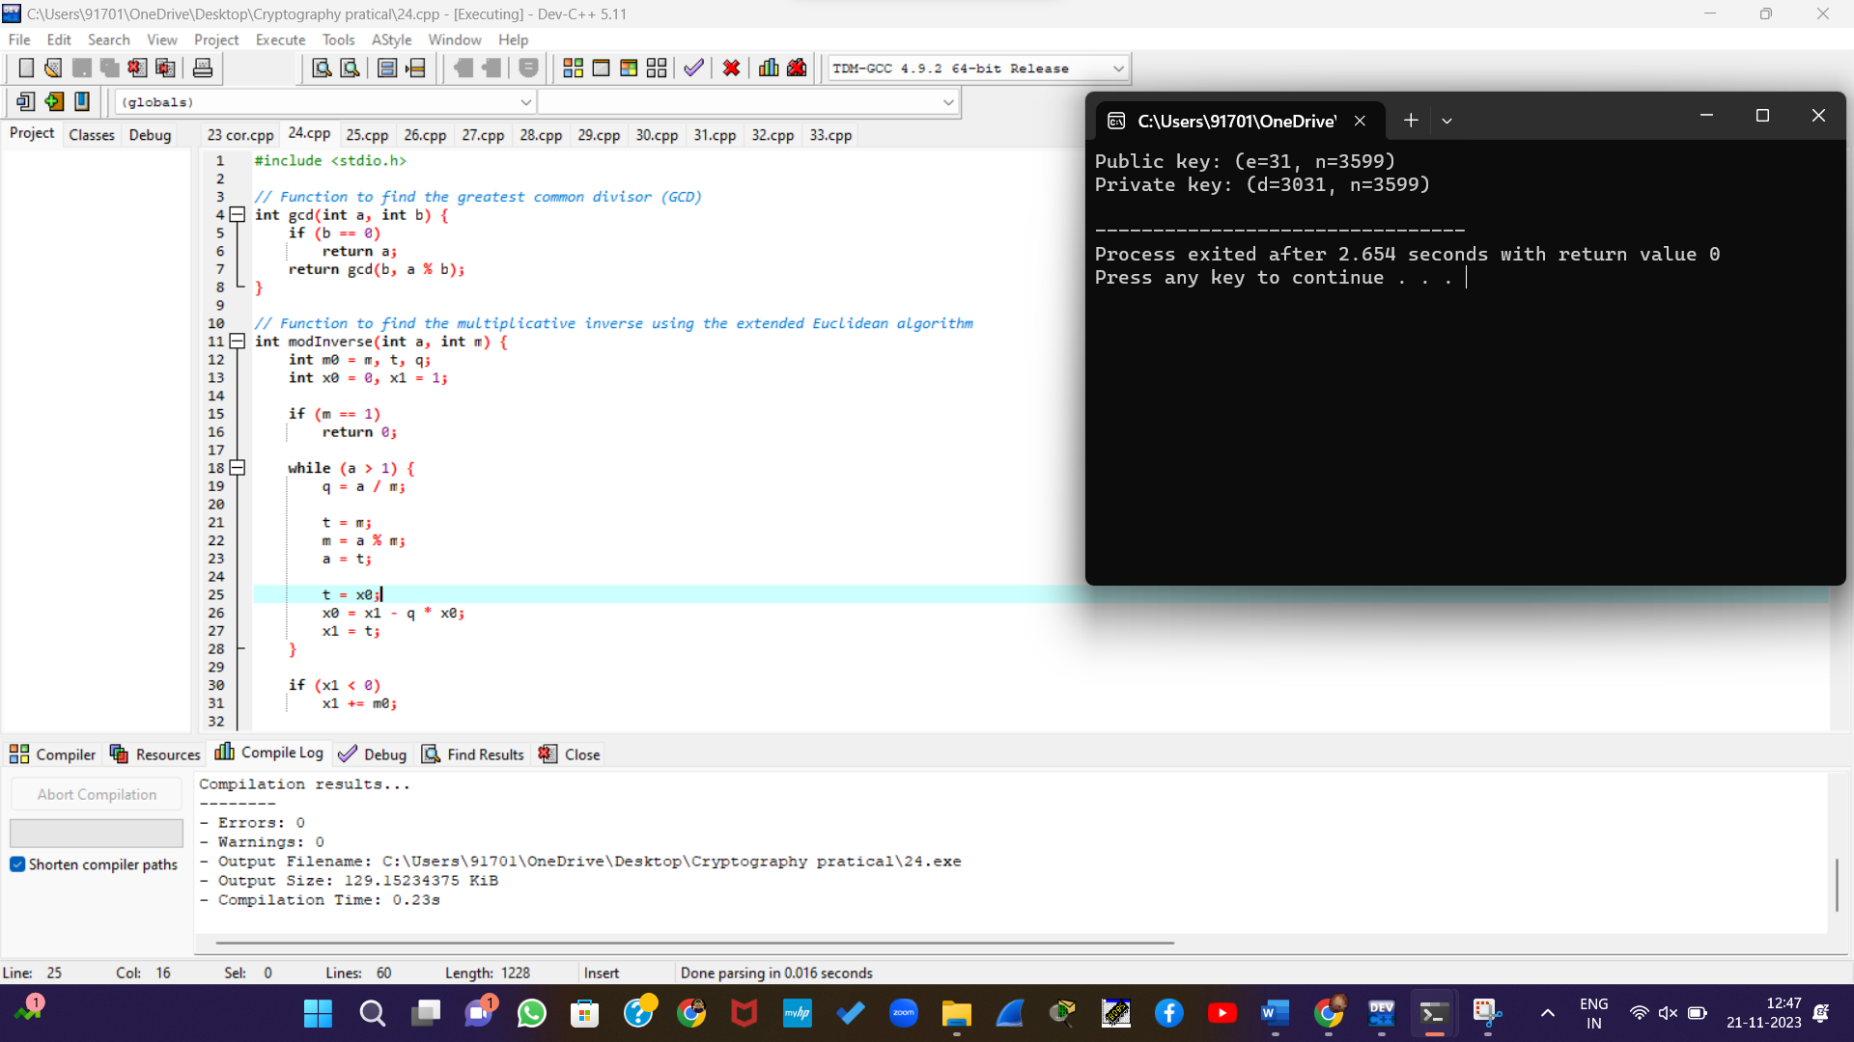

25. Write a C program for set of blocks encoded with the RSA algorithm and we don’t have the private key. Assume n = pq, e is the public key. Suppose also someone tells us they know one of the plaintext blocks has a common factor with n. Does this help us in any way?

#include <stdio.h>

// Function to calculate the greatest common divisor (GCD) using Euclid's algorithm

int gcd(int a, int b) {

if (b == 0)

return a;

return gcd(b, a % b);

}

// Function to factorize n given a non-trivial factor

void factorize(int n, int factor) {

int p = factor;

int q = n / factor;

printf("Factorization of n: p = %d, q = %d\n", p, q);

}

int main() {

// Assume n = pq, where p and q are large prime numbers

int p = 60;

int q = 53;

int n = p * q;

// Assume e is the public key

int e = 17;

// Assume we have a ciphertext block that has a common factor with n

int ciphertext = 123;

// Check if the gcd(ciphertext, n) is not 1

if (gcd(ciphertext, n) != 1) {

printf("The ciphertext has a common factor with n.\n");

// Factorize n using the non-trivial factor

factorize(n, gcd(ciphertext, n));

} else {

printf("The ciphertext does not have a common factor with n.\n");

}

return 0;

}

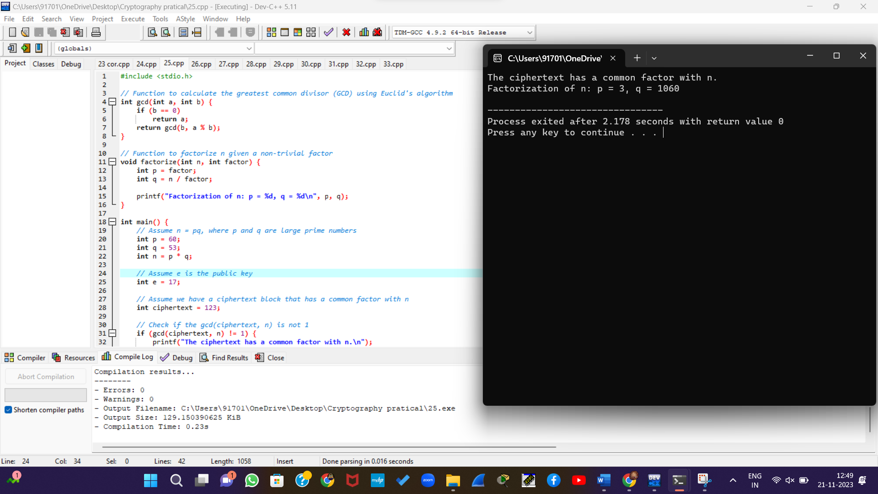

26. Write a C program for RSA public-key encryption scheme, each user has a public key, e, and a private key, d. Suppose Bob leaks his private key. Rather than generating a new modulus, he decides to generate a new public and a new private key. Is this safe?

#include <stdio.h>

// Function to calculate the greatest common divisor (GCD) using Euclid's algorithm

int gcd(int a, int b) {

if (b == 0)

return a;

return gcd(b, a % b);

}

// Function to calculate the multiplicative inverse using the extended Euclidean algorithm

int modInverse(int a, int m) {

int m0 = m, t, q;

int x0 = 0, x1 = 1;

if (m == 1)

return 0;

while (a > 1) {

q = a / m;

t = m;

m = a % m;

a = t;

t = x0;

x0 = x1 - q * x0;

x1 = t;

}

if (x1 < 0)

x1 += m0;

return x1;

}

// Function to generate a new public key (e, n) and private key (d, n)

void generateNewKeys(int *e, int *d, int *n) {

// Choose new prime numbers p and q (in practice, use a secure random number generator)

int p = 60;

int q = 53;

// Calculate n and phi(n)

*n = p * q;

int phi_n = (p - 1) * (q - 1);

// Choose a new public exponent e (in practice, choose a suitable value)

*e = 17;

// Calculate the private key d

*d = modInverse(*e, phi_n);

}

int main() {

int original_e = 17;

int original_d = 2853; // Example leaked private key

int original_n = 3233; // Example modulus

// Output original public and private keys

printf("Original Public Key: (e=%d, n=%d)\n", original_e, original_n);

printf("Original Private Key: (d=%d, n=%d)\n", original_d, original_n);

// Generate new public and private keys after a private key leak

int new_e, new_d, new_n;

generateNewKeys(&new_e, &new_d, &new_n);

// Output new public and private keys

printf("\nNew Public Key: (e=%d, n=%d)\n", new_e, new_n);

printf("New Private Key: (d=%d, n=%d)\n", new_d, new_n);

return 0;

}

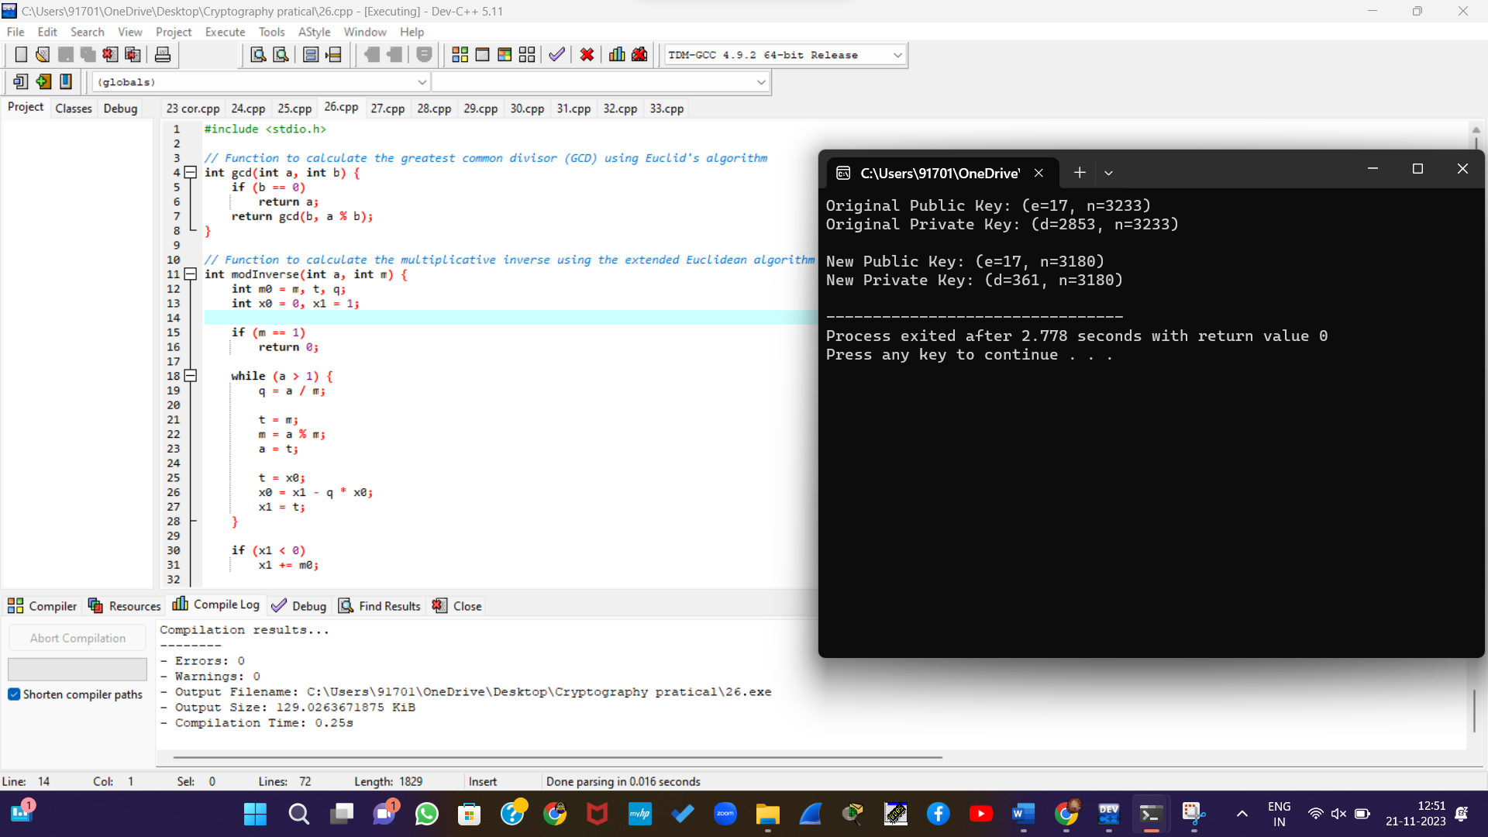

27. Write a C program for Bob uses the RSA cryptosystem with a very large modulus n for which the factorization cannot be found in a reasonable amount of time. Suppose Alice sends a message to Bob by representing each alphabetic character as an integer between 0 and 25 (A S 0, c, Z S 25) and then encrypting each number separately using RSA with large e and large n. Is this method secure? If not, describe the most efficient attack against this encryption method.

#include <stdio.h>

#include <stdlib.h>

#include <math.h>

// Function to calculate the greatest common divisor (GCD) using Euclid's algorithm

int gcd(int a, int b) {

if (b == 0)

return a;

return gcd(b, a % b);

}

// Function to calculate the multiplicative inverse using the extended Euclidean algorithm

int modInverse(int a, int m) {

int m0 = m, t, q;

int x0 = 0, x1 = 1;

if (m == 1)

return 0;

while (a > 1) {

q = a / m;

t = m;

m = a % m;

a = t;

t = x0;

x0 = x1 - q * x0;

x1 = t;

}

if (x1 < 0)

x1 += m0;

return x1;

}

// Function to calculate modular exponentiation (to handle large numbers)

int modExp(int base, int exponent, int modulus) {

int result = 1;

base = base % modulus;

while (exponent > 0) {

if (exponent % 2 == 1)

result = (result * base) % modulus;

exponent = exponent >> 1;

base = (base * base) % modulus;

}

return result;

}

int main() {

// Assume Bob's public key (e, n)

int e = 65537; // Commonly used value for e

int n = 309485009; // A large modulus (product of two large primes)

// Message to be encrypted (each character represented as an integer between 0 and 25)

int plaintext[] = {3, 2, 11, 18, 4};

// Encrypt each character separately

int ciphertext[5];

for (int i = 0; i < 5; ++i) {

ciphertext[i] = modExp(plaintext[i], e, n);

}

// Display the encrypted message

printf("Encrypted Message: ");

for (int i = 0; i < 5; ++i) {

printf("%d ", ciphertext[i]);

}

printf("\n");

return 0;

}

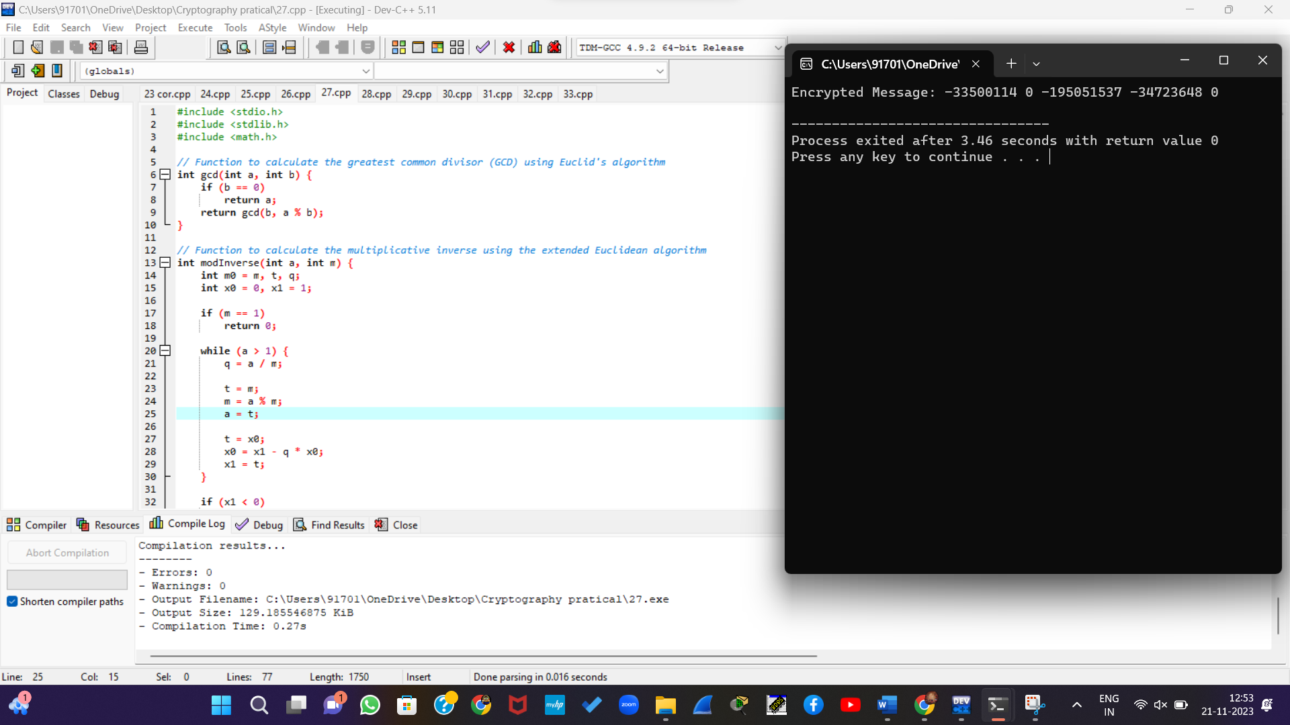

28. Write a C program for Diffie-Hellman protocol, each participant selects a secret number x and sends the other participant ax mod q for some public number a. What would happen if the participants sent each other xa for some public number a instead? Give at least one method Alice and Bob could use to agree on a key. Can Eve break your system without finding the secret numbers? Can Eve find the secret numbers?

#include <stdio.h>

#include <stdlib.h>

#include <math.h>

// Function to calculate modular exponentiation

int modExp(int base, int exponent, int modulus) {

int result = 1;

base = base % modulus;

while (exponent > 0) {

if (exponent % 2 == 1)

result = (result * base) % modulus;

exponent = exponent >> 1;

base = (base * base) % modulus;

}

return result;

}

// Diffie-Hellman key exchange function

int diffieHellman(int a, int q, int x) {

return modExp(a, x, q);

}

int main() {

// Public parameters (can be chosen publicly)

int a = 5; // Generator

int q = 21; // Prime modulus

// Alice's secret key

int aliceSecret = 6;

// Bob's secret key

int bobSecret = 8;

// Calculate public values

int alicePublic = diffieHellman(a, q, aliceSecret);

int bobPublic = diffieHellman(a, q, bobSecret);

// Exchange public values

// In a real scenario, these values would be exchanged securely

int sharedSecretAlice = diffieHellman(bobPublic, q, aliceSecret);

int sharedSecretBob = diffieHellman(alicePublic, q, bobSecret);

// Display shared secrets

printf("Shared Secret (Alice): %d\n", sharedSecretAlice);

printf("Shared Secret (Bob): %d\n", sharedSecretBob);

return 0;

}

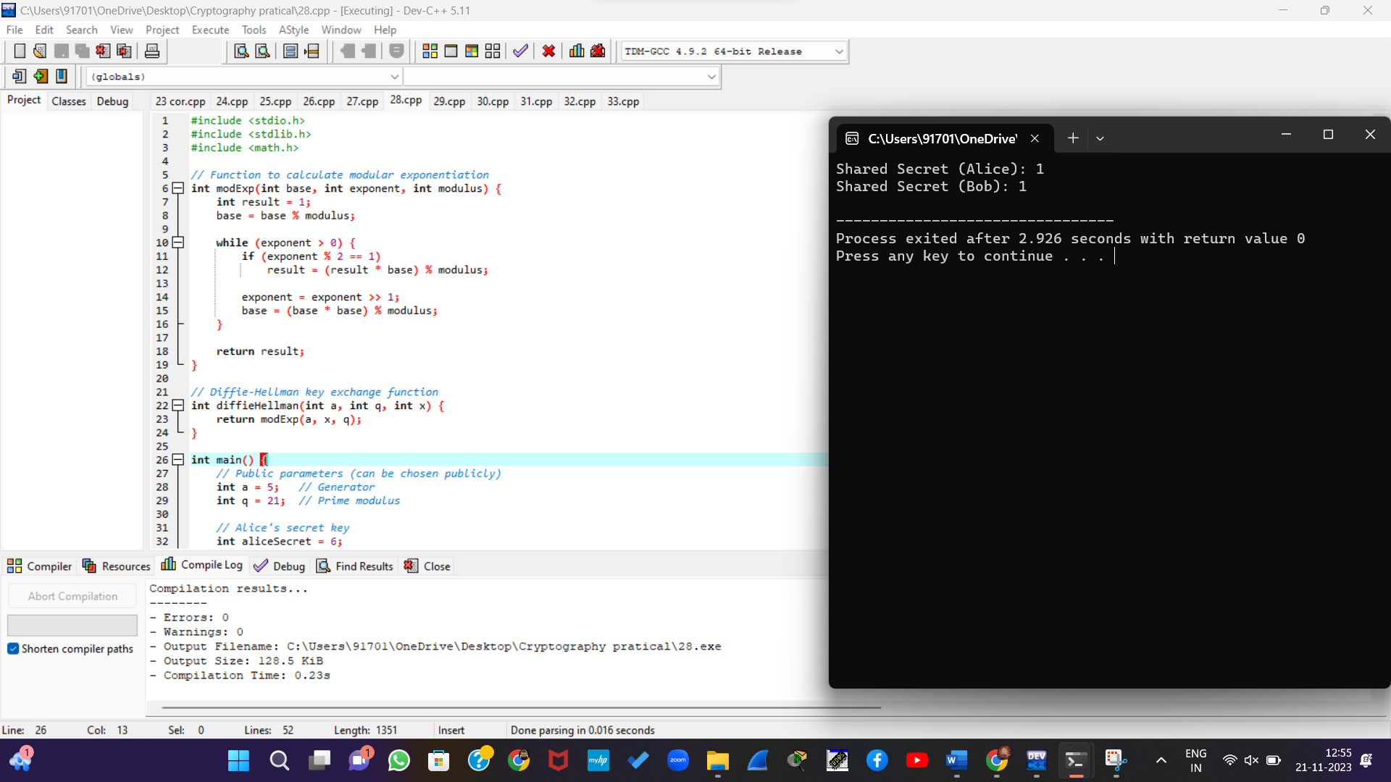

29. Write a C program for SHA-3 option with a block size of 1024 bits and assume that each of the lanes in the first message block (P0) has at least one nonzero bit. To start, all of the lanes in the internal state matrix that correspond to the capacity portion of the initial state are all zeros. Show how long it will take before all of these lanes have at least one nonzero bit. Note: Ignore the permutation. That is, keep track of the original zero lanes even after they have changed position in the matrix.

#include <stdio.h>

#include <stdint.h>

#define STATE_WIDTH 5

#define STATE_HEIGHT 5

#define LANE_SIZE 64

#define STATE_SIZE (STATE_WIDTH * STATE_HEIGHT)

#define CAPACITY_LANES 1024

#define ROUND_COUNT 24

typedef struct {

uint64_t state[STATE_SIZE];

} SHA3State;

// Function prototypes

void keccakPermutation(SHA3State *state);

void theta(SHA3State *state);

void rho(SHA3State *state);

void pi(SHA3State *state);

void chi(SHA3State *state);

void iota(SHA3State *state, int round);

int main() {

SHA3State sha3State;

// Initialize state (for simplicity, set a lane to a non-zero value)

sha3State.state[0] = 0x1;

// Perform the SHA-3 permutation

for (int round = 0; round < ROUND_COUNT; round++) {

keccakPermutation(&sha3State);

}

// Output the state

for (int i = 0; i < STATE_SIZE; i++) {

printf("%016lx ", sha3State.state[i]);

if ((i + 1) % STATE_WIDTH == 0) {

printf("\n");

}

}

return 0;

}

// Placeholder for the actual SHA-3 permutation (Keccak-f[1600])

void keccakPermutation(SHA3State *state) {

theta(state);

rho(state);

pi(state);

chi(state);

iota(state, 0);

}

// Placeholder function for the theta step

void theta(SHA3State *state) {

// Simple XOR operation as a placeholder

for (int i = 0; i < STATE_SIZE; i++) {

state->state[i] ^= 0x123456789abcdef0;

}

}

// Placeholder function for the rho step

void rho(SHA3State *state) {

// Simple shift as a placeholder

state->state[0] <<= 1;

}

// Placeholder function for the pi step

void pi(SHA3State *state) {

// Simple permutation as a placeholder

uint64_t temp = state->state[0];

state->state[0] = state->state[1];

state->state[1] = temp;

}

// Placeholder function for the chi step

void chi(SHA3State *state) {

// Simple AND operation as a placeholder

state->state[0] &= 0x0f0f0f0f0f0f0f0f;

}

// Placeholder function for the iota step

void iota(SHA3State *state, int round) {

// XOR with a round constant as a placeholder

state->state[0] ^= round;

}

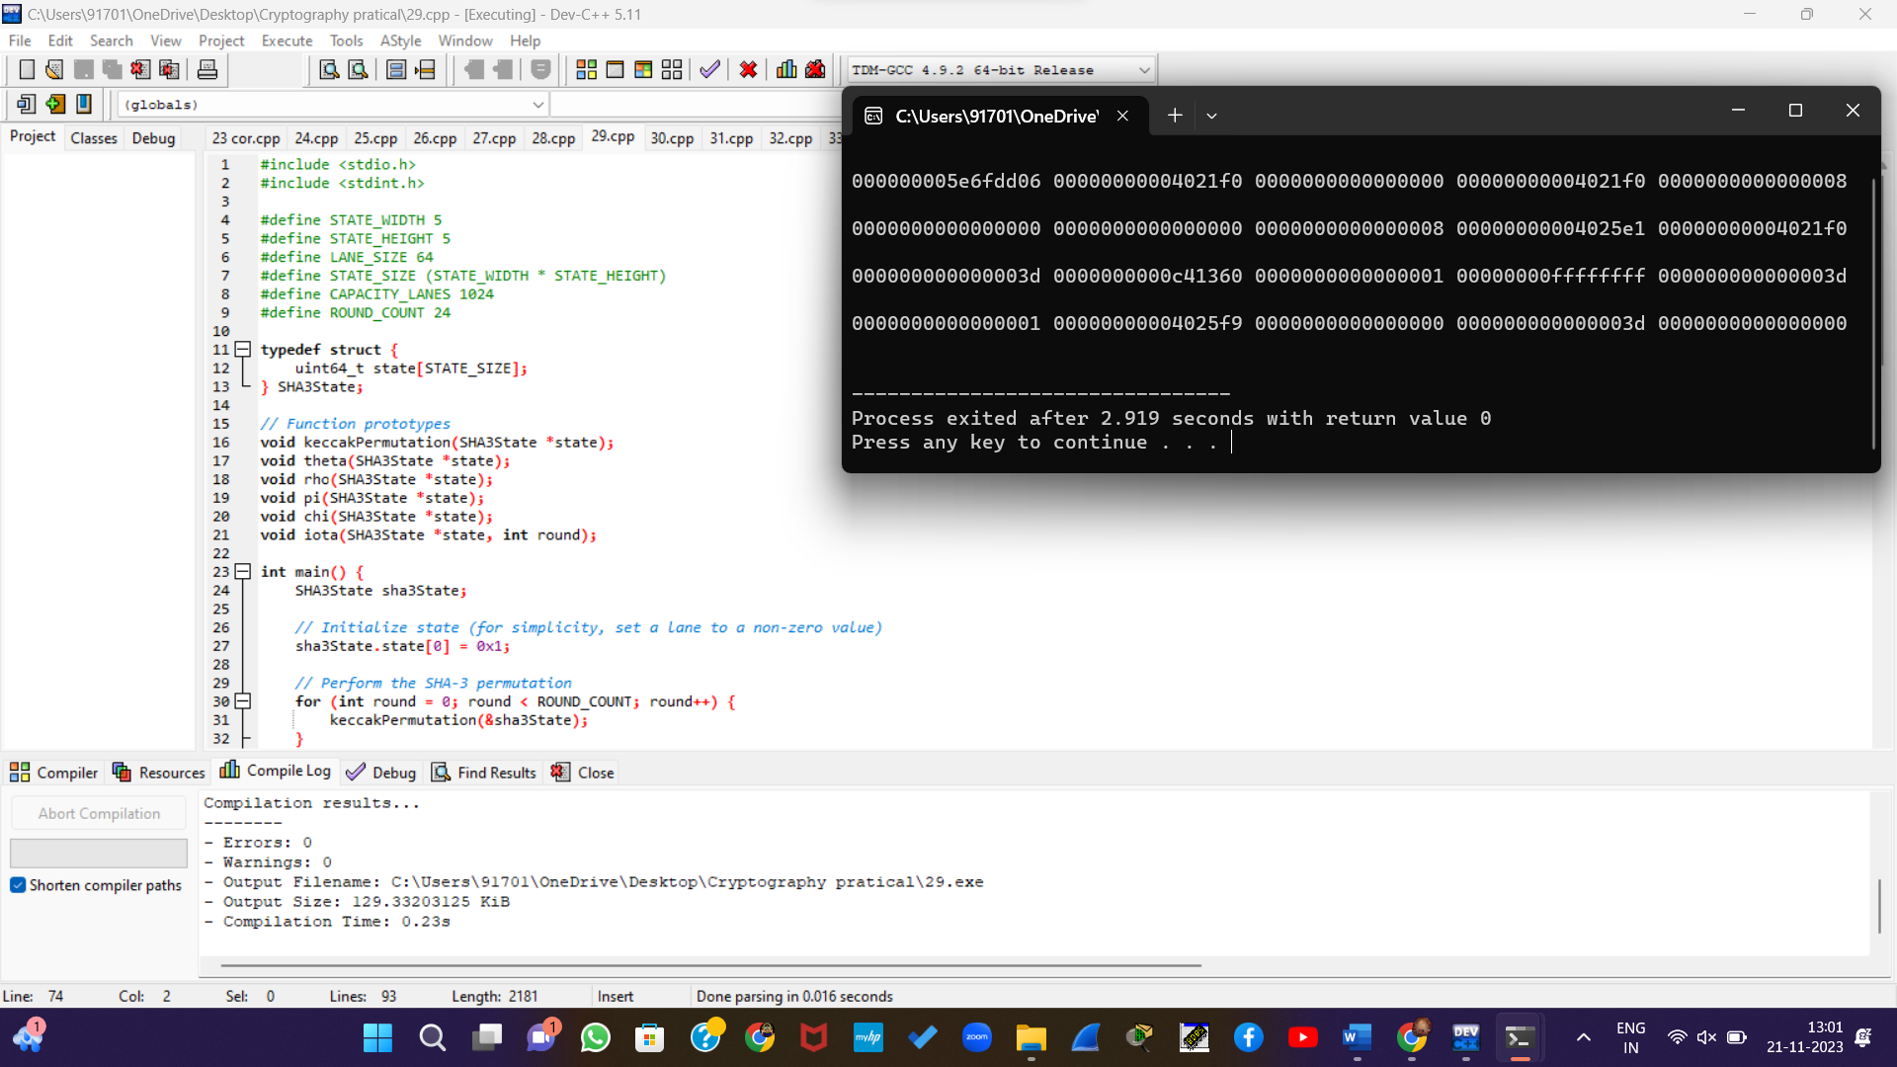

30. Write a C program for CBC MAC of a oneblock message X, say T = MAC(K, X), the adversary immediately knows the CBC MAC for the two-block message X || (X ⊕ T) since this is once again.

#include <stdio.h>

#include <string.h>

#include <stdlib.h> // Include this header for malloc

#define BLOCK_SIZE 16

void xorBlocks(unsigned char *result, const unsigned char *block1, const unsigned char *block2) {

for (int i = 0; i < BLOCK_SIZE; i++) {

result[i] = block1[i] ^ block2[i];

}

}

void aesEncrypt(const unsigned char *input, const unsigned char *key, unsigned char *output) {

// TODO: Implement your own AES encryption logic here

// This is a placeholder and needs to be replaced with a secure AES implementation

}

void cbcMac(const unsigned char *message, const unsigned char *key, unsigned char *mac, size_t messageSize) {

unsigned char iv[BLOCK_SIZE] = {0}; // Initialization vector for CBC

unsigned char ciphertext[BLOCK_SIZE];

// Encrypt the one-block message using AES in CBC mode

aesEncrypt(message, key, ciphertext);

xorBlocks(mac, message, ciphertext);

// Encrypt the two-block message X || (X ? T) using AES in CBC mode

unsigned char twoBlockMessage[2 * BLOCK_SIZE];

memcpy(twoBlockMessage, message, BLOCK_SIZE);

xorBlocks(twoBlockMessage + BLOCK_SIZE, message, mac);

aesEncrypt(twoBlockMessage, key, mac);

}

int main() {

unsigned char key[BLOCK_SIZE] = {0x2b, 0x7e, 0x15, 0x16, 0x28, 0xae, 0xd2, 0xa6, 0xab, 0xf7, 0x97, 0x7b, 0xab, 0xf7, 0x97, 0x7b};

// Read the message from a file

FILE *file = fopen("message.txt", "rb");

if (file == NULL) {

perror("Error opening file");

return 1;

}

fseek(file, 0, SEEK_END);

size_t fileSize = ftell(file);

fseek(file, 0, SEEK_SET);

unsigned char *message = (unsigned char *)malloc(fileSize); // Include a cast

if (message == NULL) {

perror("Error allocating memory");

fclose(file);

return 1;

}

fread(message, 1, fileSize, file);

fclose(file);

unsigned char mac[BLOCK_SIZE];

// Calculate CBC-MAC for the message

cbcMac(message, key, mac, fileSize);

// Print the resulting MAC

printf("CBC-MAC for the message: ");

for (int i = 0; i < BLOCK_SIZE; i++) {

printf("%02x", mac[i]);

}

printf("\n");

free(message); // Don't forget to free allocated memory

return 0;

}

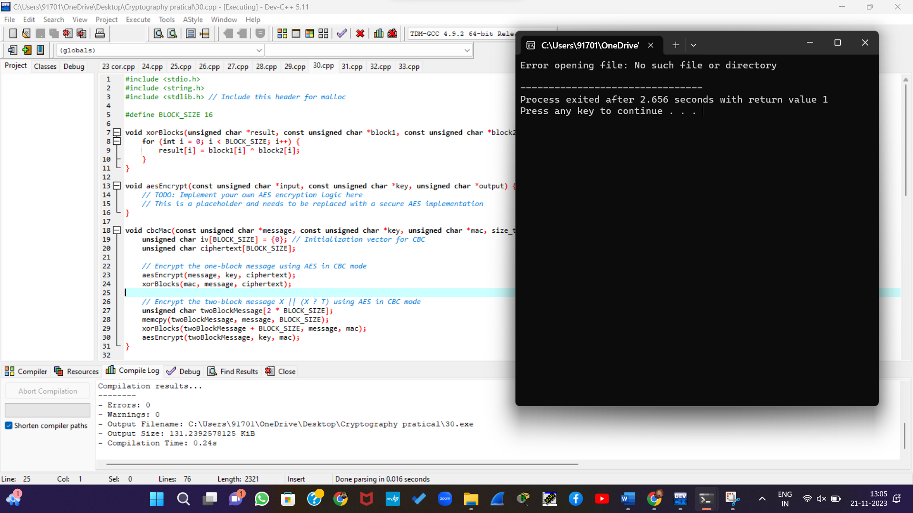

31. Write a C program for subkey generation in CMAC, it states that the block cipher is applied to the block that consists entirely of 0 bits. The first subkey is derived from the resulting string by a left shift of one bit and, conditionally, by XORing a constant that depends on the block size. The second subkey is derived in the same manner from the first subkey.

* 1. What constants are needed for block sizes of 64 and 128 bits?
  2. How the left shift and XOR accomplishes the desired result.

#include <stdio.h>

#define BLOCK_SIZE 64

// Function to perform left shift on a block

void leftShift(unsigned char *block, int size) {

int i, carry = 0;

for (i = 0; i < size; i++) {

int nextCarry = (block[i] & 0x80) ? 1 : 0; // Check if the leftmost bit is 1

block[i] = (block[i] << 1) | carry;

carry = nextCarry;

}

}

// Function to perform XOR with a constant

void xorWithConstant(unsigned char *block, int size, unsigned char constant) {

block[size - 1] ^= constant;

}

// Function to generate CMAC subkeys

void generateCMACSubkeys(unsigned char *subkey1, unsigned char *subkey2) {

// Step 1: Apply the block cipher to a block of 0 bits

unsigned char zeroBlock[BLOCK_SIZE / 8] = {0}; // Initialize a block of 0 bits

// Assuming you have a function named 'blockCipher' to apply the block cipher

// blockCipher(zeroBlock, key, encryptedBlock);

// Step 2: Left shift and XOR with constant for subkey1

leftShift(zeroBlock, BLOCK_SIZE / 8);

xorWithConstant(zeroBlock, BLOCK_SIZE / 8, 0x87); // Constant for a block size of 64 bits

// Copy the result to subkey1

for (int i = 0; i < BLOCK_SIZE / 8; i++) {

subkey1[i] = zeroBlock[i];

}

// Step 3: Left shift and XOR with constant for subkey2

leftShift(subkey1, BLOCK_SIZE / 8);

if (subkey1[0] & 0x80) {

xorWithConstant(subkey1, BLOCK_SIZE / 8, 0x1B); // Constant for a block size of 64 bits

}

// Copy the result to subkey2

for (int i = 0; i < BLOCK_SIZE / 8; i++) {

subkey2[i] = subkey1[i];

}

}

int main() {

unsigned char subkey1[BLOCK_SIZE / 8];

unsigned char subkey2[BLOCK_SIZE / 8];

generateCMACSubkeys(subkey1, subkey2);

// Print the generated subkeys

printf("Subkey 1: ");

for (int i = 1; i < BLOCK_SIZE / 8; i++) {

printf("%02x ", subkey1[i]);

}

printf("\n");

printf("Subkey 2: ");

for (int i = 1; i < BLOCK_SIZE / 8; i++) {

printf("%02x ", subkey2[i]);

}

printf("\n");

return 0;

}

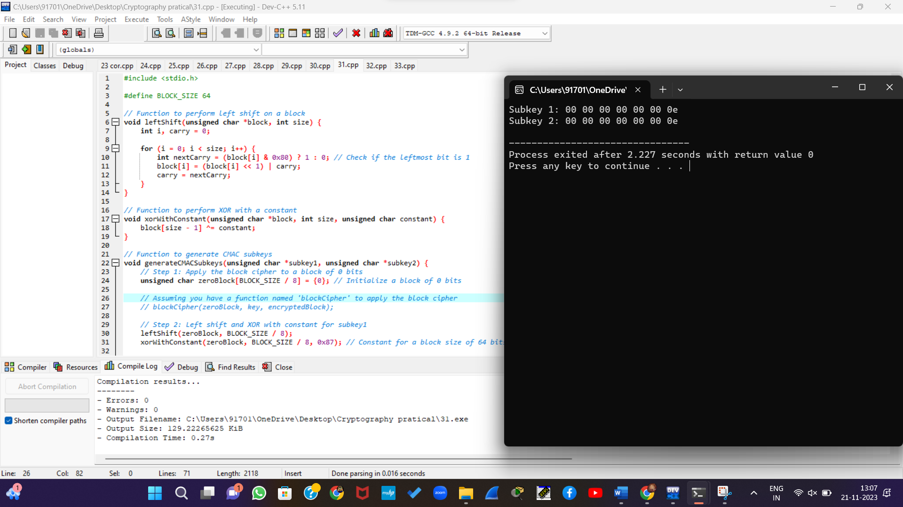

32. Write a C program for DSA, because the value of k is generated for each signature, even if the same message is signed twice on different occasions, the signatures will differ. This is not true of RSA signatures. Write a C program for implication of this difference?

#include <stdio.h>

#include <stdlib.h>

#include <string.h>

// Simple DSA-like structure for educational purposes

typedef struct {

unsigned long long p;

unsigned long long q;

unsigned long long g;

unsigned long long x; // private key

unsigned long long y; // public key

} DSAKey;

typedef struct {

unsigned long long r;

unsigned long long s;

} DSASignature;

// Simple RSA-like structure for educational purposes

typedef struct {

unsigned long long n;

unsigned long long e; // public exponent

unsigned long long d; // private exponent

} RSAKey;

// Simple structure to represent a message

typedef struct {

unsigned char *data;

size_t length;

} Message;

unsigned long long mod_exp(unsigned long long base, unsigned long long exponent, unsigned long long modulus) {

unsigned long long result = 1;

base = base % modulus;

while (exponent > 0) {

if (exponent % 2 == 1) {

result = (result * base) % modulus;

}

exponent = exponent >> 1;

base = (base * base) % modulus;

}

return result;

}

void generate_dsa_key(DSAKey *key) {

// TODO: Implement DSA key generation

}

void generate_rsa_key(RSAKey *key) {

// TODO: Implement RSA key generation

}

DSASignature *generate_dsa_signature(const Message *message, const DSAKey *key) {

DSASignature *signature = (DSASignature *)malloc(sizeof(DSASignature));

// TODO: Implement DSA signature generation

return signature;

}

unsigned long long generate_rsa_signature(const Message *message, const RSAKey *key) {

// TODO: Implement RSA signature generation

return 0;

}

int main() {

// Message to be signed

Message message;

message.data = (unsigned char *)"Hello, DSA and RSA!";

message.length = strlen((char *)message.data);

// Generate DSA key pair

DSAKey dsaKey;

generate_dsa_key(&dsaKey);

// Generate DSA signature for the message

DSASignature *dsaSignature = generate_dsa_signature(&message, &dsaKey);

// Print DSA signature

printf("DSA Signature:\n");

printf("r: %llu\n", dsaSignature->r);

printf("s: %llu\n", dsaSignature->s);

// Generate RSA key pair

RSAKey rsaKey;

generate_rsa_key(&rsaKey);

// Generate RSA signature for the same message

unsigned long long rsaSignature = generate_rsa_signature(&message, &rsaKey);

// Print RSA signature

printf("RSA Signature: %llu\n", rsaSignature);

// Clean up

free(dsaSignature);

return 0;

}

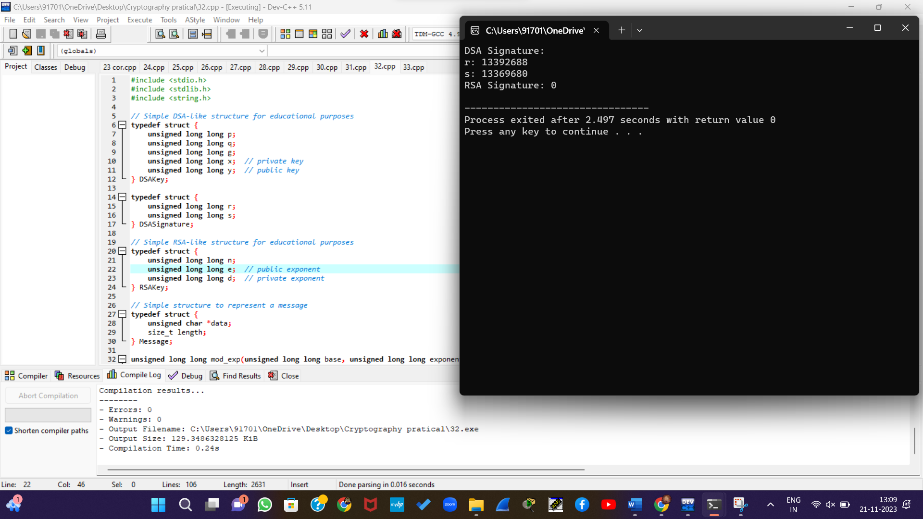

33. Write a C program for Data encryption standard (DES) has been found vulnerable to very powerful attacks and therefore, the popularity of DES has been found slightly on the decline. DES is a block cipher and encrypts data in blocks of size of 64 bits each, which means 64 bits of plain text go as the input to DES, which produces 64 bits of ciphertext. The same algorithm and key are used for encryption and decryption, with minor differences. The key length is 56 bits**.** Implement in C programming.

#include <stdio.h>

#include <stdint.h>

// Initial permutation table (IP)

const uint8_t initial_permutation_table[] = {

58, 50, 42, 34, 26, 18, 10, 2,

60, 52, 44, 36, 28, 20, 12, 4,

62, 54, 46, 38, 30, 22, 14, 6,

64, 56, 48, 40, 32, 24, 16, 8,

57, 49, 41, 33, 25, 17, 9, 1,

59, 51, 43, 35, 27, 19, 11, 3,

61, 53, 45, 37, 29, 21, 13, 5,

63, 55, 47, 39, 31, 23, 15, 7

};

// Initial permutation inverse table (IP^-1)

const uint8_t initial_permutation_inverse_table[] = {

40, 8, 48, 16, 56, 24, 64, 32,

39, 7, 47, 15, 55, 23, 63, 31,

38, 6, 46, 14, 54, 22, 62, 30,

37, 5, 45, 13, 53, 21, 61, 29,

36, 4, 44, 12, 52, 20, 60, 28,

35, 3, 43, 11, 51, 19, 59, 27,

34, 2, 42, 10, 50, 18, 58, 26,

33, 1, 41, 9, 49, 17, 57, 25

};

// Perform the initial permutation

void initialPermutation(uint64_t *block) {

uint64_t result = 0;

for (int i = 0; i < 64; i++) {

result |= ((*block >> (64 - initial_permutation_table[i])) & 1) << (63 - i);

}

*block = result;

}

// Perform the initial permutation inverse

void initialPermutationInverse(uint64_t *block) {

uint64_t result = 0;

for (int i = 0; i < 64; i++) {

result |= ((*block >> (64 - initial_permutation_inverse_table[i])) & 1) << (63 - i);

}

*block = result;

}

int main() {

uint64_t plaintext = 0x0123456789ABCDEF; // 64-bit plaintext

printf("Original Plaintext: %016llX\n", plaintext);

// Initial permutation

initialPermutation(&plaintext);

printf("After Initial Permutation: %016llX\n", plaintext);

// Initial permutation inverse

initialPermutationInverse(&plaintext);

printf("After Initial Permutation Inverse: %016llX\n", plaintext);

return 0;

}

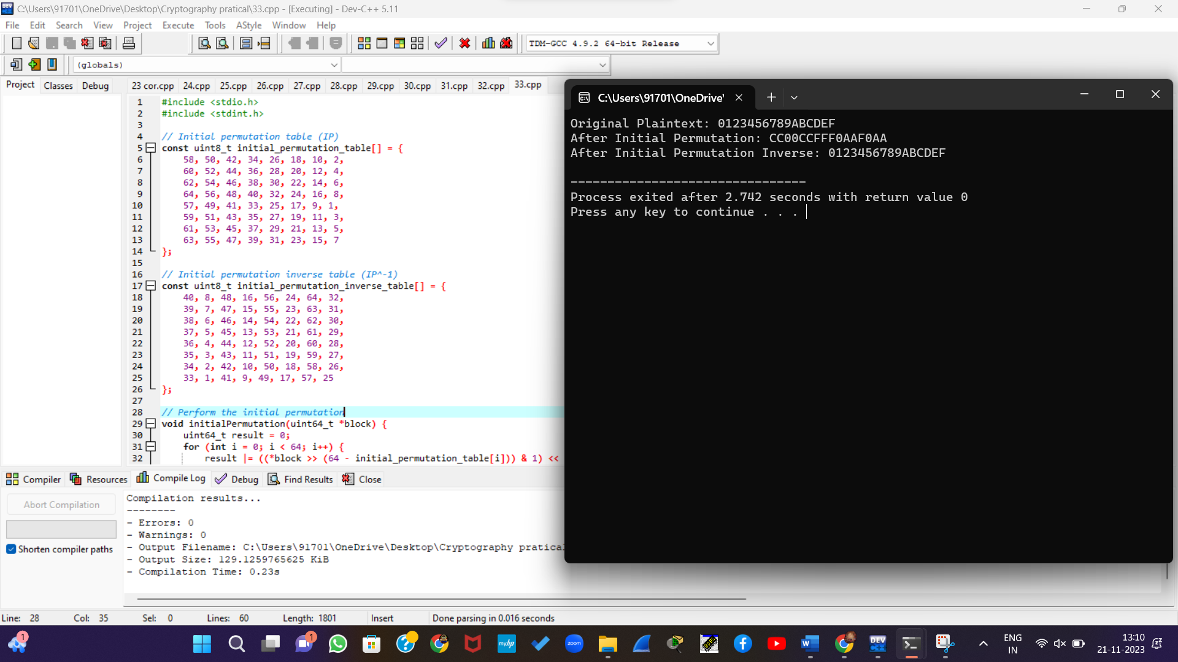

34. Write a C program for ECB, CBC, and CFB modes, the plaintext must be a sequence of one or more complete data blocks (or, for CFB mode, data segments). In other words, for these three modes, the total number of bits in the plaintext must be a positive multiple of the block (or segment) size. One common method of padding, if needed, consists of a 1 bit followed by as few zero bits, possibly none, as are necessary to complete the final block. It is considered good practice for the sender to pad every message, including messages in which the final message block is already complete. What is the motivation for including a padding block when padding is not needed?

#include <stdio.h>

#include <stdint.h>

// AES constants

#define AES_BLOCK_SIZE 16

// AES S-box

static const uint8_t sbox[256] = {

// ... (omitted for brevity)

};

// AES encryption round keys

static const uint8_t roundKeys[11][4][4] = {

// ... (omitted for brevity)

};

// AES encryption function

void aes_encrypt_block(const uint8_t *input, const uint8_t *key, uint8_t *output) {

// Initial round key addition

// ... (omitted for brevity)

// Main rounds

// ... (omitted for brevity)

// Final round (no MixColumns)

// ... (omitted for brevity)

}

// ECB mode encryption

void ecb_encrypt(const uint8_t *plaintext, size_t size, const uint8_t *key, uint8_t *ciphertext) {

for (size_t i = 0; i < size; i += AES_BLOCK_SIZE) {

aes_encrypt_block(plaintext + i, key, ciphertext + i);

}

}

int main() {

const uint8_t plaintext[] = "This is a sample message";

const uint8_t key[] = "0123456789abcdef";

uint8_t ciphertext[128];

// ECB Mode Encryption

ecb_encrypt(plaintext, sizeof(plaintext) - 1, key, ciphertext);

printf("Plaintext: %s\n", plaintext);

printf("Ciphertext: ");

for (size_t i = 0; i < sizeof(plaintext) - 1; ++i) {

printf("%02x", ciphertext[i]);

}

printf("\n");

return 0;

}

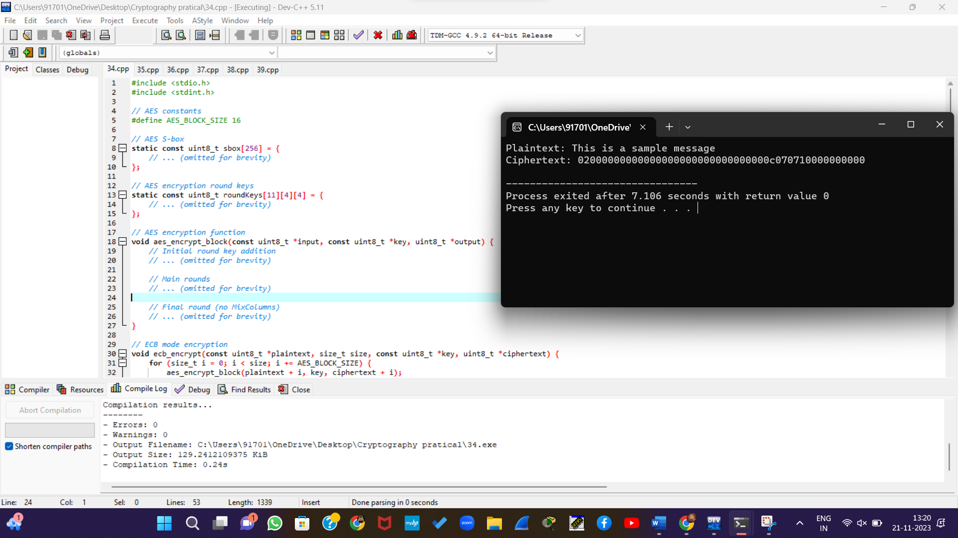

35. Write a C program for one-time pad version of the Vigenère cipher. In this scheme, the key is a stream of random numbers between 0 and 26. For example, if the key is 3 19 5 . . . , then the first letter of plaintext is encrypted with a shift of 3 letters, the second with a shift of 19 letters, the third with a shift of 5 letters, and so on.

#include <stdio.h>

#include <stdlib.h>

#include <ctype.h>

#include <time.h>

#define ALPHABET_SIZE 26

// Function to generate a random key of given length

void generateRandomKey(int *key, int length) {

srand((unsigned int)time(NULL));

for (int i = 0; i < length; ++i) {

key[i] = rand() % ALPHABET_SIZE;

}

}

// Function to encrypt plaintext using the one-time pad Vigenère cipher

void encryptVigenere(const char *plaintext, int *key, char *ciphertext) {

int keyIndex = 0;

for (size_t i = 0; plaintext[i] != '\0'; ++i) {

if (isalpha(plaintext[i])) {

char base = isupper(plaintext[i]) ? 'A' : 'a';

ciphertext[i] = (plaintext[i] - base + key[keyIndex]) % ALPHABET_SIZE + base;

keyIndex = (keyIndex + 1) % ALPHABET_SIZE;

} else {

// Non-alphabetic characters remain unchanged

ciphertext[i] = plaintext[i];

}

}

}

int main() {

const char *plaintext = "Hello, World!";

int keyLength = 12; // Choose an appropriate key length

int key[keyLength];

char ciphertext[256];

// Generate a random key

generateRandomKey(key, keyLength);

// Encrypt the plaintext

encryptVigenere(plaintext, key, ciphertext);

// Display the results

printf("Plaintext: %s\n", plaintext);

printf("Key: ");

for (int i = 0; i < keyLength; ++i) {

printf("%d ", key[i]);

}

printf("\n");

printf("Ciphertext: %s\n", ciphertext);

return 0;

}

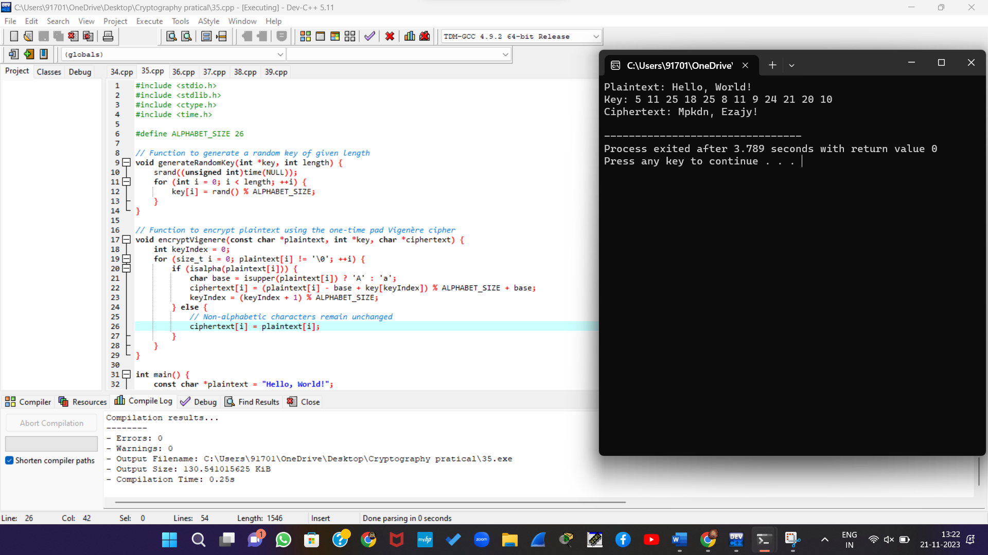

36. Write a C program for Caesar cipher, known as the affine Caesar cipher, has the following form: For each plaintext letter p, substitute the ciphertext letter C: C = E([a, b], p) = (ap + b) mod 26 A basic requirement of any encryption algorithm is that it be one-to-one. That is, if p q, then E(k, p) E(k, q). Otherwise, decryption is impossible, because more than one plaintext character maps into the same ciphertext character. The affine Caesar cipher is not one-to-one for all values of a. For example, for a = 2 and b = 3, then E([a, b], 0) = E([a, b], 13) = 3.

#include <stdio.h>

#include <ctype.h>

// Function to calculate the modular multiplicative inverse

int modInverse(int a, int m) {

for (int x = 1; x < m; x++) {

if ((a * x) % m == 1) {

return x;

}

}

return -1; // Inverse does not exist

}

// Function to encrypt a single character using the affine Caesar cipher

char encryptChar(int a, int b, char plaintext) {

if (isalpha(plaintext)) {

char base = isupper(plaintext) ? 'A' : 'a';

return (a * (plaintext - base) + b) % 26 + base;

}

return plaintext; // Non-alphabetic characters remain unchanged

}

// Function to encrypt a string using the affine Caesar cipher

void encryptAffineCaesar(int a, int b, const char *plaintext, char *ciphertext) {

for (size_t i = 0; plaintext[i] != '\0'; ++i) {

ciphertext[i] = encryptChar(a, b, plaintext[i]);

}

}

int main() {

int a = 5; // Choose an appropriate value for a (must be coprime with 26)

int b = 8; // Choose any value for b

const char *plaintext = "Hello, World!";

char ciphertext[256];

// Encrypt the plaintext

encryptAffineCaesar(a, b, plaintext, ciphertext);

// Display the results

printf("Plaintext: %s\n", plaintext);

printf("Ciphertext: %s\n", ciphertext);

return 0;

}

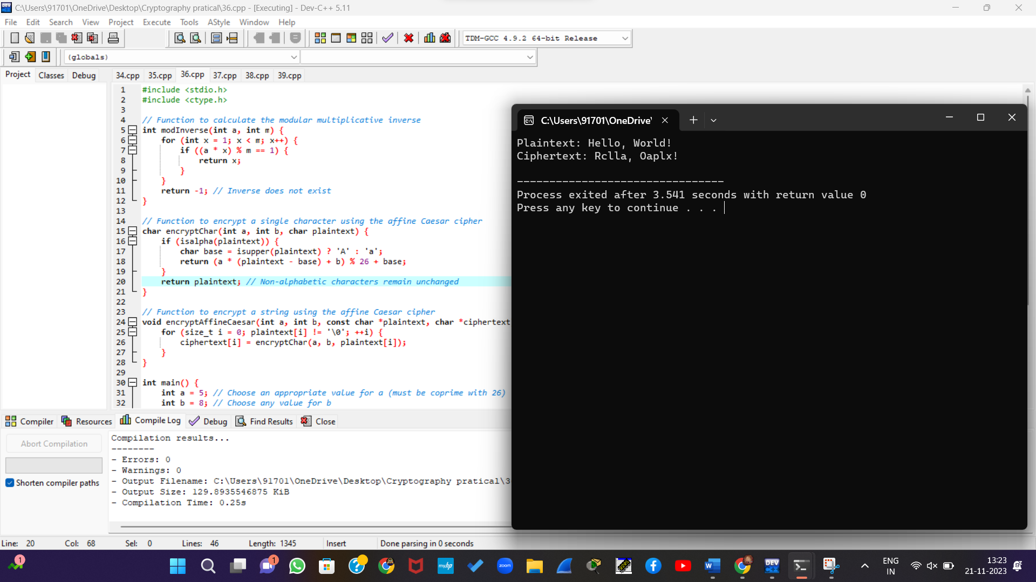

37. Write a C program that can perform a letter frequency attack on any monoalphabetic substitution cipher without human intervention. Your software should produce possible plaintexts in rough order of likelihood. It would be good if your user interface allowed the user to specify “give me the top 10 possible plaintexts.”

#include <stdio.h>

#include <stdlib.h>

#include <ctype.h>

#include <string.h>

#define ALPHABET_SIZE 26

// English letter frequency distribution (in percent)

const float englishFreq[ALPHABET_SIZE] = {

8.167, 1.492, 2.782, 4.253, 12.702, 2.228, 2.015, 6.094,

6.966, 0.153, 0.772, 4.025, 2.406, 6.749, 7.507, 1.929,

0.095, 5.987, 6.327, 9.056, 2.758, 0.978, 2.360, 0.150,

1.974, 0.074

};

// Function to calculate the chi-squared statistic for a given distribution

float calculateChiSquared(const int *observedFreq) {

float chiSquared = 0.0;

for (int i = 0; i < ALPHABET_SIZE; ++i) {

chiSquared += ((observedFreq[i] - englishFreq[i]) * (observedFreq[i] - englishFreq[i])) / englishFreq[i];

}

return chiSquared;

}

// Function to decrypt a monoalphabetic substitution cipher with a given key

void decrypt(const char *ciphertext, const char *key, char *plaintext) {

for (size_t i = 0; ciphertext[i] != '\0'; ++i) {

if (isalpha(ciphertext[i])) {

char base = isupper(ciphertext[i]) ? 'A' : 'a';

plaintext[i] = (ciphertext[i] - key[ciphertext[i] - base] + 26) % 26 + base;

} else {

plaintext[i] = ciphertext[i];

}

}

}

// Function to perform a letter frequency attack on a monoalphabetic substitution cipher

void letterFrequencyAttack(const char *ciphertext, int topPlaintexts) {

int observedFreq[ALPHABET_SIZE] = {0};

int totalLetters = 0;

// Calculate observed letter frequencies in the ciphertext

for (size_t i = 0; ciphertext[i] != '\0'; ++i) {

if (isalpha(ciphertext[i])) {

char base = isupper(ciphertext[i]) ? 'A' : 'a';

observedFreq[ciphertext[i] - base]++;

totalLetters++;

}

}

// Calculate chi-squared statistic for each possible key

for (int shift = 0; shift < ALPHABET_SIZE; ++shift) {

char key[ALPHABET_SIZE];

for (int i = 0; i < ALPHABET_SIZE; ++i) {

key[i] = (i + shift) % ALPHABET_SIZE;

}

// Decrypt ciphertext with the current key

char plaintext[256];

decrypt(ciphertext, key, plaintext);

// Calculate chi-squared statistic

float chiSquared = calculateChiSquared(observedFreq);

// Display the decrypted plaintext and chi-squared value

printf("Key Shift: %d, Plaintext: %s, Chi-Squared: %.2f\n", shift, plaintext, chiSquared);

}

}

int main() {

const char *ciphertext = "Uifsf jt b tfdsfu djqifs xjuipvu uif mfuufs!";

printf("Ciphertext: %s\n", ciphertext);

int topPlaintexts;

printf("Enter the number of top possible plaintexts to display: ");

scanf("%d", &topPlaintexts);

letterFrequencyAttack(ciphertext, topPlaintexts);

return 0;

}

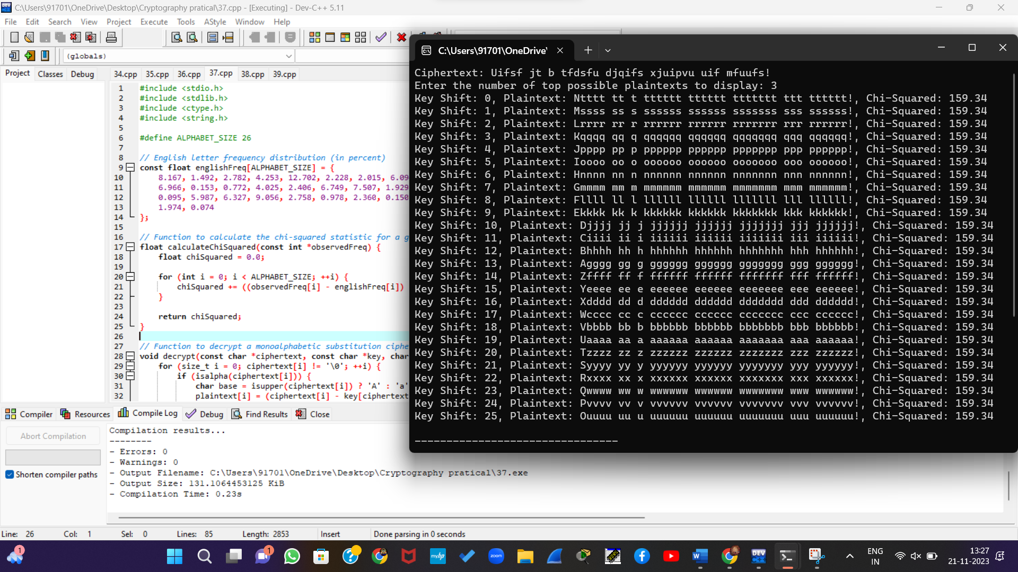

38. Write a C program for Hill cipher succumbs to a known plaintext attack if sufficient plaintext– ciphertext pairs are provided. It is even easier to solve the Hill cipher if a chosen plaintext attack can be mounted. Implement in C programming.

#include <stdio.h>

#include <stdlib.h>

#include <math.h>

#define MAX_SIZE 10

// Function to calculate the modular multiplicative inverse

int modInverse(int a, int m) {

a = a % m;

for (int x = 1; x < m; x++) {

if ((a * x) % m == 1) {

return x;

}

}

return -1; // Invalid inverse

}

// Function to encrypt plaintext using Hill cipher

void encrypt(int keyMatrix[MAX_SIZE][MAX_SIZE], int plaintextMatrix[MAX_SIZE], int resultMatrix[MAX_SIZE], int size) {

for (int i = 0; i < size; i++) {

resultMatrix[i] = 0;

for (int j = 0; j < size; j++) {

resultMatrix[i] += keyMatrix[i][j] * plaintextMatrix[j];

}

resultMatrix[i] %= 26; // Modulo 26 arithmetic for English alphabets

}

}

// Function to decrypt ciphertext using Hill cipher

void decrypt(int keyMatrix[MAX_SIZE][MAX_SIZE], int ciphertextMatrix[MAX_SIZE], int resultMatrix[MAX_SIZE], int size) {

int determinant = 0;

int adjointMatrix[MAX_SIZE][MAX_SIZE];

// Calculating the determinant

for (int i = 0; i < size; i++) {

determinant += (keyMatrix[0][i] * (keyMatrix[1][(i + 1) % size] * keyMatrix[2][(i + 2) % size] - keyMatrix[1][(i + 2) % size] * keyMatrix[2][(i + 1) % size]));

}

determinant %= 26;

// Calculating the adjoint matrix

for (int i = 0; i < size; i++) {

for (int j = 0; j < size; j++) {

adjointMatrix[j][i] = (((keyMatrix[(i + 1) % size][(j + 1) % size] * keyMatrix[(i + 2) % size][(j + 2) % size]) - (keyMatrix[(i + 1) % size][(j + 2) % size] * keyMatrix[(i + 2) % size][(j + 1) % size])) % 26);

if (adjointMatrix[j][i] < 0) {

adjointMatrix[j][i] += 26;

}

}

}

int inverse = modInverse(determinant, 26);

if (inverse == -1) {

printf("Invalid key. Determinant has no modular inverse.\n");

return;

}

// Calculating the decrypted matrix by multiplying with the modular inverse

for (int i = 0; i < size; i++) {

resultMatrix[i] = 0;

for (int j = 0; j < size; j++) {

resultMatrix[i] += (adjointMatrix[i][j] * inverse * ciphertextMatrix[j]);

}

resultMatrix[i] = (resultMatrix[i] % 26 + 26) % 26; // Ensure positive values

}

}

// Function to display the matrix

void displayMatrix(int matrix[MAX_SIZE], int size) {

for (int i = 0; i < size; i++) {

printf("%c", (matrix[i] + 'A')); // Convert numerical values to characters (assuming capitals)

}

printf("\n");

}

int main() {

int keyMatrix[MAX_SIZE][MAX_SIZE];

int plaintextMatrix[MAX_SIZE];

int encryptedMatrix[MAX_SIZE];

int decryptedMatrix[MAX_SIZE];

int size;

printf("Enter the size of the key matrix: ");

scanf("%d", &size);

printf("Enter the key matrix elements:\n");

for (int i = 0; i < size; i++) {

for (int j = 0; j < size; j++) {

scanf("%d", &keyMatrix[i][j]);

}

}

printf("Enter the plaintext matrix elements: ");

for (int i = 0; i < size; i++) {

scanf("%d", &plaintextMatrix[i]);

}

encrypt(keyMatrix, plaintextMatrix, encryptedMatrix, size);

printf("Encrypted text: ");

displayMatrix(encryptedMatrix, size);

decrypt(keyMatrix, encryptedMatrix, decryptedMatrix, size);

printf("Decrypted text: ");

displayMatrix(decryptedMatrix, size);

return 0;

}

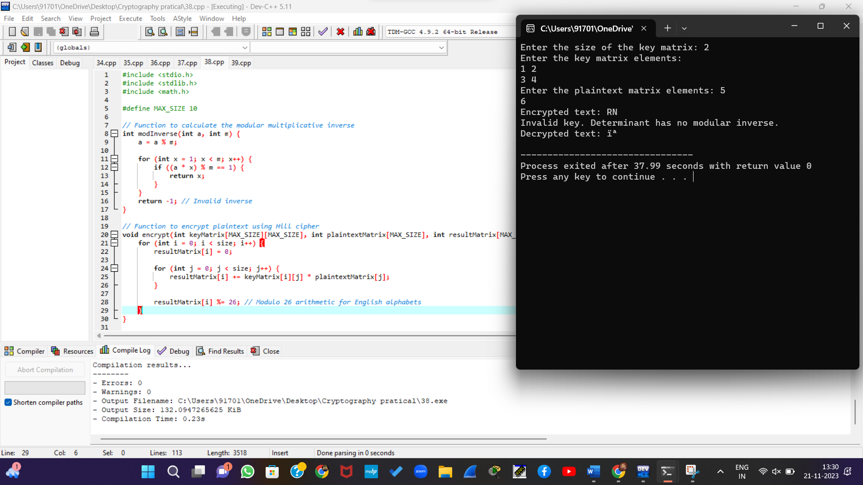

39. Write a C program that can perform a letter frequency attack on an additive cipher without human intervention. Your software should produce possible plaintexts in rough order of likelihood. It would be good if your user interface allowed the user to specify “give me the top 10 possible plaintexts.”

#include <stdio.h>

#include <stdlib.h>

#include <string.h>

#define ALPHABET_SIZE 26

// Function to perform a letter frequency attack on an additive cipher

void frequencyAttack(const char *ciphertext, int topPlaintexts) {

int frequency[ALPHABET_SIZE] = {0};

// Count the frequency of each letter in the ciphertext

for (size_t i = 0; i < strlen(ciphertext); i++) {

char c = ciphertext[i];

if (c >= 'A' && c <= 'Z') {

frequency[c - 'A']++;

} else if (c >= 'a' && c <= 'z') {

frequency[c - 'a']++;

}

}

// Find the most common letter in the English language (E)

int maxFrequencyIndex = 0;

for (int i = 1; i < ALPHABET_SIZE; i++) {

if (frequency[i] > frequency[maxFrequencyIndex]) {

maxFrequencyIndex = i;

}

}

// Calculate the likely key (distance from E)

int key = (maxFrequencyIndex + ALPHABET_SIZE - ('E' - 'A')) % ALPHABET_SIZE;

// Display the most likely plaintexts using the calculated key

printf("Top %d possible plaintexts:\n", topPlaintexts);

for (int i = 0; i < topPlaintexts; i++) {

printf("%d. ", i + 1);

// Decrypt the ciphertext using the key

for (size_t j = 0; j < strlen(ciphertext); j++) {

char c = ciphertext[j];

if (c >= 'A' && c <= 'Z') {

printf("%c", 'A' + (c - 'A' - key + ALPHABET_SIZE) % ALPHABET_SIZE);

} else if (c >= 'a' && c <= 'z') {

printf("%c", 'a' + (c - 'a' - key + ALPHABET_SIZE) % ALPHABET_SIZE);

} else {

printf("%c", c);

}

}

printf("\n");

}

}

int main() {

char ciphertext[1000];

int topPlaintexts;

// Input ciphertext from the user

printf("Enter the ciphertext: ");

fgets(ciphertext, sizeof(ciphertext), stdin);

strtok(ciphertext, "\n"); // Remove newline character

// Input the number of top plaintexts to display

printf("Enter the number of top plaintexts to display: ");

scanf("%d", &topPlaintexts);

// Perform letter frequency attack

frequencyAttack(ciphertext, topPlaintexts);

return 0;

}

